**Non-Contact Analysis of Health-Informatics via Observable Metrics**

ECE4012 Senior Design Project

Section L5A, Non-Contact Analysis of Health-Informatics via Observable Metrics Team

Project Advisor: Dr. Ying Zhang

Zachary Lasater, [zlasater3@gatech.edu](mailto:zlasater3@gatech.edu), Team Leader

Julian Rosker, [Julian.Rosker@gatech.edu](mailto:Julian.Rosker@gatech.edu)

Ahmed Elsabbagh, [aelsabbagh3@gatech.edu](mailto:aelsabbagh3@gatech.edu)

Anthony Genutis, [agenutis3@gatech.edu](mailto:agenutis3@gatech.edu)

Andrew Renuart, [arenuart3@gatech.edu](mailto:arenuart3@gatech.edu)

Submitted

May 03, 2018

**Executive Summary**

The Non-Contact Analysis of Health-Informatics via Observable Metrics (NAHOM) Team built a device that improves health and minimizes response time in medical emergencies. The NAHOM device serves this purpose by alerting users of certain health emergencies and general health trends without physical contact with the measurement device. It addresses the need for a device that monitors heart and respiration rates in real time without physical contact with the user.

Every year, approximately 735,000 people in the United States have a heart attack, and 1 in 4 deaths are related to heart disease [1]. In addition, while overlooked by many hospitals, respiration rate is an excellent predictor of a wide array of many medical issues [2], [3]. By making heart and respiration rates measurements easily and quickly accessible, the NAHOM device allows for more continuous monitoring of health.

This team continued past development efforts for the NAHOM device. A signal generator and a transceiver, with transmit and receive antennas, were set up by previous teams to extract a signal. The transmit antenna sends a 5.8GHz signal, which is reflected off of the subject’s body to the receiving antenna. The team was responsible for a STM32 microcontroller (MCU) that uses SPI to control an AD7770 analog to digital converter (ADC) to digitize the signal and send it to the microcontroller. The microcontroller transmits the waveform to a PC through UART and an RS232 to USB connection. The PC processes the waveform and calculates the subject’s biometric data using the frequency components of the reflected signal. The biometric data is displayed to the user in a user-friendly interface on a computer application.

The team successfully developed the signal processing algorithm and the user interface that is able to display, in real-time, the health-informatics to the user on the PC. The ADC and MCU were both configured to support the real-time processing and plotting of the health data. The team requested $607.83 for the prototype that was developed, and the device would be sold for $500 on the market.

**Table of Contents**

**Executive Summary** ............................................................................................................................. ii

**1 Introduction** .............................................................................................................................. 1

1.1 Objective .................................................................................................................................... 1

1.2 Motivation .................................................................................................................................. 2

1.3 Background ................................................................................................................................ 3

**2 Project Description and Goals** ................................................................................................ 6

**3 Technical Specifications & Verification** ................................................................................ 7

**4 Design Approach and Details** ................................................................................................ 9

4.1 Design Approach ....................................................................................................................... 9

4.2 Codes and Standards .................................................................................................................. 13

4.3 Constraints, Alternatives, and Tradeoffs................................................................................... 14

**5 Schedule, Tasks, and Milestones** ............................................................................................ 15

**6 Final Project Demonstration**................................................................................................... 16

**7 Marketing and Cost Analysis** ................................................................................................. 18

7.1 Marketing Analysis ................................................................................................................... 18

7.2 Cost Analysis ............................................................................................................................. 19

**8 Conclusion** ................................................................................................................................ 22

**9 Leadership Roles** .................................................................................................................... 24

**10 References** ................................................................................................................................ 25

**Appendix A** .......................................................................................................................................... 29

**Appendix B** ........................................................................................................................................... 31

**Appendix C** ........................................................................................................................................... 32

**Non-Contact Vital Sign Monitoring System**

**1. Introduction**

The NAHOM Team designed and prototyped a system for real-time analysis of user biometric data gathered without physical contact between the user and the system for display and health analytics. The aforementioned team requested $607.83 in funding to achieve this task.

1.1 **Objective**

The objective of our project was to use the existing antennas and function generator to build a system that will report heart and respiration rates of a user in real time without physical contact with aforementioned user. **Figure 1** shows a block diagram of the system at a high level of abstraction. The signal generator propagates a signal through the transceiver transmit antenna towards the user. The receiving antenna receives a phase shifted signal. The phase shift of the received signal is dependent on the user’s heart and respiration rates. An Analog to Digital Converter (ADC) digitizes the signal received from the antennas and transmits it to a microcontroller unit (MCU). The microcontroller unit transmits the waveform to a PC through UART and USB. The PC digitally processes the signal to produce a set of biometric measurements. The application displays the results to the user in a user-friendly manner through a GUI.

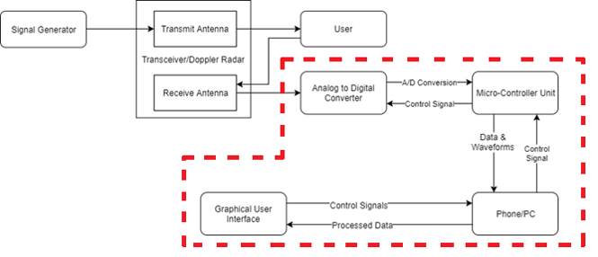

**Figure 1:** System overview block diagram of the NAHOM device. The red border indicates the scope of our project.

1.2 **Motivation**

The goal of the NAHOM Team is to detect diseases early and increase response time in medical emergencies by making access to heart and respiration rates cheaper, non-obtrusive and more readily available. The changes that our system introduces are centered around the facts that it is non-contact [4], [5], cheaper, able to provide real time readings, is not affected by environmental factors such as light or clothing material [3] and is simple to use.

In addition to convenience, there is a great need for a non-contact solution. For example, for a person with burns or sensitive skin, current contact solutions are not viable [6]. And current devices which monitor certain conditions such as sleep apnea may cause inconvenience to the user during their sleep thereby invalidating the measurement [3].

Furthermore, many of the currently available solutions require an expert to use them [4], which may reduce the frequency of measurements or, particularly in the case of respiration rate, lead to measurements not being taken at all [2].

1.3 **Background**

**1.3.1 Vital Sign Monitoring**

Extensive research has been done in the area of vital sign monitoring and multiple solutions have been developed. For example, a Fitbit is a device that is worn around the wrist and monitors heart rate and costs $150 [7]. Fitbit is the world’s best-selling fitness tracker manufacturer. It uses light emitting diodes that reflect off the skin to detect changes in blood volume to detect heart rate. The accuracy of this device has been challenged in multiple lawsuits which claim the measurements are low which can lead the user to drive their heart rate to dangerous levels [8]. A Qardio device that is worn around the chest to monitor respiration rate and costs $450 [9]. Researchers were also able to use computer vision [4] and a Kinect [6] to measure respiration rate but their results were dependent on the environment (such as temperature and room lighting) [3].

**1.3.2 The Doppler Radar**

The Doppler Radar is used in the existing system and the team used it in this iteration of the project. The Doppler Radar sends a signal and receives a signal with a phase shift that is dependent on the reflected signal. This effect is similar to the “Doppler Shift” observed in sound waves. Doppler processing will be used to interpret the received signal. The Doppler Radar has been heavily researched and the team is planning to utilize research done in that area [10]. The NAHOM device is based on research done on Doppler radar [3].

**1.3.3 Analog to Digital Converter**

The team purchased and used a Delta-Sigma Analog to Digital Converter (ADC) developed by Analog Devices. The ADC purchased and used was the AD7770. The team utilized the results of past research in ADCs and the particular datasheet and resources developed for the ADC used.

A Sigma Delta ADC is a closed negative feedback loop. The feedback is subtracted from the input voltage. The integrator adds the sum to a value stored from the previous integration. If the non-inverting input of the op-amp is greater than zero a logic high is output, otherwise a logic low is output. Over multiple cycles, this sum will equal zero due to the negative feedback. The output of this feedback loop is a digital word that is used to determine the input voltage [11], [12], [13]. Because of this architecture that requires multiple cycles of feedback to accurately determine the input voltage, the Delta Sigma is generally slower than the SAR ADC.  
 The Delta Sigma ADC stands out for having high resolution and signal-to-noise ratio (SNR) with low power dissipation. It over-samples the input voltage (sample rate is much higher than Nyquist rate). A Delta Sigma ADC is generally more expensive than an SAR ADC, though cheaper than the Pipeline ADCs [11], [14].

**1.3.4 Microcontroller Unit and SPI Communication Protocol**

The team purchased and used a Microcontroller (MCU) developed by STMicroelectronics. The MCU purchased was the STM32F446ZEJ6. The datasheet and support material provided with the microcontroller were used. The MCU used UART to communicate with a USB serial port adapter, which exchanges data with the PC. SPI is used to communicate between the MCU and ADC. SPI is a synchronous communication protocol between a master and multiple slaves. It is widely used today in many applications such as RFIDs and transceivers. SPI has four lines for communication:

(1) Master-In-Slave-Out for communication from slave to master,

(2) Master-Out-Slave-In for communication from master to slave,

(3) a clock line,

(4) a slave select line that sets the slave in a mode in which it can listen to the master.

SPI can send signals continuously with as many bits as required, as opposed to UART which sends signals in 8-bit packets. Data can also be sent to and received from the slave simultaneously [15].

**1.3.5 Embedded Digital Signal Processing**

In embedded applications, there are two main ways to process signals: digital signal processors (DSPs) and field-programmable gate arrays (FPGAs) [16]. The former follows a standard Von Neumann architecture in which input is stored in short-term memory units and statements are processed sequentially [17]. This architecture can have lower hardware costs, but most of the savings come in the form of having a faster development time [17]. Since the technology is inherently easier to work with, test, and implement on a physical device, staff and technology reuse costs will be lower [17]. If the intended use is within a rapidly changing field, it may be desirable to sacrifice some performance or cost so that new iterations of a product can be released faster.

The alternative option to digital signal processors is field-programmable gate arrays (FPGAs), which offer potentially higher processing speeds but with high costs due to programming complexity [16]. The strength of FPGAs arises from the fact that each computation can be easily parallelized. In a digital signal processor, one can have at most one computation per clock cycle per core [16],[17]. For realistic (read: feasibly priced) embedded processors, it would be highly unlikely to have more than four cores. However, since at their core FPGAs are a collection of independent logic gates, a parallel-friendly process can have huge amounts of parallel tasks executing at once if ran on an FPGA [16].

In the health industry, Embedded Digital Signal Processing is used to reduce the cost and increase the quality of medical imaging [18]. MRIs, X-Rays, and Ultrasounds all benefit from an onboard DSP analyzing images in real time, allowing doctors to quickly diagnose potential problems [18]. Furthermore, the small size of DSPs make medical imaging techniques more portable, which is vital for providing healthcare to rural and low-income areas [18]. Of course, requirements for a DSP in a medical image processing vary widely based on intended usage, but the TI TMS320C6455BCTZA, a $263.91, 1.2GHz quad-core embedded DSP is representative of the type of device which would be needed for a portable ultrasound system [18],[19].

**2. Project Description and Goals**

The goal of our project was to analyze and display a user’s vital signs in real time without requiring physical contact with the user. Our group implemented a design that allows the NAHOM device to achieve the aforementioned goal. The setup of the system is simple and the results are easy to interpret. The system has a signal generator that propagates a signal at the user through a transceiver transmit antenna and receives a phase shifted signal. The received signal is sent to an Analog Devices delta-sigma analog to digital converter to digitize received signals and feed the data to a STMicroelectronics microprocessor. Evaluation boards with connector terminals to the chip ports were used for both the analog to digital converter and the microcontroller. Communication was established between the microcontroller and the PC through UART and USB. Through this communication, the waveform will be sent to the PC which has an algorithm that we designed to process the data and interpret it based on the Doppler Effect. A user-friendly graphical user interface was developed to display the data. The system will be used by the elderly, parents who want to monitor babies, hospitals, patients with diseases related to respiration and heart rate, those in risk of sudden illness, drivers, and those who want to monitor their health in general. It is expected that a fully functional non-contact vital sign monitoring system will cost $500 when mass produced.

The key features of this system are:

* Ability to extract accurate heart and respiration rates from recovered waveforms
* Real time analysis and display of received waveforms

Future improvements for this project are:

* User alerts if dramatic changes in any measurements are observed
* Improve signal processing to achieve better resolution
* Send data from the MCU to the PC on its own thread, separate from the receiving data
* Remove redundant reads in the ADC to allow for a higher sampling rate
* Create phone application to display data to users

3. **Technical Specifications & Verification**

There are three distinct parts to the project relevant to the NAHOM Team: the analog to digital converter, the microcontroller, and the processing and display of data on a PC.

**Table 1.** Analog to digital converter specifications

|  |  |  |
| --- | --- | --- |
| **Feature** | **Target Specifications** | **Achieved Specifications** |
| Bits of resolution | >= 16 bits | 24 bits |
| Number of Channels | 8 | 2 |
| Sampling Rate | >=1000 samples/channel/s | 1000 samples/channel/s |
| Power Supply | < 5.0V | 12.0V |
| Size | Nothing specific, but able to be portable | With EVAL board used, maximum size achieved. Has potential to be smaller if EVAL board removed |

**Table 2.** Microcontroller specifications

|  |  |  |
| --- | --- | --- |
| **Feature** | **Target Specifications** | **Achieved Specifications** |
| SPI data rate | >= 24 kB/s | 24 kB/s |
| Microcontroller to PC interface | USB >= 2.0 | USB >= 2.0 |
| Data Processing Ability | Dedicated Floating Point Unit | Dedicated Floating Point Unit |
| Power Supply | < 5.0V | <5.0V |
| Size | Nothing specific, but able to be portable | With EVAL board used, maximum size achieved. Has potential to be smaller if EVAL board removed |

**Table 3.** PC and signal processing specifications

|  |  |  |
| --- | --- | --- |
| **Feature** | **Target Specifications** | **Achieved Specifications** |
| Software requirements | MATLAB >=2017 | C# with .NET framework |
| Operating System | Windows 7+ | Windows 7+ |
| Communications Port | USB >= 2.0 | USB >= 2.0 |
| Data Processing Ability | Real-time signal processing | Real-time signal processing |
| Display and Plotting Capabilities | Real-time plotting of analyzed data | Real-time plotting of analyzed data |
| Size | Nothing specific, but able to be portable | N/A |

**4. Design Approach and Details**

**4.1 Design Approach**

**4.1.1 ADC**

The existing NAHOM front end consists of the signal generator, antenna, and transceiver, which feeds the received modulated baseband signals to the ADC. These signals consist of an in-phase and a quadrature analog signal, known as the “I” and “Q” signals respectively. The chosen ADC is the Analog Devices AD7770, which has 24 bits of resolution and eight available channels [20]. The ADC was purchased on an evaluation board which has the necessary on-board connectors to interface with the existing front end and the MCU [21]. The ADC utilized two channels of the eight total channels available to sample the I and Q signals. The baseband signals contained in the I and Q signals have most of their frequency content between 0.2 Hz and 40 Hz, thus the minimum sampling rate for the ADC must be 80 Hz. The signal was oversampled at a sample rate of 1000 Hz to guarantee performance of the sampled data. The remaining six channels are reserved for other applications, including sampling white noise from various parts of the circuit for signal processing purposes.

**4.1.2 Communication between ADC and MCU**

The previously determined SPI communication protocol continues to be used for communication between the ADC and MCU. An external interrupt generated by the ADC indicates when a new sample is ready to be sent. When the ADC is sampled at 1000 Hz on two channels as required, a transfer rate of 6 kB/second is needed. The ADC’s SPI clock signal was set to allow for a transfer rate of 62.5 kB/second. For our prototype, three channels had to be sampled due to a defect in the ADC but the SPI protocol was still sufficiently fast to allow for this.

**4.1.3 Microcontroller Unit**

The microcontroller unit (MCU) chosen is the STM32F446ZEJ6 by STMicroelectronics. The MCU sends configuration commands to the ADC to select the correct number of channels, sampling rate, etc. on startup. The microcontroller unit receives the digitized I channel and Q channel signals from the ADC. It holds this data and sends the signals to the PC for processing when they are requested. The MCU code can be found in **Appendix C.**

**4.1.4 Communication between MCU and PC**

The MCU communicates with the PC via a virtual USB serial port. The MCU uses a UART peripheral and a UART-to-RS232 chip on the development board to communicate with an RS232-to-USB Serial Port adapter, which exchanges data with the PC. To transfer the required 2000 samples per second, a speed of 6 kB/second is required. The MCU’s UART runs at a baud rate of 115200 bits/second, or 14.4 kB/second, so the UART has sufficient speed to transfer the data. The PC can send commands to the MCU to indicate that it should start sampling the ADC, stop sampling the ADC, send the data it has stored, and to change the sampling rate.

**4.1.5 Digital Signal Processing**

The digital I and Q signal data is passed from the MCU to the PC. The data is processed using C#. The processing is focused on finding heartbeat and respiration information. The process for extracting data starts with combining the I and Q data into one robust, noise resilient signal. Then, a Fast Fourier Transform (FFT) is performed on the signal to find frequency components of the signal. With knowledge that respiration contributes the largest amplitude to the FFT, a peak finder is used to find the respiration rate. Once the respiration rate is determined, knowledge of the links between heart rate and the harmonics of respiration are used to determine the heart rate. After both the heart rate and respiration rate have been determined on the data, bandpass filters are centered on the heart rate and respiration rate to extract the transient signal for each aspect. The heart rate, respiration rate, and transients of each are then sent to the GUI to be displayed.

With the end goal of a real time system in mind, C# was used over MATLAB since this language is supported better for real time systems. The same signal processing procedure is used, and with the improved resolution from the AD7770 ADC, there is a possibility more heart respiration information can be extracted. The end goal is to extract detailed respiration information to be able to recreate an electrocardiogram (ECG) reading to be displayed on the user interface.

**4.1.6 User Interface**

For easy system control and communication by the user, a user interface was created. The interface was written in the programming language C#. On startup, the main screen is displayed, which displays the (empty) graphs for respiration rate and heart rate for each channel. This screen has various options, such as selecting a sample rate, an analysis type (continuous, timed, or static), and saving data once it has been recorded. **Figure 2** shows the expected appearance of this screen on startup. Options are located in the “Settings” dropdown and along the toolbar just below the aforementioned dropdown. Most options launch a corresponding form for application-specific information when clicked. From left to right, the toolbar options are: Save data, Print Data, Start/Pause continuous recording (this “play” icon changes to a pause icon when recording is active), Stop (clearing all data), jump to show most recent data on the graph, perform timed analysis, perform static analysis, and two scrollbars to scale the graphs in the X or Y direction, respectively. The settings dropdown allows for COM port selection, changing the ADC sample rate, setting colors, setting graph display, and setting plotting accuracy versus speed tradeoffs.

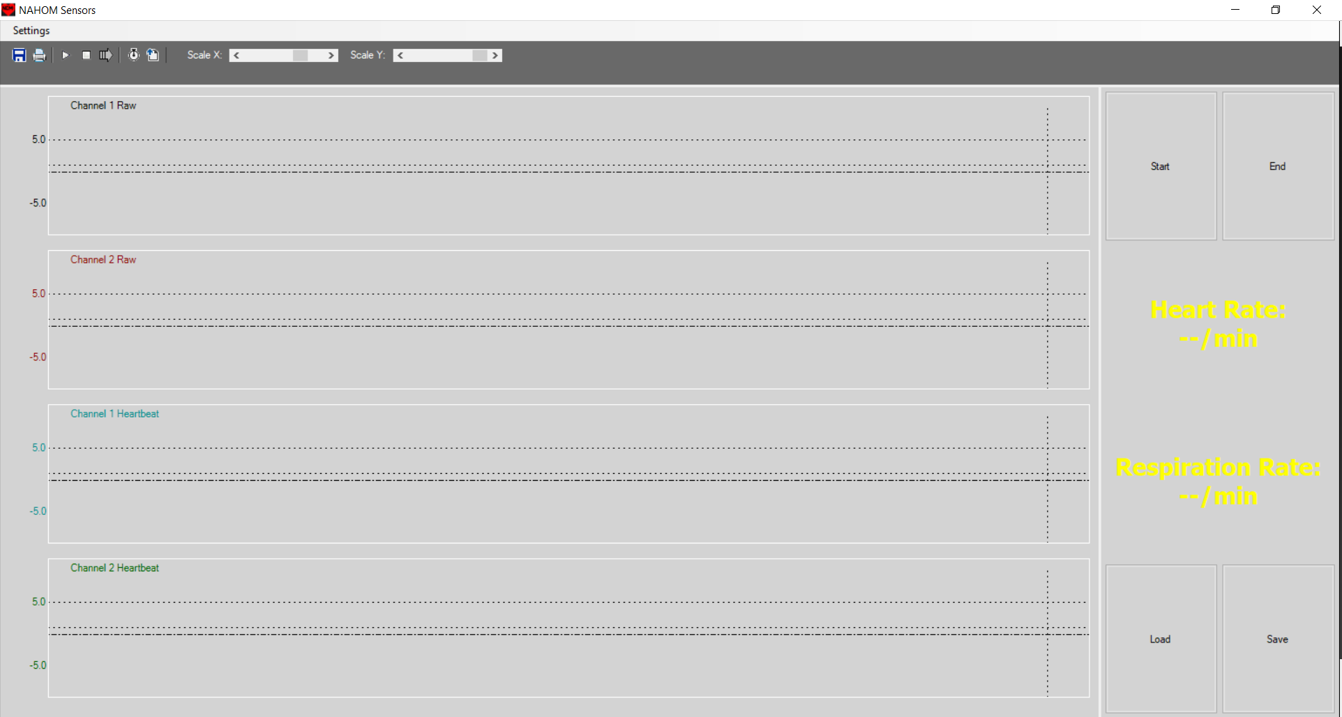**Figure 2.** NAHOM Interface upon startup.

The backend of this user interface is comprised of data structures and communications that continually move data from the digital signal processing part of the program to the data structures for display. Multithreading was used to accomplish real-time plotting without freezing one display while another display is updated. Race conditions in the code due to this multithreading were carefully monitored and verified to not be an issue. Communication was implemented using a Windows serial library to connect to the MCU’s virtual COM port.

4.2 **Codes and Standards**

The Health Insurance Portability and Accountability Act (HIPAA) legislates the privacy and means of ensuring privacy of sensitive medical information. It is stated that the only people who are allowed to view health data related to an individual is the individual or medical professionals who use the data to assist the patient [23]. Online storage of medical information is regulated by HIPAA as well [24]. To follow these regulations, password protection will need to be included in the user interfaces to ensure legal confidentiality of health information. Additionally, encryption will be needed for the subsequent databases of health information to protect the information from exposure.

ANSI/AAMI ES60601-1:2005 is another relevant standard to system design. The standard governs the accuracy of medical instruments by stating that the Signal to Noise Ratio (SNR) must be must be low enough to not mislead users [25]. This must be taken into account resulting in the need for a low-noise detection system. This will require sufficient noise cancellation and computing power in digital filtering to ensure a low enough error rate.

Institutional Review Board for Protection in Human Subjects in Research (IRB) approval is needed since testing is done on human subjects. Since signals are being sent into the body, the main concern for human subject safety is the signal power level [26]. Dr. Zhang and her graduate students have already received IRB approval and training with a chosen power level of 6 dBm.

Lastly, since the signal processing and user interface will be implemented with C# programming language, ISO International Standard ISO/IEC 23270:2003 - C# Language Specification will need to be followed [27]. It is the current ISO C# standard that governs the language.

4.3 **Constraints, Alternatives, and Tradeoffs**

The major design alternative was to perform the signal processing on the MCU or a portion of the processing on the MCU since the unit included a floating point unit (FPU) that could implement a full set of DSP instructions. This might have been beneficial in real time processing because performing an FFT on the data set on the MCU could have resulted in a smaller amount of data that needs to be transferred to the PC. The MCU has a clock speed of 180 MHz [21] which is about 10 times slower than a normal PC. Given that a relatively small amount of information was required to be sent to the PC, the slower processing speed on the MCU was a bigger factor than data transfer speed. This is why the signal processing was chosen to be done on the PC. Since the signal processing was converted to C#, it could have been easily implemented on the MCU as well as the PC it is intended to run on. Benchmark testing could then be done to determine the effectiveness of doing signal processing on the MCU compared to doing signal processing on the PC.

Other design alternatives included the communication protocol for the MCU to PC communication and ADC to MCU communication. Implementing a USB virtual COM port on the PC was straightforward to implement on the MCU and avoided any complications associated with using the USB protocol directly. Because of this factor, and that our data transfer speed requirements were not very high, it was agreed that the UART protocol for MCU to PC communication was the most effective method. The virtual serial port capability built into the MCU was harder to implement than expected so a UART to virtual COM port adapter was used. The ADC can output data over 4 serial channels along with SPI. SPI allows data to be requested from the ADC whenever it is needed. Given this factor and that the data speed requirements are not very high, it was agreed that the SPI protocol for ADC to MCU communication was the most effective method.

5. **Schedule, Tasks, and Milestones**

The Non-Contact Vital Signs Monitoring Team designed and implemented the aforementioned device between November 2017 and April 2018. Appendix A shows a list of major milestones which the group reached over this time period. Appendix A holds the Gantt chart for the design and implementation of the project.

Listed below is the relative contributions of each group member:

* Anthony: Worked on configuring and testing the ADC
* Ahmed: Worked on configuring and testing the ADC
* Andrew: Setup MCU to mediate data transfer between the ADC and PC
* Julian: Created the GUI and DSP that allowed for real-time processing and plotting
* Zach: Made all the documentation for the project from weekly reports to the final report

Listed below is a breakdown of the major tasks and their corresponding difficulties:

* Configure ADC: This part of the project was the hardest and most time-consuming. There was not much documentation on this particular ADC, and that made debugging various issues very stressful.
* Develop GUI: This part was time-consuming and that’s about it. It was difficult to get the DSP to accurately analyze the health metrics from the signals.
* Code MCU: This part was time-consuming, but not too difficult. It was a crucial step to have completed since it was the link between the ADC and the PC.

6. **Final Project Demonstration**

Although the production system will be a portable system, the prototype developed by the NAHOM Team is larger and less mobile than it will be in the future. As such, all testing was done in Dr. Zhang’s lab on the fourth floor of Van Leer. To demonstrate the prototype was working, we did the following:

1. While sitting at rest, a person was instructed to breathe rapidly for some time, and then instructed to take slow, deep breaths. Their different respiration rates were visible on the output respiration rate graphs which the system generates.

During the final project demonstration, we let multiple people test out the live demo. Below is a list of the items that were demonstrated at the final demonstration:

* Obtained standard heart and respiration rates (with some leeway due to outside interferences with the background moving causing interferences with the reflected signal obtained).
* Live data display on the GUI for the audience to see as their measurements were taken
* The entire system was present so we could explain the entire process

Tables 1-3 show the target and obtained specifications for our project. We satisfied all but 3 of the target specifications. The target number of channels was 8 for the ADC, and we used 2 channels. When originally writing the specifications for this project, we said 8 channels was needed because that was how many channels the ADC that was purchased had available to use. During the design process, we realized we only need to use two of the channels to do all of the data transfer that needed to be done.

The targeted ADC power supply was <5.0V, but we had to use a 12V power supply to power the evaluation board for the ADC. The targeted specification of <5.0V was selected because when this project is in final production stages, it will need to be lower power so that it can be energy efficient and have a long lasting battery. Since we are still in the design and prototype stages of the project, an evaluation board was used for the ADC for debugging purposes. The evaluation board purchased required power of 12.0V, 7.0V higher than originally anticipated. While this specification was not satisfied during our project, it will be in the future when the product gets closer to mass production.

The last target specification that was not met was the software requirements for the PC and signal processing. We originally planned to do all the coding for the DSP and GUI in MATLAB, but decided to use C# instead. The reason for the switch between languages was because C# is better supported for real-time applications. Since developing a GUI that could do real-time plotting and processing was a major end-goal for the project, it only made sense that we did all the coding for the PC in C#. Transitioning to C# was also beneficial in that it saved a lot of money, in terms of future production, since every unit of the product would have to have a version of MATLAB.

As the system is entirely self-contained, it needed no external components to run for demonstration purposes.

Each specification was verified during testing in the following ways:

**Sampling rate**: By fixing sampling time and counting the number of samples obtained in this timeframe, the sampling rate of the functional analog-to-digital converter was determined.

**Plotting engine**: By feeding test data into a developed plotting library, it was easy to determine if the library was able to plot incoming, real time data. This data was already available from past semesters and does not need to be acquired.

**Real-time signal processing**: Although not a core requirement of the project, the ability to process the incoming signals in real time was a future reach goal for this project. This was verified by timing the signal processing functionality on existing data. Since the signal processing was accomplished in under a second per second of input data, the system can be said to be real-time.

Below is a list, with appropriate links to them, of items that were used during the final demonstration:

* Project Poster: http://ece4012y2018.ece.gatech.edu/spring/sd18sZY1/finalpresentation.pdf
* Project Video: https://www.youtube.com/watch?v=Xlx3-3zMOCY
* Team website (Contains project documentation and pictures from the demo): http://ece4012y2018.ece.gatech.edu/spring/sd18sZY1/

**7. Marketing and Cost Analysis**

7.1 **Marketing Analysis**

The target market for this product is hospitals, doctor offices, elderly homes, infant care centers, pharmacies, and consumers that to need monitor their vital signs on their own time or throughout the day. Currently, there are no non-contact vital signs monitoring systems on the market. Current vital signs monitoring systems that are on the market range from $995 to $3495 according to Venture Medical [28]. These monitors are contact and can obtain measurements that the non-contact system cannot, such as blood pressure and peripheral capillary oxygen saturation (SpO2). The NAHOM device will cost less than contact systems on the market because it will not perform as many measurements. The main advantage this system will have over the available competition is that this system will be non-contact, low cost, and portable, preventing patients from being strapped in and from having to take trips to the hospital in order to receive health measurements. This product is different from past variations in that it is able to provide real time readings.

7.2 **Cost Analysis**

The total cost of the parts for a prototype of the NAHOM device was approximately $607.83. The parts used to build the prototype include the MCU evaluation board, AD7770 evaluation board, SMA cables, SMA jacks, SMA jack to SMB plugs, and SMB terminators. The remaining parts were provided, by our advisor or by the senior design lab, free of cost. Table 4 shows a breakdown of the material costs of the prototype.

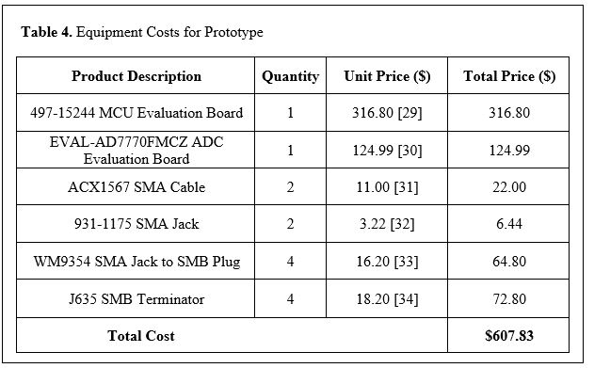

Five engineers worked on the design and development of the prototype. Table 5 gives a detailed breakdown of the actual work hours for each engineer over the span of this project.

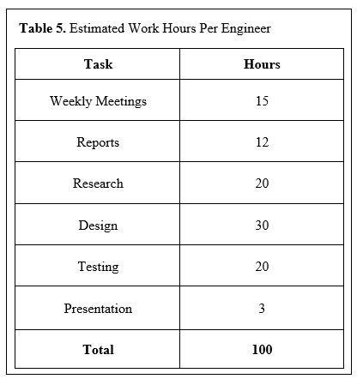

Each engineer is assumed to have a yearly salary of $70,000 and spent 82 hours (calculated in Table 5) designing and developing the prototype. The total cost of labor for five engineers comes out to be $13,798.08. As determined by Table 4, the cost of parts for the prototype is $607.83. We will assume 30% fringe benefits of labor and 120% overhead on materials/labor/fringe benefits. The total development cost of the prototype is $40,799.73, as shown in Table 6.

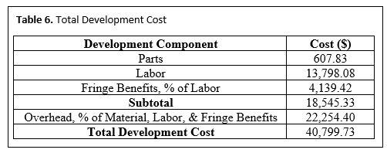

Over a five year time frame, 5,000 units will be produced and sold at a unit price of $500. Table 7 gives a breakdown of the bulk unit prices for the parts that need to be purchased. The cost, of parts alone, for one unit of the product comes out to be about $125. A customized board will be designed to eliminate the need of an evaluation board for the MCU and the ADC. The sales expense will be 7% of the sale price, which is $35. At $500 per unit, the expected revenue is $2,500,000, yielding a profit of $96.00 per unit. The percent profit for each unit sold is 19.20% (Profit divided by sale price). The total profit over this 5 years comes out to be $480,000. At this selling price, this product would be very competitive on the market because the price is significantly lower than other related products ($495 less than the lowest product offered by Venture Medical [28]). The amortized development cost over the 5,000 units is about $8 (Total development cost divided by 5,000 units). The production costs, profit, and selling price of the product are shown in Table 8.

|  |  |  |  |  |  |  |  |  |  |  |  |  |  |  |  |  |  |  |  |  |  |  |  |  |  |  |  |  |  |  |  |  |  |  |  |  |
| --- | --- | --- | --- | --- | --- | --- | --- | --- | --- | --- | --- | --- | --- | --- | --- | --- | --- | --- | --- | --- | --- | --- | --- | --- | --- | --- | --- | --- | --- | --- | --- | --- | --- | --- | --- | --- |
| **Table 7.** Equipment Costs to Produce 5,000 Units   |  |  |  |  | | --- | --- | --- | --- | | **Product Description** | **Quantity** | **Unit Price ($)** | **Total Price ($)** | | STM32F446ZEJ6 MCU Chip | 5,000 | 5.66 [35] | 28,300 | | AD7770 ADC Chip | 5,000 | 7.74 [36] | 38,700 | | FT232RL USB to UART Chip | 5,000 | 2.65 [37] | 13,250 | | ACX1567 SMA Cable | 10,000 | 6.65 [31] | 66,500 | | 931-1175 SMA Jack | 10,000 | 2.75 [32] | 27,500 | | WM9354 SMA Jack to SMB Plug | 20,000 | 10.57 [33] | 211,400 | | J635 SMB Terminator | 20,000 | 11.87 [34] | 237,400 | | **Total Cost** | | | **$623,050** | |

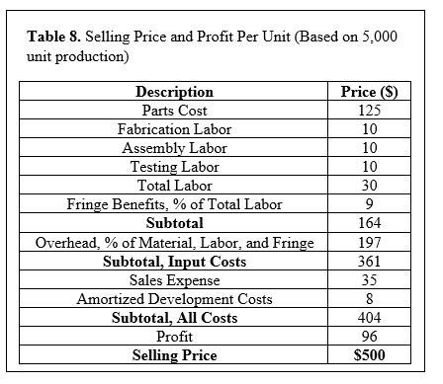

8. **Conclusion**

The NAHOM team was able to successfully complete the project a week before the Design Expo. We were able to properly configure the ADC to allow SPI communication between itself and the MCU, setup the MCU to mediate the data transfer between the ADC and the PC, and create a GUI that was able to do real-time digital signal processing and plotting of the health informatics data. Overall, the project was a success since almost every target specification was met. The target specifications that were not met, as explained earlier, were either not important as the design developed or will be met later on in the development of this device.

The current status of this project is that the system is able to do real-time analysis and plotting of heart and respiration rates of a user. The next steps for this project, as mentioned earlier in the report, would be to develop a phone application, add user alerts if dramatic changes in any measurements are observed, improve signal processing to achieve better resolution, send data from the MCU to the PC on its own thread, separate from the receiving data, and remove redundant reads in the ADC to allow for a higher sampling rate.

If we were to do anything differently for this project, we would have allocated a lot more resources to the ADC part of the project. This was definitely the bottleneck of this project, and we almost didn’t finish because of it. Originally, we split the group up into three groups thinking that would be fine for finishing everything. It became apparent later on that we should have started helping the ADC group weeks sooner to speed up the design process. The group knew the ADC group was having issues for weeks, as we discussed in the weekly meetings, but we never did anything to help them until the last few weeks of the semester. Finishing up the ADC portion earlier than we did would have been extremely instrumental in improving our DSP. The group could have performed more real testing of the system weeks in advance to the Expo, allowing us to improve the DSP capabilities that determine the heart and respiration rates.

One lesson learned from this entire project was that communication and acting on communication are very important in having a successful group project. If we would have acted on the issues the ADC group brought up throughout the semester, our project could have been finished weeks earlier. Another lesson learned was that having good, detailed documentation of hardware or software is crucial to any project. The ADC that we were working with had very little documentation and it made debugging the ADC for various issues seem almost impossible.

For future teams continuing on this project, everything mentioned earlier in this documentation will give you a very good idea of how the system works to this point. The code for the GUI can be found in **Appendix B**. All of the resources such as documentation and pictures can either be found in the following pages or our team website which is mentioned in the report. When divvying up work in the future, make sure you allocate enough resources to the most time-consuming portion. If you realize that a group is struggling earlier on trying to hit their deadlines, jump in and help them out. It will save you a lot of stress and time in the end.

This device promotes sustainability by not requiring the use of disposable leads or mouthpieces to measure heart and breathing rate. In the final design of this system, it should be very small to the point of portability. As compared to the contact sensors on the market, it will be a lot less material.

**9. Leadership Roles**

Zachary Lasater was the Team Leader, Expo Coordinator, and Documentation Coordinator. He developed the weekly reports throughout the semester summarizing progress and planned tasks, coordinated the setup at the Design Expo, and was in charge of the final documentation for the project.

Andrew Renuart was the Webmaster and MCU-to-PC expert. He designed the website and ensured that all of the deliverables were posted there in a timely manner. He developed code to handle storing ADC samples and sending them via UART to the PC when they are requested.

Julian Rosker was the GUI and DSP expert. He developed the UI that was used to display the health informatics to the user. He also created the DSP that was able to accurately determine the user’s heart and respiration rates.

Anthony Genutis was an ADC-to-MCU expert. He configured the ADC to allow for SPI communication with the ADC and to be able to receive digital sample data on the MCU

Ahmed Elsabbagh was an ADC-to-MCU expert. He configured the ADC so that we could use its registers and allow for successful SPI communication to the MCU.

10. **References**

[1] Center for Disease Control and Prevention. (2017, Aug. 24). Heart Disease Facts. [Online]. Available: https://www.cdc.gov/heartdisease/facts.htm. [Accessed: Nov. 25, 2017].

[2] M. A. Cretikos, R. Bellomo, K. Hillman, J. Chen, S. Finfer, and A. Flabouris, “Respiratory rate: the neglected vital sign,” The Medical Journal of Australia, vol. 188, no. 11, 2008. [Online serial]. Available: https://www.mja.com.au/journal/2008/188/11/respiratory-rate-neglected-vital-sign. [Accessed Nov. 25, 2017].

[3] Y. S. Lee, P. N. Pathirana, C. L. Steinfort, and T. Caelli, “Monitoring and Analysis of Respiratory Patterns Using Microwave Doppler Radar,” IEEE Journal of Translational Engineering in Health and Medicine, vol. 2, October, 2014. [Online serial]. Available: http://ieeexplore.ieee.org/stamp/stamp.jsp?arnumber=6942141. [Accessed Nov. 25, 2017].

[4] N. Bernacchia, L. Scalise, L. Casacanditella, I. Ercoli, P. Marchionni, E. P. Tomasini, “Non contact measurement of heart and respiration rates based on Kinect™,” IEEE International Symposium on Medical Measurements and Applications (MeMeA) ’06, 2014. Available: <http://ieeexplore.ieee.org/document/6860065/>. [Accessed Nov. 25, 2017].

[5] K. Mayank, A. Veeraraghavan, and A. Sabharwal. "DistancePPG: Robust Non-contact Vital Signs Monitoring Using a Camera." *Biomedical Optics Express* 6, no. 5 (2015): 1565-588.

[6] J. Kuutti, M. Paukkunen, M. Aalto, P. Eskelinen, and R. E.Sepponen, “Evaluation of a Doppler radar sensor system for vital signs detection and activity monitoring in a radio-frequency shielded room ,” Science Direct, Measurement, vol. 68, May, 2015. [Online serial]. Available: https://doi.org/10.1016/j.measurement.2015.02.048. [Accessed Nov. 25, 2017].

[7] Fitbit, “Our Technology,” [Online]. Available: <https://www.fitbit.com/technology>. [Accessed: Nov. 25, 2017].

[8] J. Titcomb, “Fitbit heart rate tracking is dangerously inaccurate, lawsuit claims,” telegraph.co.uk, Jan. 7, 2016. [Online]. Available: http://www.telegraph.co.uk/technology/news/12086337/Fitbit-heart-rate-tracking-is-dangerously-inaccurate-lawsuit-claims.html. [Accessed Nov. 25, 2017].

[9] Qardio, “Qardio Core Wearable ECG EKG Monitor Iphone,” [Online]. Available: https://www.getqardio.com/qardiocore-wearable-ecg-ekg-monitor-iphone/. [Accessed: Nov. 25, 2017].

[10] National Weather Service, “How Radar Works”. [Online]. Available: http://www.srh.noaa.gov/jetstream/doppler/how.html. [Accessed: Nov. 25, 2017].

[11] H. Gonçalves, “Analog-Digital Converters,” onmyphd.com [Online]. Available: http://www.onmyphd.com/?p=analog.digital.converter#h3_sigmadelta. [Accessed: 23-Oct-2017].  
  
[12] J. Pytel, “ADC,” YouTube, 15-Jul-2010. [Online]. Available: https://www.youtube.com/watch?v=7X53_QCXbjk&t=1899s. [Accessed: 23-Oct-2017].

[13] “Sigma-Delta ADC Tutorial,” Sigma-Delta ADC Tutorial | Design Center | Analog Devices. [Online]. Available: http://www.analog.com/en/design-center/interactive-design-tools/sigma-delta-adc-tutorial.html. [Accessed: 23-Oct-2017].

[14] “Choose the right A/D converter for your application,” *Texas Instruments*. [Online]. Available: https://www.ti.com/europe/downloads/Choose%20the%20right%20data%20converter%20for%20your%20application.pdf [Accessed 30-Nov-2017]

[15] Circuits Basics, “Basics of the SPI Communication Protocol,” circuitsbasics.com. [Online]. Available: http://www.circuitbasics.com/basics-of-the-spi-communication-protocol/. [Accessed Nov. 30, 2017].

[16] Sepulveda, C., Munoz, J., Espinoza, J., Figueroa, M. and Baier, C. (2013). “FPGA v/s DSP Performance Comparison for a VSC-Based STATCOM Control Application”. *IEEE Transactions on Industrial Informatics*, 9(3), pp.1351-1360.

[17] K. Keutzer, "http://bwrcs.eecs.berkeley.edu/Classes/CS252/Notes/Lec09-DSP.pdf", Berkeley, 2000.

[18] M. Nadeski and A. Gatherer, "See the difference: DSPs in medical imaging", Texas Instruments, 2017.

[19] Texas Instruments, “TMS320C6455 Fixed-Point Digital Signal Processor,” TMS320C6455 datasheet, May 2005 [Revised Mar. 2012].

[20] Analog Devices, “8-Channel, 24-Bit Simultaneous Sampling ADC”, AD7770 datasheet, Aug. 2017.

[21] STMicroelectronics, “ARM® Cortex®-M4 32b MCU+FPU...”, STM32F446xC/E datasheet, Sept. 2016.

[22] Silicon Labs, “EFM8 Busy Bee Family EFM8BB2 Reference”, EFM8BB2 datasheet, Nov. 2016.

[23] “Health Insurance Portability and Accountability Act,” California Department of Health Care

Services, 2016. [Online]. Available:

http://www.dhcs.ca.gov/formsandpubs/laws/hipaa/Pages/1.00WhatisHIPAA.aspx. [Accessed: Nov 30,

2017]

[24] U.S. Department of Health and Human Services, “Guidance on HIPAA and Cloud Computing”, *hhs.gov*, para. 1-4, June 16, 2017. [Online] Available: https://www.hhs.gov/hipaa/for-professionals/special-topics/cloud-computing/index.html. [Accessed Nov. 29, 2017]

[25] “ANSI/AAMI ES60601-1:2005,” AAMI Standards and Recommended Practices, 2012.

[26] “Institutional Review Boards Frequently Asked Questions,” U S Food and Drug Administration, Jan. 25, 2016. [Online]. Available: https://www.fda.gov/RegulatoryInformation/Guidances/ucm126420.htm. [Accessed: 28-Nov-2017].

[27] “C# Language Specification,” Standard C# Foundation . [Online]. Available: https://www.iso.org/standard/36768.html. [Accessed: 29-Apr-2018]

[28] Venture Medical, “Patient Monitors for Sale,” *venturemedical.com,* Jan. 1, 2012. [Online]. Available: <http://www.venturemedical.com/products/patient_monitors_and_accessories/patient_monitors/?gclid=Cj0KCQiA0vnQBRDmARIsAEL0M1n2CA4wB1YVmm7I-U8oWL7dawhn8UWgPqULXbn9K63TI79KhLTIieYaAis-EALw_wcB>. [Accessed: Nov. 30, 2017].

[29] Digi-Key Electronics, “Eval board STM32446 MCU,” *digikey.com,* Nov. 30, 2017. [Online]. Available: <https://www.digikey.com/product-detail/en/stmicroelectronics/STM32446E-EVAL/497-15244-ND/5168453>. [Accessed: Nov. 30, 2017].

[30] Digi-Key Electronics, “Eval board for AD7770,” *digikey.com,* Nov. 30, 2017. [Online]. Available: <https://www.digikey.com/product-detail/en/analog-devices-inc/EVAL-AD7770FMCZ/EVAL-AD7770FMCZ-ND/6133435>. [Accessed: Nov. 30, 2017].

[31] Digi-Key Electronics, “Cable Assembly Coaxial SMA to SMA Male to Male,” *digikey.com,* Nov. 30, 2017. [Online]. Available: <https://www.digikey.com/product-detail/en/amphenol-rf-division/135101-01-06.00/ACX1567-ND/2003900>. [Accessed: Nov. 30, 2017].

[32] Digi-Key Electronics, “SMA Connector Jack,” *digikey.com,* Nov. 30, 2017. [Online]. Available: <https://www.digikey.com/product-detail/en/taoglas-limited/EMPCB.SMAFSTJ.B.HT/931-1175-ND/3522337>. [Accessed: Nov. 30, 2017].

[33] Digi-Key Electronics, “Adapter Coaxial Connector SMA Jack,” *digikey.com,* Nov. 30, 2017. [Online]. Available: <https://www.digikey.com/products/en?keywords=WM9354-nd>. [Accessed: Nov. 30, 2017].

[34] Digi-Key Electronics, “Terminator Coax Connector Plug,” *digikey.com,* Nov. 30, 2017. [Online]. Available: <https://www.digikey.com/products/en?keywords=j635-nd>. [Accessed: Nov. 30, 2017].

[35] Mouser Electronics, “STM32F446ZEJ6,” *mouser.com,* Nov, 30, 2017. [Online]. Available: <https://www.mouser.com/ProductDetail/STMicroelectronics/STM32F446ZEJ6/?qs=sGAEpiMZZMu6TJb8E8Cjr48fBFXdXSHKqPteavoH9uc%3D>. [Accessed: Nov. 30, 2017].

[36] Mouser Electronics, “AD7779ACPZ,” *mouser.com,* Nov, 30, 2017. [Online]. Available: <https://www.mouser.com/ProductDetail/Analog-Devices/AD7779ACPZ/?qs=sGAEpiMZZMvTvDTV69d2QoIMHehgkbmswLCUTk0UP3g%3d>. [Accessed: Nov. 30, 2017].

[37] Mouser Electronics, “FT232RL-REEL FTDI”, *mouser.com*, Apr. 29, 2018. [Online]. Available: <https://www.mouser.com/ProductDetail/FTDI/FT232RL-REEL?qs=sGAEpiMZZMs5ceO8zL%252bTxyQLQIH6hE7q>. [Accessed: Apr. 29, 2018].

**Appendix A**

**Gantt Chart**

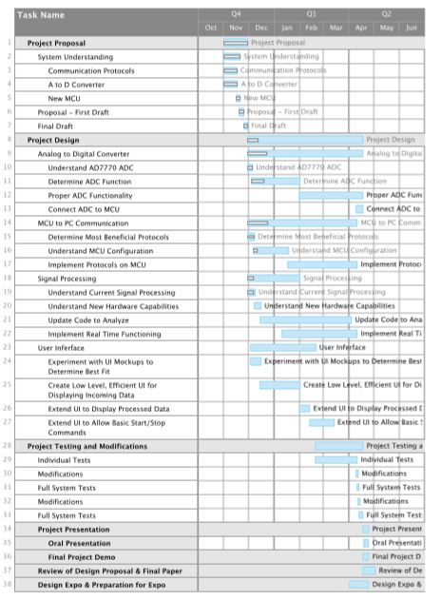

**Appendix B**

**GUI Code**

The code was posted to our website to be archived. No links are provided on the website for the code. The code was sent to Doctor Zhang, and she has record of it.

**Appendix C**

**MCU Code**

The code was posted to our website to be archived. No links are provided on the website for the code. The code was sent to Doctor Zhang, and she has record of it.