**Non-Contact Analysis of Health-Informatics via Observable Metrics**

ECE4011 Senior Design Project

Team Name: Non-Contact Analysis of Health-Informatics via Observable Metrics Team

Project Advisor: Dr. Ying Zhang

Zachary Lasater, [zlasater3@gatech.edu](mailto:zlasater3@gatech.edu)

Julian Rosker, [Julian.Rosker@gatech.edu](mailto:Julian.Rosker@gatech.edu)

Ahmed Elsabbagh, [aelsabbagh3@gatech.edu](mailto:aelsabbagh3@gatech.edu)

Anthony Genutis, [agenutis3@gatech.edu](mailto:agenutis3@gatech.edu)

Andrew Renuart, [arenuart3@gatech.edu](mailto:arenuart3@gatech.edu)

Submitted

December 1, 2017

**Table of Contents**

**Executive Summary**  ii

1. **Introduction** 1
   1. Objective 1
   2. Motivation 2
   3. Background 3
2. **Project Description and Goals** 6
3. **Technical Specification** 7
4. **Design Approach and Details** 12
   1. Design Approach xx
   2. Codes and Standards xx
   3. Constraints, Alternatives, and Tradeoffs xx
5. **Schedule, Tasks, and Milestones**  xx
6. **Project Demonstration**  xx
7. **Marketing and Cost Analysis**  xx
   1. Marketing Analysis xx
   2. Cost Analysis xx
8. **Current Status**  xx
9. **References**  xx

**Appendix A** xx

**Appendix B** xx

**Appendix C** xx

**Executive Summary**

The Non-Contact Analysis of Health-Informatics via Observable Metrics (NAHOM) Team is building a device that improves health and minimizes response time in medical emergencies. The NAHOM serves this purpose by alerting users of certain health emergencies and general health trends without physical contact with the measurement device. It addresses the need for a device that monitors heart and respiration rates in real time without physical contact with the user.

Every year, approximately 735,000 people in the United States have a heart attack, and 1 in 4 deaths are related to heart disease [1]. In addition, while overlooked by many hospitals, respiration rate is an excellent predictor of a wide array of many medical issues [2], [3]. By making heart and respiration rates measurements easily and quickly accessible, the NAHOM device would allow for more continuous monitoring of health.

This team is continuing past development efforts for the NAHOM. A signal generator and a transceiver, with transmit and receive antennas, have been set up by previous teams to extract a signal. The transmit antenna sends a 5.8GHz signal, which is reflected off of the subject’s body to the receiving antenna. The team is responsible for a microcontroller and an analog to digital converter to digitize the signal and send it to the microcontroller. The microcontroller transmits the waveform to a PC through Serial Peripheral Interface (SPI) protocol and USB. The PC processes the waveform and calculates the subject’s biometric data from the phase shift of the reflected signal relative to the source signal, which is then displayed to the user in a user-friendly interface on a computer or mobile phone application. The team will develop the signal processing algorithm and the user interface. It is expected that a fully functional NAHOM will cost $300 when mass produced and $607.83 in this current phase of development.

**Non-Contact Vital Sign Monitoring System**

**1. Introduction**

The Non-Contact Vital Signs Monitoring Team aims to design and prototype a system for real-time analysis of user biometric data gathered without physical contact between the user and the system for display and health analytics. The aforementioned team is requesting $607.83 in funding to achieve this task.

**1.1 Objective**

The objective of our project is to use the existing antennas and function generator to build a system that will report heart and respiration rates of a user in real time without physical contact with aforementioned user. **Figure 1** shows a block diagram of the system at a high level of abstraction. The signal generator propagates a signal through the transceiver transmit antenna towards the user. The receiving antenna will receive a phase shifted signal. The phase shift of the received signal is dependent on the user’s heart and respiration rates. An Analog to Digital Converter (ADC) will digitize the signal received from the antennas and will transmit it to a microcontroller unit. The microcontroller unit will transmit the waveform to a PC through SPI protocol and USB. The PC will digitally processes the signal to produce a set of biometric measurements. The application would display the results to the user in a user-friendly manner through a GUI.

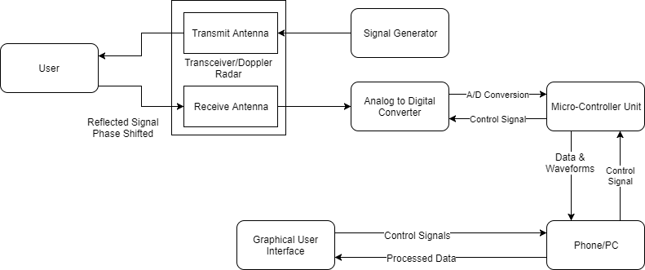

**Figure 1:** System overview block diagram of Non-Contact Vital Sign Monitoring System.

**1.2 Motivation**

The goal of the Non-Contact Vital Sign Monitoring Team is to detect diseases early and increase response time in medical emergencies by making access to heart and respiration rates cheaper, non-obtrusive and more readily available. The changes that our system introduces are centered around the facts that it is non-contact [4], [5], cheaper, able to provide real time readings, is not affected by environmental factors such as light or clothing material [3] and is simple.

In addition to convenience, there is a great need for a non-contact solution. For example, for a person with burns or sensitive skin, current contact solutions are not viable [6]. And current devices which monitor certain conditions such as sleep apnea may cause inconvenience to the user during their sleep thereby invalidating the measurement [3].

Furthermore, many of the currently available solutions require an expert to use them [4], which may reduce the frequency of measurements or, particularly in the case of respiration rate, lead to measurements not being taken at all [2].

**1.3 Background**

**1.3.1 Vital Sign Monitoring**

Extensive research has been done in the area of vital sign monitoring and multiple solutions have been developed. For example, a Fitbit is a device that is worn around the wrist and monitors heart rate and costs $150 [7]. Fitbit is the world’s best selling fitness tracker manufacturer. It uses light emitting diodes that reflect off the skin to detect changes in blood volume to detect heart rate. The accuracy of this device has been challenged in multiple lawsuits which claim the measurements are low which can lead the user to drive their heart rate to dangerous levels [8]. A Qardio device that is worn around the chest to monitor respiration rate and costs $450 [9]. Researchers were also able to use computer vision [4] and a Kinect [6] to measure respiration rate but their results were dependent on the environment (such as temperature and room lighting) [3].

**1.3.2 The Doppler Radar**

The Doppler Radar is used in the existing system and the team plans to continue using it. The Doppler Radar sends a signal and receives a signal with a phase shift that is dependent on the reflected signal. This effect is similar to the “Doppler Shift” observed in sound waves. Doppler processing will be used to interpret the received signal. The Doppler Radar has been heavily researched and the team is planning to utilize research done in that area [10]. The NAHOM is based on research done on Doppler radar [3].

**1.3.3 Analog to Digital Converter**

The team plans to purchase and use an Delta-Sigma Analog to Digital Converter developed by Analog Devices. The team is planning to utilize the results of past research in Analog to Digital Converters(ADCs) and the particular datasheet and resources developed for the particular ADC used.

A Sigma Delta ADC is a closed negative feedback loop. The feedback is subtracted from the input voltage. The integrator adds the sum to a value stored from the previous integration. If the non-inverting input of the op-amp is greater than zero a logic high is output, otherwise a logic low is output. Over multiple cycles, this sum will equal zero due to the negative feedback. The output of this feedback loop is a digital word that is used to determine the input voltage [11], [12], [13]. Because of this architecture that requires multiple cycles of feedback to accurately determine the input voltage, the Delta Sigma is generally slower than the SAR ADC.  
 The Delta Sigma ADC stands out for having high resolution and SNR with low power dissipation. It over-samples the input voltage (sample rate is much higher than nyquist rate). A Delta Sigma ADC is generally more expensive than an SAR ADC, though cheaper than the Pipeline ADCs [11], [14].

**1.3.4 Microcontroller Unit and SPI Communication Protocol**

The team plans to purchase and use a Microcontroller (MCU) developed by STMicroelectronics. The datasheet and support material provided with the microcontroller will be used. The MCU uses the Serial Peripheral Interface (SPI) protocol to communicate with a USB serial port chip contained on the development board, which exchanges data with the PC. SPI is a synchronous communication protocol between a master and multiple slaves. It is widely used today in many applications such as RFIDs and transceivers. SPI has four lines for communication:

(1) Master-In-Slave-Out for communication from slave to master,

(2) Master-Out-Slave-In for communication from master to slave,

(3) a clock line,

(4) a slave select line that sets the slave in a mode in which it can listen to the master.

SPI can send signals continuously with as many bits as required, as opposed to UART which sends signals in 8-bit packets. Data can also be sent to and received from the slave simultaneously [15].

**1.3.5 Embedded Digital Signal Processing**

In embedded applications, there are two main ways to process signals: digital signal processors (DSPs) and field-programmable gate arrays (FPGAs) [16]. The former follows a standard Von Neumann architecture in which input is stored in short-term memory units and statements are processed sequentially [17]. This architecture can have lower hardware costs, but most of the savings come in the form of having a faster development time [17]. Since the technology is inherently easier to work with, test, and implement on a physical device, staff and technology reuse costs will be lower [17]. If the intended use is within a rapidly changing field, it may be desirable to sacrifice some performance or cost so that new iterations of a product can be released faster.

The alternative option to digital signal processors is field-programmable gate arrays (FPGAs), which offer potentially higher processing speeds but with high costs due to programming complexity [16]. The strength of FPGAs arises from the fact that each computation can be easily parallelized. In a digital signal processor, one can have at most one computation per clock cycle per core [16],[17]. For realistic (read: feasibly priced) embedded processors, it would be highly unlikely to have more than four cores. However, since at their core FPGAs are a collection of independent logic gates, a parallel-friendly process can have huge amounts of parallel tasks executing at once if ran on an FPGA [16].

In the health industry, Embedded Digital Signal Processing is used to reduce the cost and increase the quality of medical imaging [18]. MRIs, X-Rays, and Ultrasounds all benefit from an onboard DSP analyzing images in real time, allowing doctors to quickly diagnose potential problems [18]. Furthermore, the small size of DSPs make medical imaging techniques more portable, which is vital for providing healthcare to rural and low-income areas [18]. Of course, requirements for a DSP in a medical image processing vary widely based on intended usage, but the TI TMS320C6455BCTZA, a $263.91, 1.2GHz quad-core embedded DSP is representative of the type of device which would be needed for a portable ultrasound system [18],[19].

**2. Project Description and Goals**

The main purpose of the proposed non-contact vital monitoring system is to analyze and display a user’s vital signs in real time without requiring physical contact with the user. The setup of the system should be simple and the results should be easy to interpret. The system has a signal generator that propagates a signal at the user through a transceiver transmit antenna and receives a phase shifted signal. The received signal will be sent to a delta-sigma Analog Devices analog to digital converter to digitize received signals and feed the data to a STMicroelectronics microprocessor. Evaluation boards with connector terminals to the chip ports will be used for both the analog to digital converter and the microcontroller. Communication will be established between the microcontroller and the PC through Serial Peripheral Interface(SPI) protocol and USB. Through this communication, the waveform will be sent to the PC which will have an algorithm to process the data and interpret it based on the Doppler Effect. A user-friendly graphical user interface will be developed to display the data. The system will be used by the elderly, parents who want to monitor babies, hospitals, patients with diseases related to respiration and heart rate, those in risk of sudden illness, drivers, and those who want to monitor their health in general. It is expected that a fully functional non-contact vital sign monitoring system will cost $420 when mass produced and $1500 in this current phase of development with evaluation boards and SMA connector lugs.

The key features of this system are:

* Ability to extract accurate heart and respiration rates from recovered waveforms
* Real time analysis and display of received waveforms
* User alerts if dramatic changes in any measurements are observed

1. **Technical Specifications**

There are three distinct parts to the project relevant to the The Non-Contact Vital Signs Monitoring Team: the analog to digital converter, the microcontroller, and the processing and display of data on a PC.

**Table 1.** Analog to digital converter specifications

|  |  |
| --- | --- |
| **Feature** | **Specification** |
| Bits of resolution | >= 16 |
| Number of Channels | 8 |
| Sampling Rate | >=1000 samples/second |
| Power Supply | < 5.0V |
| Size | Nothing specific, but able to be portable |

**Table 2.** Microcontroller specifications

|  |  |
| --- | --- |
| **Feature** | **Specification** |
| SPI data rate | > 24 kB/s |
| Microcontroller to PC interface | USB >= 2.0 |
| Data Processing Ability | Dedicated Floating Point Unit |
| Power Supply | < 5.0V |
| Size | Nothing specific, but able to be portable |

**Table 3.** PC and signal processing specifications

|  |  |
| --- | --- |
| **Feature** | **Specification** |
| Software requirements | MATLAB >=2017 |
| Operating System | Windows 7+ |
| Communications Port | USB >= 2.0 |
| Data Processing Ability | Real-time signal processing |
| Display and Plotting Capabilities | Real-time plotting of analyzed data |
| Size | Nothing specific, but able to be portable |

1. **Design Approach and Details**
   1. **Design Approach**
      1. **ADC**

The existing NAHOM front end consists of the signal generator, antenna, and transceiver, which feeds the received modulated baseband signals to the ADC. These signals consist of an in-phase and a quadrature analog signal, known as the “I” and “Q” signals respectively. The chosen ADC is the Analog Devices AD7770, which has 24 bits of resolution and eight available channels [20]. The ADC was purchased on an evaluation board which has the necessary on-board connectors to interface with the existing front end and the MCU [21]. The ADC will utilize three channels of the eight total channels available. One channel of the ADC will be used to sample a system synchronization signal. Two more channels will be used to sample the I and Q signals. The baseband signals contained in the I and Q signals have most of their frequency content between 0.2 Hz and 40 Hz, thus the minimum sampling rate for the ADC must be 80 Hz. The signal will be oversampled at a sample rate of 1000 Hz to guarantee performance of the sampled data. The remaining five channels are reserved for other applications, including sampling white noise from various parts of the circuit for signal processing purposes.

* + 1. **Communication between ADC and MCU**

The previously determined SPI communication protocol will continue to be used for communication between the ADC and MCU. It is agreed that this is the best for two-way data transfer on a shared clock. If sampling at 1000 Hz was required for all eight of the 24-bit ADC channels, this would require a data transfer rate of 24 kB/second. The ADC’s SPI clock signal is limited to 30 MHz [20], representing a data transfer rate of 3.75 MB/second. The MCU’s SPI controller is capable of faster data rates [21]. Even though overhead for this protocol reduces this maximum data rate, SPI is still plenty fast to be used as the data transfer method between the ADC and the MCU.

* + 1. **Microcontroller Unit**

The microcontroller unit will receive the digitized I channel, Q channel, and system synchronization signals from the ADC. It will interpret this data and output the interpreted digitized I and Q signals to the PC for processing and will output a system synchronization signal back to the ADC. The MCU chosen is the STM32F446ZEJ6 by STMicroelectronics. The EFM8 Busy Bee MCU previously used in the system was sufficient for the needed functionality of interfacing the ADC with the PC, but the STM32 MCU alone can be purchased for $9.98 which is a fourth of the price of the Busy Bee MCU alone. This helps ensure even lower prototype costs and low development costs. Additionally, the STM32 MCU contains four SPI interfaces which are needed for data transfer and unit communication while the the Busy Bee MCU only has one SPI interface which limits communication [21],[22]. It also provides some additional features for on board processing, which will be investigated later on. The MCU will be purchased as part of an integrated evaluation board which has SPI-to-USB interfaces to allow communication between ADC and the PC.

* + 1. **Communication between MCU and PC**

The MCU will communicate with the PC via a virtual USB serial port. The MCU will use SPI to communicate with a USB serial port chip contained on the development board, which exchanges data with the PC. The MCU’s SPI is capable of speeds up to 5.6 MB/sec [21]. If all 8 ADC channels were sampled at 1000 samples per second, this would require a transfer speed of 24 kB/second, which is easily handled by the MCU’s SPI interface.

* + 1. **Digital Signal Processing**

The digital I and Q signal data is passed from the MCU to the PC. Currently, the data is loaded into MATLAB for signal processing. The processing is focused on finding heartbeat and respiration information. The process for extracting data starts with combining the I and Q data into one robust, noise resilient signal. Then, a Fast Fourier Transform (FFT) is performed on the signal to find frequency components of the signal. With knowledge that respiration contributes the largest amplitude to the FFT, a peak finder is used to find the respiration rate. Once the respiration rate is determined, knowledge of the links between heart rate and the harmonics of respiration are used to determine the heart rate. After both the heart rate and respiration rate have been determined on the data, bandpass filters are centered on the heart rate and respiration rate to extract the transient signal for each aspect. The heart rate, respiration rate, and transients of each are then sent to the GUI to be displayed.

With the end goal of a real time system in mind, the MATLAB processing code will be converted to C++ since this language is supported better for real time systems. The same signal processing procedure will be used, and with the improved resolution from the AD7770 ADC, there is a possibility more heart respiration information can be extracted. The end goal is to extract detailed respiration information to be able to recreate an electrocardiogram (ECG) reading to be displayed on the user interface.

* + 1. **User Interface**

For easy system control and communication by the user, a user interface is needed. The interface will be written in the programming languages C++ or C#. The entire interface comprises of three screens. On startup, the first screen is displayed, which will have an option specifying how much data will be captured from the MCU before applying the digital signal processing methods and an option to choose a COM port to use for communication with the MCU. Figure 2 shows the expected appearance of this screen. After this, two other screens will be shown. The first of these will display a scrolling graph of the signal in real time. Figure 3 shows the expected appearance of this screen. The second of these will show the respiration and heart rates and displays two graphs of the signal filtered to reveal the respiration and heart rate transients. Figure 4 shows the expected appearance of this screen. Both of these screens will have options to save the raw or processed data to a CSV file.

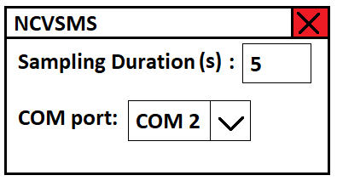

**Figure 2:** Expected starting screen of the NAHOM.

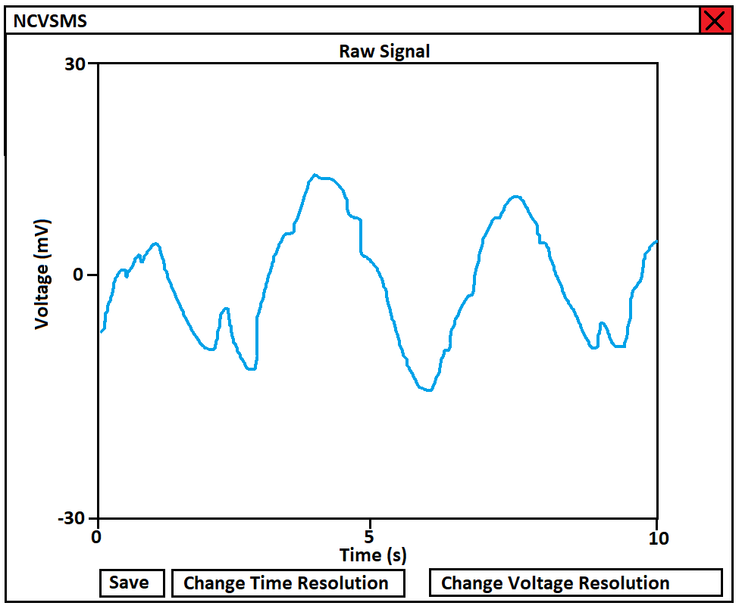

**Figure 3:** Expected raw data screen of the NAHOM.

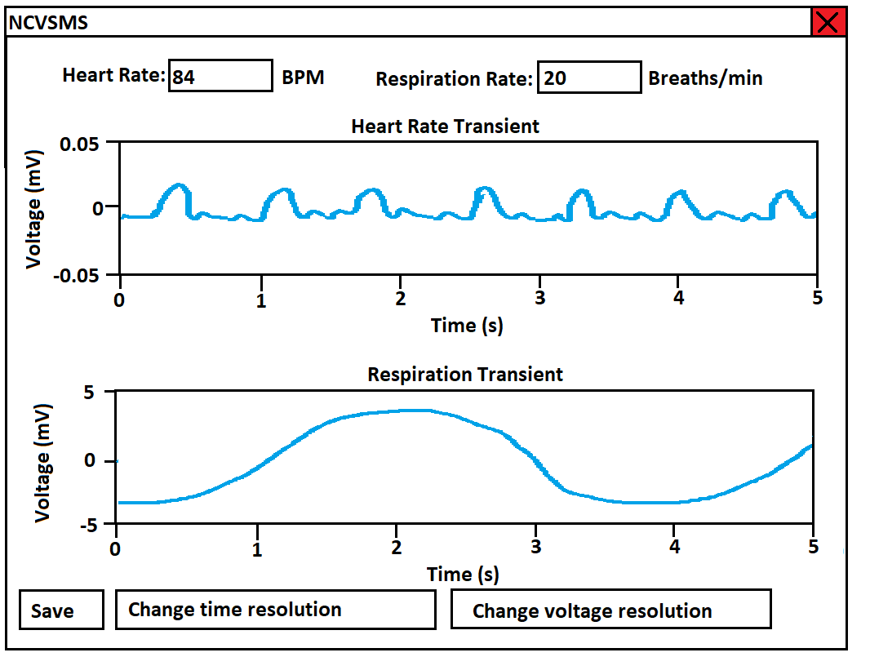

**Figure 4:** Expected processed data screen of the NAHOM.

The backend of this user interface will be comprised of data structures and communications that continually move data from the digital signal processing part of the program to the data structures for display. Multithreading will be used to accomplish real-time plotting without freezing one display while another display is updated. Race conditions in the code due to this multithreading will be carefully monitored. Communication will be implemented using a serial library to connect to the MCU’s virtual COM port.

* + 1. **Phone Application**

If developed, the phone application will have a similar user interface to that of the PC program: an initial screen to with some configuration settings, and then a screen displaying heart rate, breathing rate, and the heart rate and respiration transients. Since the raw signal display is used more for debugging and testing, the phone app would probably not have the raw signal display. Information would be sent to the phone via an SPI-controlled bluetooth module.

* 1. **Codes and Standards**

The Health Insurance Portability and Accountability Act (HIPAA) legislates the privacy and means of ensuring privacy of sensitive medical information. It is stated that the only people who are allowed to view health data related to an individual is the individual or medical professionals who use the data to assist the patient [23]. Online storage of medical information is regulated by HIPAA as well [24]. To follow these regulations, password protection will need to be included in the user interfaces to ensure legal confidentiality of health information. Additionally, encryption will be needed for the subsequent databases of health information to protect the information from exposure.

ANSI/AAMI ES60601-1:2005 is another relevant standard to system design. The standard governs the accuracy of medical instruments by stating that the Signal to Noise Ratio (SNR) must be must be low enough to not mislead users [25]. This must be taken into account resulting in the need for a low-noise detection system. This will require sufficient noise cancellation and computing power in digital filtering to ensure a low enough error rate.

Institutional Review Board for Protection in Human Subjects in Research (IRB) approval is needed since testing is done on human subjects. Since signals are being sent into the body, the main concern for human subject safety is the signal power level [26]. Dr. Zhang and her graduate students have already received IRB approval and training with a chosen power level of 6 dBm.

Lastly, since the signal processing and user interface will be implemented with C++ programming language, ISO International Standard ISO/IEC 14882:2017(E) – Programming Language C++ will need to be followed [27]. It is the current ISO C++ standard that governs the language.

* 1. **Constraints, Alternatives, and Tradeoffs**

The major design alternative is to perform the signal processing on the MCU or a portion of the processing on the MCU since the unit includes a floating point unit (FPU) that can implement a full set of DSP instructions. This might be beneficial in real time processing because performing an FFT on the data set on the MCU could result in a smaller amount of data that needs to be transferred to the PC. The MCU has a clock speed of 180 MHz [21] which is about 10 times slower than a normal PC. Given that a relatively small amount of information is required to be sent to the PC, the slower processing speed on the MCU is a bigger factor than data transfer speed. This is why the signal processing has been chosen to be done on the PC. Since the signal processing will be converted to C++, it could easily be implemented on the MCU as well as the PC it is intended to run on. Benchmark testing can then be done to determine the effectiveness of doing signal processing on the MCU compared to doing signal processing on the PC.

Other design alternatives include the communication protocol for the MCU to PC communication and ADC to MCU communication. Using a UART by implementing a USB virtual COM port on the PC is straightforward to use in a program and avoids any complications associated with using the USB protocol directly. Because of this factor, and that our data transfer speed requirements are not very high, it is agreed that the UART protocol for MCU to PC communication is the most effective method. The ADC can output data over 4 serial channels along with SPI. SPI allows data to be requested from the ADC whenever it is needed. Given this factor and that the data speed requirements are not very high, it is agreed that the SPI protocol for ADC to MCU communication is the most effective method.

1. **Schedule, Tasks, and Milestones**

The Non-Contact Vital Signs Monitoring Team will design and implement the aforementioned device between November 2017 and April 2018. Appendix A shows a list of major milestones which the group will attempt to reach. Appendix A holds the Gantt chart for the design and implementation of the project. Appendix B contains a PERT chart which shows tasks, milestones, and critical paths. The PERT chart was used for critical path analysis of the project, and that analysis is contained in Appendix C.

1. **Project Demonstration**

Although the production system will be a portable system, the prototype developed by the Non-Contact Vital Signs Monitoring Team will be larger and less mobile. As such, all testing will be done in Dr. Zhang’s lab on the fourth floor of Van Leer. To demonstrate that the prototype is working, both of the following will be tested:

1. A person will have their resting heart rate measured by the system. Then, they will perform light exercise, such as doing 25 jumping jacks, and their heart rate will be measured again. It is hypothesized that the second measurement will have a visibly higher heart rate, a graph of which will be produced by the system.
2. While sitting at rest, a person will be instructed to breath rapidly for some time, and then instructed to take slow, deep breaths. Their different respiration rates should be visible on the output respiration rate graphs which the system generates.

As the system is entirely self contained, it needs no external components to run for demonstration purposes.

Each specification will be verified during testing in the following ways:

**Sampling rate**: By fixing sampling time and counting the number of samples obtained in this timeframe, the sampling rate of the functional analog-to-digital converter can be determined.

**Plotting engine**: By feeding test data into a developed plotting library, it will be easy to determine if the library is able to plot incoming, real time data. This data is already available from past semesters and does not need to be acquired.

**Real-time signal processing**: Although not a core requirement of the project, the ability to process the incoming signals in real time is a reach goal for this project. This can be verified by timing the signal processing functionality on existing data. If the signal processing is accomplished in under a second per second of input data, the system can be said to be real-time.

1. **Marketing and Cost Analysis**
   1. **Marketing Analysis**

The target market for this product is hospitals, doctor offices, elderly homes, infant care centers, pharmacies, and consumers that to need monitor their vital signs on their own time or throughout the day. Currently, there are no non-contact vital signs monitoring systems on the market. Current vital signs monitoring systems that are on the market range from $995 to $3495 according to Venture Medical [28]. These monitors are contact and can obtain measurements that the non-contact system cannot, such as blood pressure and peripheral capillary oxygen saturation (SpO2). The NAHOM will cost less than contact systems on the market because it will not perform as many measurements. The main advantage this system will have over the available competition is that this system will be non-contact, low cost, and portable, preventing patients from being strapped in and from having to take trips to the hospital in order to receive health measurements. This product is different from past variations in that it will be able to provide real time readings and the measurements will not be affected by environmental factors such as light or clothing.

* 1. **Cost Analysis**

The total cost of the parts for a prototype of the NAHOM is approximately $607.83. The parts needed to build the prototype include the MCU evaluation board, AD7770 evaluation board, SMA cables, SMA jacks, SMA jack to SMB plugs, and SMB terminators. The remaining parts will be provided, by our advisor, free of cost.Table 4 shows a breakdown of the material costs of the prototype.

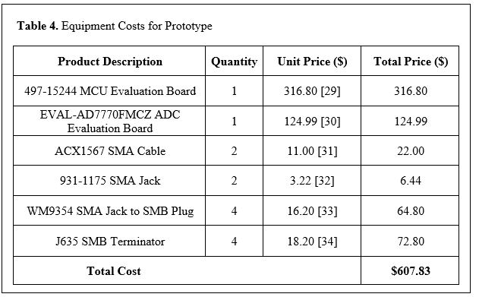

Five engineers will be working on the design and development of the prototype. Table 5 gives a detailed breakdown of the estimated work hours for each engineer over the span of this project.

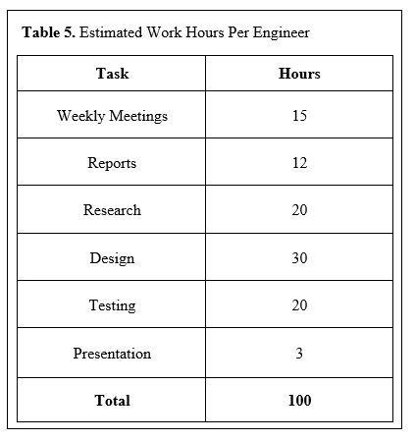

Each engineer is assumed to have a yearly salary of $70,000 and will spend 100 hours (calculated in Table 5) designing and developing the prototype. The total cost of labor for five engineers comes out to be $16,826.92. As determined by Table 4, the cost of parts for the prototype is $607.83. We will assume 30% fringe benefits of labor and 120% overhead on materials/labor/fringe benefits. The total development cost of the prototype is $49,462.23, as shown in Table 6.

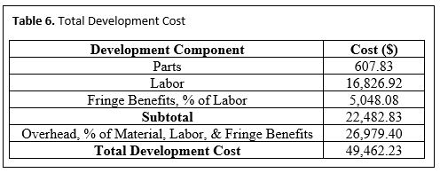

Over a five year time frame, 5,000 units will be produced and sold at a unit price of $300. Table 7 gives a breakdown of the bulk unit prices for the parts that need to be purchased. The cost, of parts alone, for one unit of the product comes out to be about $50. A customized board will be designed to eliminate the need of an evaluation board for the MCU and the ADC. The sales expense will be 7% of the sale price, which is $21. At $300 per unit, the expected revenue is $1,500,000, yielding a profit of $73.00 per unit. The percent profit for each unit sold is 24.33% (Profit divided by sale price). The total profit over this 5 years comes out to be $365,000. At this selling price, this product would be very competitive on the market because the price is significantly lower than other related products ($695 less than the lowest product offered by Venture Medical [28]). The amortized development cost over the 5,000 units is about $10 (Total development cost divided by 5,000 units). The production costs, profit, and selling price of the product are shown in Table 8.

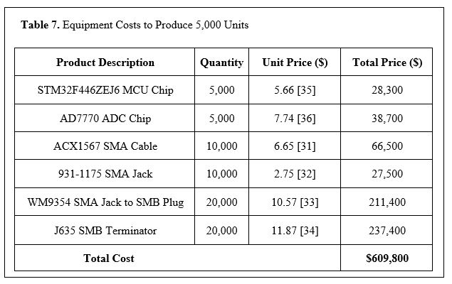

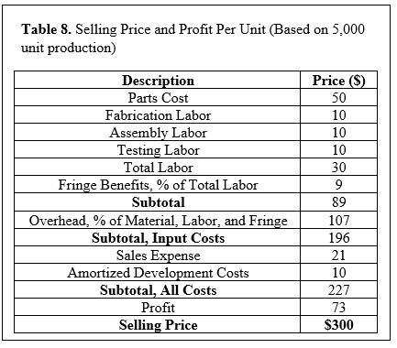

1. **Current Status**

As a previous senior design project, there has been a significant amount of work which directly assists the team’s current project. All of the parts have been determined and are in the lab (save for some cables), but extras are needed for additional testing. The current product has a lower sampling rate than required and does not possess the ability to process the input data in real-time. Fixing these two issues is the primary target for the NAHOM Team. As the current plotting library is slow and inflexible, it is a goal of the team (though not a formal requirement) to develop a high performance plotting interface for displaying outputs. Additionally, development of an Android application to interface with the PC is needed if that (non-essential) goal is to be undertaken.

The current NAHOM team has made important decisions regarding the project, such as deciding to do signal processing on the microprocessor chip as opposed to on the PC and continuing to use UART for communication between the MCU and the PC. The team is currently studying the datasheets for the MCU and the ADC to better understand how the will be connected and fit within the system. Furthermore, the team is studying and testing digital signal processing techniques using old captured data.

1. **References**

[1] Center for Disease Control and Prevention. (2017, Aug. 24). Heart Disease Facts. [Online]. Available: https://www.cdc.gov/heartdisease/facts.htm. [Accessed: Nov. 25, 2017].

[2] M. A. Cretikos, R. Bellomo, K. Hillman, J. Chen, S. Finfer, and A. Flabouris, “Respiratory rate: the neglected vital sign,” The Medical Journal of Australia, vol. 188, no. 11, 2008. [Online serial]. Available: https://www.mja.com.au/journal/2008/188/11/respiratory-rate-neglected-vital-sign. [Accessed Nov. 25, 2017].

[3] Y. S. Lee, P. N. Pathirana, C. L. Steinfort, and T. Caelli, “Monitoring and Analysis of Respiratory Patterns Using Microwave Doppler Radar,” IEEE Journal of Translational Engineering in Health and Medicine, vol. 2, October, 2014. [Online serial]. Available: http://ieeexplore.ieee.org/stamp/stamp.jsp?arnumber=6942141. [Accessed Nov. 25, 2017].

[4] N. Bernacchia, L. Scalise, L. Casacanditella, I. Ercoli, P. Marchionni, E. P. Tomasini, “Non contact measurement of heart and respiration rates based on Kinect™,” IEEE International Symposium on Medical Measurements and Applications (MeMeA) ’06, 2014. Available: <http://ieeexplore.ieee.org/document/6860065/>. [Accessed Nov. 25, 2017].

[5] K. Mayank, A. Veeraraghavan, and A. Sabharwal. "DistancePPG: Robust Non-contact Vital Signs Monitoring Using a Camera." *Biomedical Optics Express* 6, no. 5 (2015): 1565-588.

[6] J. Kuutti, M. Paukkunen, M. Aalto, P. Eskelinen, and R. E.Sepponen, “Evaluation of a Doppler radar sensor system for vital signs detection and activity monitoring in a radio-frequency shielded room ,” Science Direct, Measurement, vol. 68, May, 2015. [Online serial]. Available: https://doi.org/10.1016/j.measurement.2015.02.048. [Accessed Nov. 25, 2017].

[7] Fitbit, “Our Technology,” [Online]. Available: <https://www.fitbit.com/technology>. [Accessed: Nov. 25, 2017].

[8] J. Titcomb, “Fitbit heart rate tracking is dangerously inaccurate, lawsuit claims,” telegraph.co.uk, Jan. 7, 2016. [Online]. Available: http://www.telegraph.co.uk/technology/news/12086337/Fitbit-heart-rate-tracking-is-dangerously-inaccurate-lawsuit-claims.html. [Accessed Nov. 25, 2017].

[9] Qardio, “Qardio Core Wearable ECG EKG Monitor Iphone,” [Online]. Available: https://www.getqardio.com/qardiocore-wearable-ecg-ekg-monitor-iphone/. [Accessed: Nov. 25, 2017].

[10] National Weather Service, “How Radar Works”. [Online]. Available: http://www.srh.noaa.gov/jetstream/doppler/how.html. [Accessed: Nov. 25, 2017].

[11] H. Gonçalves, “Analog-Digital Converters,” onmyphd.com [Online]. Available: http://www.onmyphd.com/?p=analog.digital.converter#h3_sigmadelta. [Accessed: 23-Oct-2017].  
  
[12] J. Pytel, “ADC,” YouTube, 15-Jul-2010. [Online]. Available: https://www.youtube.com/watch?v=7X53_QCXbjk&t=1899s. [Accessed: 23-Oct-2017].

[13] “Sigma-Delta ADC Tutorial,” Sigma-Delta ADC Tutorial | Design Center | Analog Devices. [Online]. Available: http://www.analog.com/en/design-center/interactive-design-tools/sigma-delta-adc-tutorial.html. [Accessed: 23-Oct-2017].

[14] “Choose the right A/D converter for your application,” *Texas Instruments*. [Online]. Available: https://www.ti.com/europe/downloads/Choose%20the%20right%20data%20converter%20for%20your%20application.pdf [Accessed 30-Nov-2017]

[15] Circuits Basics, “Basics of the SPI Communication Protocol,” circuitsbasics.com. [Online]. Available: http://www.circuitbasics.com/basics-of-the-spi-communication-protocol/. [Accessed Nov. 30, 2017].

[16] Sepulveda, C., Munoz, J., Espinoza, J., Figueroa, M. and Baier, C. (2013). “FPGA v/s DSP Performance Comparison for a VSC-Based STATCOM Control Application”. *IEEE Transactions on Industrial Informatics*, 9(3), pp.1351-1360.

[17] K. Keutzer, "http://bwrcs.eecs.berkeley.edu/Classes/CS252/Notes/Lec09-DSP.pdf", Berkeley, 2000.

[18] M. Nadeski and A. Gatherer, "See the difference: DSPs in medical imaging", Texas Instruments, 2017.

[19] Texas Instruments, “TMS320C6455 Fixed-Point Digital Signal Processor,” TMS320C6455 datasheet, May 2005 [Revised Mar. 2012].

[20] Analog Devices, “8-Channel, 24-Bit Simultaneous Sampling ADC”, AD7770 datasheet, Aug. 2017.

[21] STMicroelectronics, “ARM® Cortex®-M4 32b MCU+FPU...”, STM32F446xC/E datasheet, Sept. 2016.

[22] Silicon Labs, “EFM8 Busy Bee Family EFM8BB2 Reference”, EFM8BB2 datasheet, Nov. 2016.

[23] “Health Insurance Portability and Accountability Act,” California Department of Health Care

Services, 2016. [Online]. Available:

http://www.dhcs.ca.gov/formsandpubs/laws/hipaa/Pages/1.00WhatisHIPAA.aspx. [Accessed: Nov 30,

2017]

[24] U.S. Department of Health and Human Services, “Guidance on HIPAA and Cloud Computing”, *hhs.gov*, para. 1-4, June 16, 2017. [Online] Available: https://www.hhs.gov/hipaa/for-professionals/special-topics/cloud-computing/index.html. [Accessed Nov. 29, 2017]

[25] “ANSI/AAMI ES60601-1:2005,” AAMI Standards and Recommended Practices, 2012.

[26] “Institutional Review Boards Frequently Asked Questions,” U S Food and Drug Administration, Jan. 25, 2016. [Online]. Available: https://www.fda.gov/RegulatoryInformation/Guidances/ucm126420.htm. [Accessed: 28-Nov-2017].

[27] “The Standard,” Standard C++ Foundation . [Online]. Available: https://isocpp.org/std/the-standard. [Accessed: 28-Nov-2017]

[28] Venture Medical, “Patient Monitors for Sale,” *venturemedical.com,* Jan. 1, 2012. [Online]. Available: <http://www.venturemedical.com/products/patient_monitors_and_accessories/patient_monitors/?gclid=Cj0KCQiA0vnQBRDmARIsAEL0M1n2CA4wB1YVmm7I-U8oWL7dawhn8UWgPqULXbn9K63TI79KhLTIieYaAis-EALw_wcB>. [Accessed: Nov. 30, 2017].

[29] Digi-Key Electronics, “Eval board STM32446 MCU,” *digikey.com,* Nov. 30, 2017. [Online]. Available: <https://www.digikey.com/product-detail/en/stmicroelectronics/STM32446E-EVAL/497-15244-ND/5168453>. [Accessed: Nov. 30, 2017].

[30] Digi-Key Electronics, “Eval board for AD7770,” *digikey.com,* Nov. 30, 2017. [Online]. Available: <https://www.digikey.com/product-detail/en/analog-devices-inc/EVAL-AD7770FMCZ/EVAL-AD7770FMCZ-ND/6133435>. [Accessed: Nov. 30, 2017].

[31] Digi-Key Electronics, “Cable Assembly Coaxial SMA to SMA Male to Male,” *digikey.com,* Nov. 30, 2017. [Online]. Available: <https://www.digikey.com/product-detail/en/amphenol-rf-division/135101-01-06.00/ACX1567-ND/2003900>. [Accessed: Nov. 30, 2017].

[32] Digi-Key Electronics, “SMA Connector Jack,” *digikey.com,* Nov. 30, 2017. [Online]. Available: <https://www.digikey.com/product-detail/en/taoglas-limited/EMPCB.SMAFSTJ.B.HT/931-1175-ND/3522337>. [Accessed: Nov. 30, 2017].

[33] Digi-Key Electronics, “Adapter Coaxial Connector SMA Jack,” *digikey.com,* Nov. 30, 2017. [Online]. Available: <https://www.digikey.com/products/en?keywords=WM9354-nd>. [Accessed: Nov. 30, 2017].

[34] Digi-Key Electronics, “Terminator Coax Connector Plug,” *digikey.com,* Nov. 30, 2017. [Online]. Available: <https://www.digikey.com/products/en?keywords=j635-nd>. [Accessed: Nov. 30, 2017].

[35] Mouser Electronics, “STM32F446ZEJ6,” *mouser.com,* Nov, 30, 2017. [Online]. Available: <https://www.mouser.com/ProductDetail/STMicroelectronics/STM32F446ZEJ6/?qs=sGAEpiMZZMu6TJb8E8Cjr48fBFXdXSHKqPteavoH9uc%3D>. [Accessed: Nov. 30, 2017].

[36] Mouser Electronics, “AD7779ACPZ,” *mouser.com,* Nov, 30, 2017. [Online]. Available: <https://www.mouser.com/ProductDetail/Analog-Devices/AD7779ACPZ/?qs=sGAEpiMZZMvTvDTV69d2QoIMHehgkbmswLCUTk0UP3g%3d>. [Accessed: Nov. 30, 2017].

**Appendix A: Gantt Chart For Non-Contact Vital Sign Monitoring System**

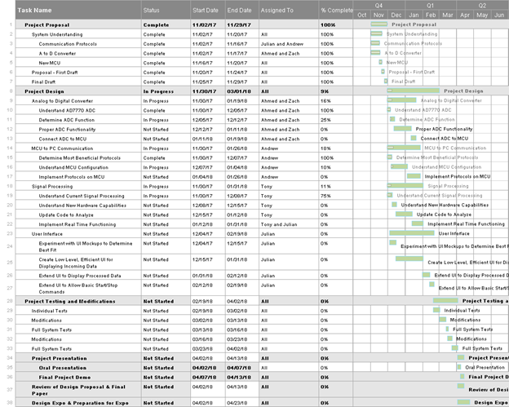

**Appendix B: PERT Chart For the NAHOM**

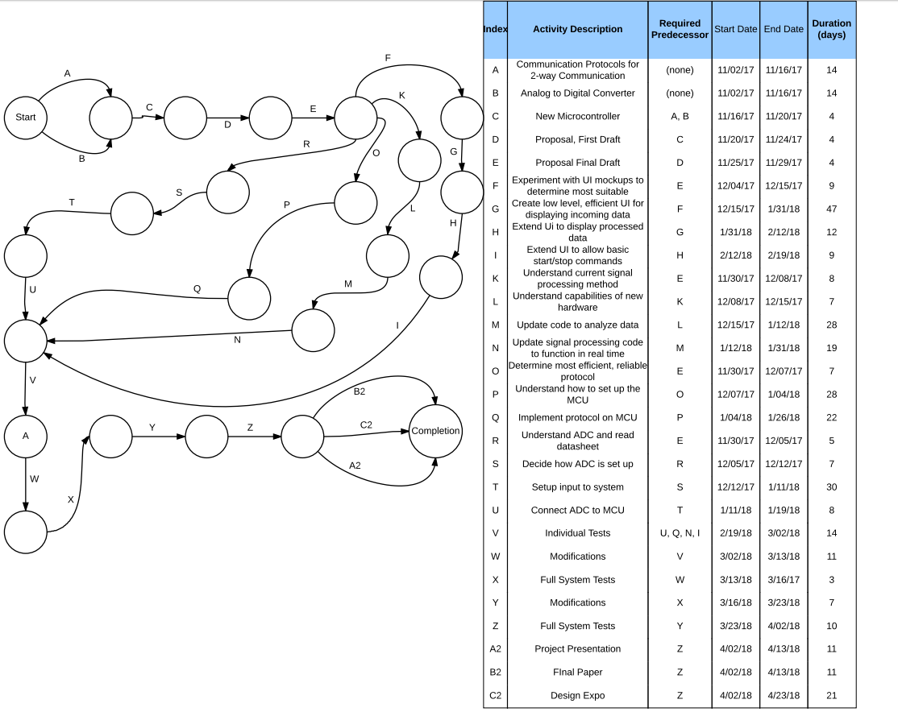

**Appendix B: Critical Path Analysis from PERT Chart**

