**Hydra: Underwater Swarm Robot System for Efficient Deepwater Search**

ECE4011 Senior Design Project

Project Hydra

Advisor: Dr. Mick West

Team Members

Priyansh Bhatnagar, [pbhatnagar6@gatech.edu](mailto:pbhatnagar6@gatech.edu)

Trevor Jones, [tjones6289@gmail.com](mailto:tjones6289@gmail.com)

Hemanth Koralla, [hkoralla3@gatech.edu](mailto:hkoralla3@gatech.edu)

Aneri Muni, [amuni3@gatech.edu](mailto:amuni3@gatech.edu)

Vishnu Perumal, [vishnu96@gatech.edu](mailto:vishnu69@gatech.edu)

Michael Tatum, [michaelptatum@gatech.edu](mailto:michaelptatum@gatech.edu)

Submitted

1 December 2017**Table of Contents**

**Executive Summary (5 pts)** ii

1. **Introduction (5 pts)** 1
   1. Objective xx
   2. Motivation xx
   3. Background xx
2. **Project Description and Goals (15 pts)**  xx
3. **Technical Specification (20 pts)** xx
4. **Design Approach and Details (20 pts)** 
   1. Design Approach xx
   2. Codes and Standards xx
   3. Constraints, Alternatives, and Tradeoffs xx
5. **Schedule, Tasks, and Milestones (10 pts)**  xx
6. **Project Demonstration (5 pts)** xx
7. **Marketing and Cost Analysis (5 pts)**  xx
   1. Marketing Analysis xx
   2. Cost Analysis xx
8. **Current Status (10 pts)** xx
9. **References (5 pts)** xx

**Appendix A** xx

**Appendix B** xx

**Appendix C** xx

**Executive Summary**

A flight recorder, or a black box, is an electronic recording device placed in an aircraft to facilitate the investigation of aviation accidents and incidents. The flight recorder is fitted with an underwater locator beacon (ULB) or underwater acoustic beacon (UAB). Once immersed into water, a built-in "water switch" activates the beacon by closing an electric circuit, and the beacon starts emitting its "pings"; the battery power should be sufficient for at least 30 days after the activation.

The disappearance of Malaysia Airlines Flight 370 demonstrated the limits of the contemporary flight recorder technology, namely the need for the ULB’s range and battery life to be extended. Current beacons are typically supplied with electrical power by a lithium battery, thus giving them a limited lifespan. This makes recorder retrieval a time sensitive mission. It would be more efficient and, in some cases, safer to send robots instead of divers for such missions.

The goal of our project is to develop a swarm robotics system of six autonomous underwater vehicles (AUVs) that would aid in the search and retrieval missions for flight recorders. Each robot in this system will contain light and acoustic sensors to communicate with one another and determine the location of the missing black box. An estimate cost for developing a prototype swarm is approximately $700.00. The robots will demonstrate the ability of decentralized control algorithms to command swarms of AUVs through tests where the swarm searches for a beacon while maintaining a specified formation. These prototype tests will be used to present the project’s applicability to real-world problems, such as the search and retrieval of a flight recorder.

**Hydra: Underwater Swarm Robot System for Efficient Deepwater Search**

**1. Introduction**

Hydra will be an underwater swarm robotics system that will traverse areas of the ocean that are inconvenient for humans in order to perform tasks such as airplane black box identification and retrieval. The system consists of multiple robots each configured with a microcontroller, thrusters, and various sensors. The team requests $1,000.00 to fund the prototype of Hydra.

* 1. **Objective**

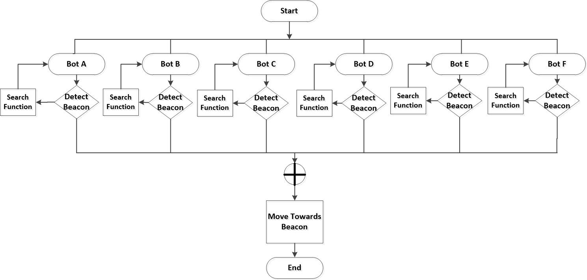

**Figure 1.** Overview flowchart of black box search algorithm.

It is the objective of the team to design and prototype a system that will allow multiple robots to collaborate with one another in an underwater setting. These robots will communicate with one another through a combination of optical signals. Together, they will be able to listen for pulses from the locator beacon of an airplane’s black box once it is submerged in the water. Each robot will communicate with others that are adjacent to it. When a signal is received from a certain direction, all the robots will use a predetermined swarm algorithm to maintain a formation and move towards that signal. Once a HydraBot encounters the beacon, it will notify the user of the location. Figure 1 above depicts a high level approach to the black box search algorithm process.

* 1. **Motivation**

The main motivations for Hydra are removing the need of human presence in dangerous underwater situations, as well as creating the most efficient ocean searching mechanism. Airplane catastrophes are time-sensitive. By having a system of autonomous underwater robots that will efficiently work together to quickly locate a black box, authorities will be able to deal with these situations in a more responsive end effective manner. Products with similar objectives include General Dynamics’ Bluefin 12D AUV and OceanServer’s Iver3 580. Hydra aims to improve on them by focusing on being cost-effective, commercial, and autonomous [1].

* 1. **Background**

Recently, many efforts and resources are being dedicated towards research on the implementation of swarm robotics systems in underwater settings. Many companies are investing in the research and development of AUVs for commercial products: fishing-drones like PowerRay, photography-focused AUV’s such as Trident, and Blueye’s underwater drone meant for marine biologists [2]. These different products are slowly beginning to come to market, and are paving the way forward for AUV presence in the commercial sector.

Universities are also focusing on underwater swarm robotics systems. The Autonomous Control Engineering (ACE) Lab at the University of Texas, Austin focuses on creating swarm robotics systems in different settings and how various systems of swarm robots could work together. Their goal is to build a “system of systems,” specifically in the underwater realm [3]. Additionally, CoCoRo is a EU funded project with the goal to “efficiently and autonomously search areas of the ocean for specific, hard-to-find targets” [4], an objective similar to that of Hydra.

The physical design of a HydraBot is a modified version of the design of the Underwater Learning Robot (ULR). This is a programmable autonomous underwater vehicle whose programs and sensor systems allow it to operate effectively and navigate through the water as per the user's commands. While the goals of Project Hydra and the ULR are very different, ULR’s physical design includes a variety of sensors and a waterproof body that is adequate for Hydra [5].

Existing underwater drones are not economical, and research efforts such as CoCoRo are proprietary and not available to the public. For these reasons, Hydra is focused on cost-minimization and commercialization.

**2. Project Description and Goals**

The goal of Hydra is to produce a system of aquatic swarm robots that are autonomously able to create and execute an efficient ocean traversal algorithm. The targeted users of this product are the military and authorities who are responsible for locating airplane wreckages. Six AUVs will be designed and prototyped by this group. Each AUV will consist of a waterproof chassis, motors, propellers, sensors, and microcontrollers. The microcontrollers will allow implementation of high and low-level programming, controlling the swarm’s performance. Sensors will be used for communication between neighboring AUVs, detect a beacon, and provide feedback to a controller for smoother motions. Six AUVs will be sold for an estimated target price of $10,000.00.

Each AUV will have the following features:

* Ability to transmit and receive data through visible light communication
* Propellers that provide three-dimensional movement capability
* Ability to function for one hour on a single charge

The swarm of AUVs will have the following features:

* Ability to create and maintain formations underwater while moving in search of a beacon
* Ability to alert the user when the beacon is detected

1. **Technical Specifications**

This swarm project consists of a minimum of six robots that are each modeled after the design of the ULR. Below are all the specifications defining the technical details of an individual robot within the swarm:

**Table 1.** Enclosure Specifications

|  |  |
| --- | --- |
| **Item** | **Specification** |
| Minimum dimensions(*l* x *w* x *h*) | 22 cm x 22.4 cm x 5.6 cm |
| Maximum depth | 3 m |
| Speed (min/max) | 1/20 cm/s |
| Power Interface | Micro-USB |
| Build Material | ABS (plastic) |

**Table 2.** Components: Actuators

|  |  |
| --- | --- |
| **Item** | **Specification** |
| DC Motors | 3 |

**Table 3.** Components: Sensors

|  |  |
| --- | --- |
| **Item** | **Specification** |
| Time-of-Flight Sensors | 6 |
| Three-axis accelerometer | 1 |
| Gyroscope | 1 |
| MS5803-14BA Pressure Sensor | 1 |
| Rain Sensors | 5 |

**Table 4.** Components: Microprocessor and Communications

|  |  |
| --- | --- |
| **Item** | **Specification** |
| Processor | Raspberry Pi Zero |
| Microcontroller | Arduino Pro Mini |
| Visible Light Communication LED Transmitter | 1 RGB LED |
| Visible Light Communication Receiver | 470-527 nm wavelength |

1. **Design Approach and Details**
   1. **Design Approach**

**System Overview**

This project consists of two major components: the hardware design and implementation and multi-agent coordination algorithms. With regards to the hardware platform, this system consists of six robots that are based on the design of the ULR. Each of these robots will contain a microcontroller, time-of-flight (TOF) sensors, a battery, propellers, motors, LED lights, pressure sensors, rain sensors, accelerometer, and a gyroscope. Figure 2 shows the overall flow of how all of these elements interact with one another. The software will use decentralized graph theory to achieve the desired swarm capabilities.

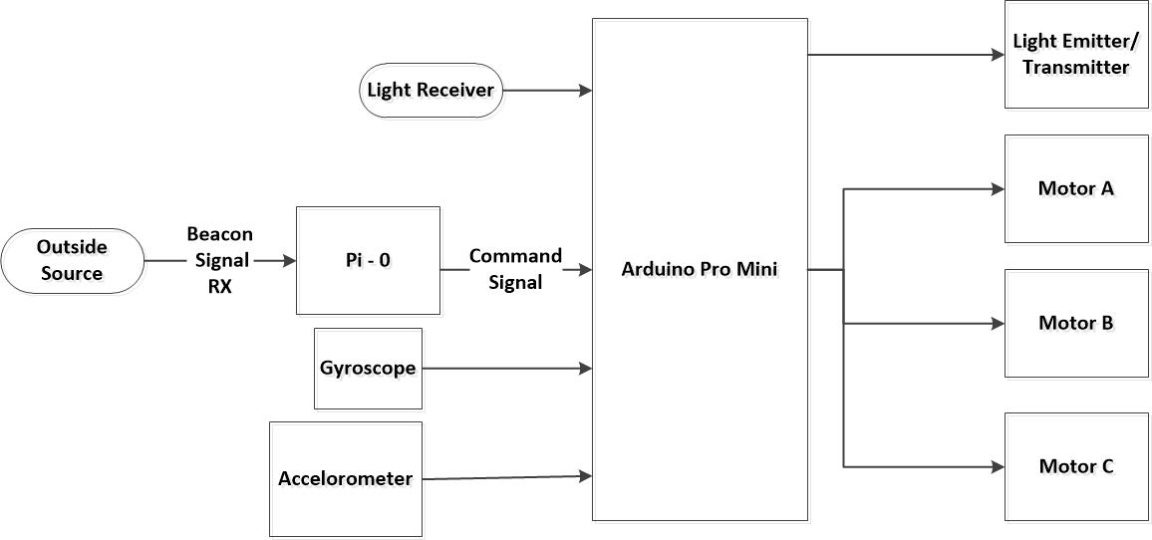

**Figure 2.** Data flow from sensors and inputs to motors and communication module.

**4.1.1 Hardware Specification**

**4.1.1.1 Platform**

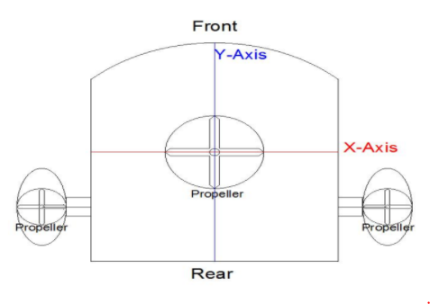

**Figure 3.** Preliminary design of the ULR.

The chassis will be 3D printed with the design seen in Figure 3. The chassis will have three motor-propeller pairs, two on either side for turning and one on the bottom for depth control. The enclosure is made positively buoyant, to ensure that it will rise to the surface in case of system failure. Epoxy glue will be used to seal the enclosure, making it waterproof.

**4.1.1.2 Sensors**

Each HydraBot will include six TOF sensors to measure the distance to its neighbors, as shown in Figure 4. The accelerometer provides information about direction and velocity of the robot’s movements and the gyroscope will be used to maintain the correct orientation in the water. The accelerometer and gyroscope readings will provide feedback to the system controller to control the heading and depth. Rain sensors will be used to detect a water breach in the chassis. A light transmitter and receiver on each agent will indicate to the rest of the agents that a beacon signal was detected. This will terminate the search algorithm and the swarm will proceed to the surface.

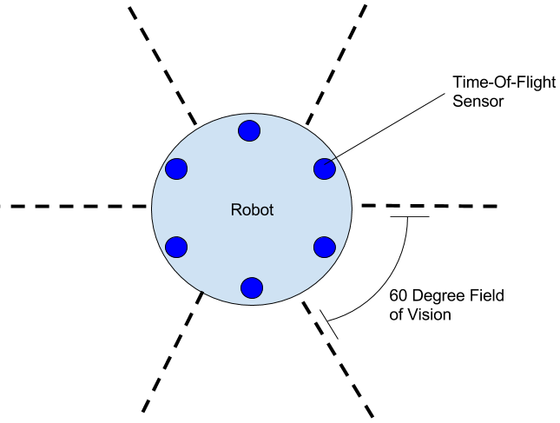

**Figure 4.** Sensor skirt of robot that shows full coverage of its surroundings.

**4.1.1.3 Microcontroller/Computer**

Each robot will use a Raspberry Pi Zero as an onboard computer along with an Arduino Pro Mini for controlling sensors and actuators. The choice of these controllers is due to their small size, that will in turn help limit the size of the overall robot. In addition, both of these processors are economically efficient and provide an adequate number of input/output ports for the necessary number of sensors and motors this project requires. The Raspberry Pi will be the main communication and processing center and will be used to send motor control commands to the Arduino via serial.

**4.1.2 Software**

The software development process will concurrently take place with the hardware design process. Software for this project has three main components: swarm algorithm, feedback controller, and communication protocol.

**4.1.2.1 Coverage Control Algorithms**

The main algorithm for multi-agent coordination is based on a decentralized graph theory algorithm. This algorithm does not have a central communication unit or mechanism that communicates with each robot of the swarm. Instead, each member of the swarm communicates only with its immediate neighbors and maintains a specified distance between them to create an maximally-spanning configuration. This decentralized method is beneficial to this system since underwater communication is often difficult.

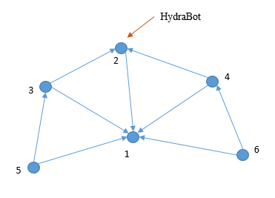

**Figure 5.** Triangular configuration with six robots in decentralized coverage control algorithm.

For the purposes of this project, a lead-follow coverage control algorithm will be implemented to dictate the formation of the swarm to explore the area it is in. In order to maximize the area that the swarm explores, each agent in the swarm will communicate with its neighbors in a triangular fashion, such that they can all form a configuration like the one shown in Figure 5. In order to determine the direction of how the swarm travels, the system will automatically assign a random member to be the leader. This leader will then dictate the direction by moving in a linear search pattern across the area of water. However, the decision of which agent the leader is will change dynamically based on inputs from the environment. The swarm will follow a linear search pattern because there is no simple method to map an underwater space. This algorithm will be written in MATLAB and tested in the Robotarium, a swarm robotics laboratory at Georgia Tech, before being implemented underwater.

**4.1.2.2 PID Controller**

The PID controller will use inputs from the gyroscope and accelerometer to control the motion of the bots. The System Identification Toolbox in MATLAB will be used for modeling each AUV to develop controllers and system identification techniques will be used to identify the PID gains for controlling the AUV’s heading and depth.

**4.1.2.3 Communication Protocol**

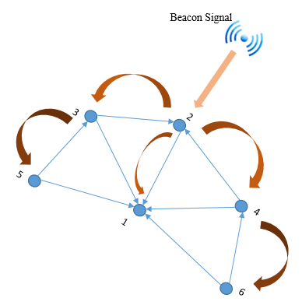

**Figure 6.** Beacon Detection Signal Propagation. Note that darker arrows indicate later iterations in communication protocol.

An LED transmitter and receiver will be used to communicate between the various robots within this system. When the missing beacon is located by any of the robots in the swarm, its LED will light up to transmit this information to its immediate neighbors. These neighbors will receive this message through their LED receiver and will in turn inform their immediate neighbors that the beacon was detected. This process will continue until every member of the swarm is aware of this information as shown in Figure 6. Since blue light travels best underwater, the color of the LED transmitter will be blue. This technique of communication via light can be extended in the future using different colors to indicate other information such as critical battery level, or other information.

* 1. **Codes and Standards**

The microcontroller will use inter-integrated circuit (I2C) specification in order to communicate with on-board sensors. All devices within this standard follow a master-slave relationship for communication. The universal serial bus will be used on both the Raspberry Pi Zero and Arduino Pro Mini to create the necessary connection with a PC to transport algorithms and code.

* 1. **Constraints, Alternatives, and Tradeoffs**

Constraints of the robot include size, weight, cost, waterproofing, battery power consumption, and sensor range. The robot must be designed with a size and weight that makes it aerodynamically ideal to move through the water, as well as one that results in natural buoyancy. It is also crucial to fully waterproof each robot. Robots must be able to operate for one hour on a full charge, thus an appropriate battery must be selected. Finally, TOF sensors on each agent must be effectively selected and placed so that they can collectively cover the entire circumference surrounding a robot and have adequate range to detect nearby robots. In the design process so far, there were three scenarios in which different alternatives were debated upon: the use of ULR versus modifying a pre-existing toy, the use of light versus sound for multi-robot communication, and higher processing microcontroller versus a cheaper alternative. Initially, the team was hoping to leverage pre-existing toys in the market to use for the swarm system. Many toys were found but are not viable for this project because they are not big enough and did not provide the capability needed for this project. Communication is a difficult task underwater and underdeveloped technology. Sound is a strong alternative that was avoided because the signal becomes too distorted in short range and light is a simpler solution for short range communication. Finally, when choosing microcontrollers, many factors including size, available ports, power consumption and processing speed were considered. While the ULR platform uses a Raspberry Pi 3 and an Arduino due to higher processing speed, this project will utilize the Raspberry Pi Zero and Arduino Pro Mini in order to save space and build a smaller robot.

1. **Schedule, Tasks, and Milestones**

The Hydra team will be designing and testing the robots over the next couple of months. Appendix A contains a Gantt flowchart which shows the tasks that are able to be accomplished concurrently. Appendix B contains the complete Gantt Chart. Each section of the chart was determined by approximating the amount of time needed to accomplish each task. Some tasks comprise of smaller tasks which will be divided among team members. Appendix C contains the Pert Chart which lists the probabilities of completion.

1. **Project Demonstration**

The swarm AUVs will be demonstrated in a clear water children’s swimming pool at the Design Expo and the J. Erskine Love Building’s pool, depending on the size of pool needed for testing. If the J. Erskine Love Building’s pool is used, a video of the swarm performance will be shown at the Design Expo. In either case, the swarm AUVs will demonstrate:

* **Formation:** The AUVs will form a shape using triangulation so that each robot is equidistant from its neighbors.
* **Synchronous Movement:** The AUVs will synchronously move according to the given drift term defined by the leader AUV.
* **Beacon Search:** The AUVs will sweep the pool in a linear fashion, going up and down the pool, while moving slightly to the right with each sweep to search the pool until the beacon is detected by an AUV.
* **Beacon Detection:** Upon detection of the beacon by any of the AUVs, all AUVs will surface and blink LEDs to indicate success.

**Prototype Testing:**

The Robotarium in Van Leer will be used to test the swarming algorithms. Prototype testing will proceed as follows:

1. Test swarming algorithms in simulations in Matlab
2. Implement swarming algorithms in Robotarium
3. Implement swarming algorithms on AUVs
4. **Marketing and Cost Analysis**
   1. **Marketing Analysis**

The target customers for AUVs that perform search functionalities are researchers, the military, and disaster relief organizations. For example, the National Oceanic and Atmospheric Administration (NOAA) uses submersibles, such as the Hercules Remotely Operated Vehicle (ROV) to explore the ocean [6]. The military and disaster relief organizations often have common goals for their AUVs, namely search and rescue missions. The U.S. Navy is currently using the torpedo-sized Bluefin 12D AUV and three OceanServer Iver3 580 AUVs to search for the sunken Argentine Armada submarine *San Juan* [7]. General Dynamics created the Bluefin 12D AUV and it was previously used in the search for Malaysia Airlines Flight 370. The Bluefin 12D is 14.2 feet long and 574 pounds on dry land, explaining its use for military operations as opposed to commercially-available swarm operations [8].

While significantly smaller than the Bluefin 12D AUV, the OceanServer Iver3 580 AUV still ranges between 60 and 85 inches with a weight between 59 and 85 pounds, both measurements significantly higher compared to the Hydra AUVs’ dimensions. In addition, a single Iver3 AUV costs $119,250.00 [9]. The main advantages Hydra has over its competitors is its swarming capability, reduced size and weight, and comparably minimal cost. Hydra’s swarming capabilities allow it to gain greater coverage of an area in a shorter amount of time. In addition, its decreased size and weight makes it more accessible to all users, as opposed to militaries that can transport AUVs weighing hundreds of pounds into the middle of the ocean. Finally, Hydra’s economical cost of $10,000.00 makes it affordable to researchers and universities interested in swarming AUVs, not just militaries and well-funded disaster relief organizations.

* 1. **Cost Analysis**

According to Table 5, the parts for developing six AUVs for prototyping the swarming capabilities of Hydra will cost approximately $800.66. The most expensive part chosen is the inertial measurement unit (IMU) at $14.95. Currently, this team is planning to build the AUVs with parts similar to those used for the ULR. Furthermore, the cost to create all prototypes remains low because the AUV chassis can be printed at Georgia Tech for free using 3D printers.

**Table 5.** Parts Costs

|  |  |  |  |
| --- | --- | --- | --- |
| ***Product Description*** | ***Quantity*** | ***Unit Cost*** | ***Total Cost (6 AUVs)*** |
| Raspberry Pi Zero [10] | 6 | $ 5.00 | $ 30.00 |
| Arduino Pro Mini [11] | 6 | $ 9.95 | $ 59.70 |
| Turnigy 1600mAh 2S 20C Lipo Pack Battery [12] | 6 | $ 7.64 | $ 45.84 |
| Switched Mode Regulator [13] | 6 | $ 4.30 | $ 25.80 |
| DC Motor [14] | 18 | $ 7.29 | $ 131.22 |
| RGB LED [15] | 6 | $ 1.95 | $ 11.70 |
| TOF Sensor (Senior Design Lab) | 36 | $ - | $ - |
| Chassis (3D Printed) | 6 | $ - | $ - |
| Propellers [16] | 18 | $ - | $ - |
| IMU [17] | 6 | $ 14.95 | $ 89.70 |
| Rain Sensor [18] | 30 | $ 7.89 | $ 236.70 |
| Miscellaneous (Cables, Wiring, Epoxy, Etc.) |  | $ 50.00 | $ 50.00 |
| Packaging |  | $ 30.00 | $ 30.00 |
| **Total Parts** | | | **$ 710.66** |

Table 6 displays the approximate development costs for Swimming Swarm, assuming each engineer is paid $40 per hour. Group meetings require the most hours of labor because all team members must meet frequently to update each other on their independent progress to maintain a clear understanding of progress and required tasks.

**Table 6. Development Costs**

|  |  |  |
| --- | --- | --- |
| ***Project Component*** | ***Total Hours of Labor*** | ***Labor Cost*** |
| **Chassis Development** | | |
| Chassis Design | 20 | $ 800.00 |
| Chassis Construction | 10 | $ 400.00 |
| **Hardware Development** | | |
| Sensor Testing | 30 | $ 1,200.00 |
| Microcontroller Configuration | 40 | $ 1,600.00 |
| System Integration | 40 | $ 1,600.00 |
| **Software Development** | | |
| Algorithm Programming | 200 | $ 8,000.00 |
| Algorithm Simulation Testing | 100 | $ 4,000.00 |
| Algorithm Robotarium Testing | 50 | $ 2,000.00 |
| Algorithm AUV Testing | 100 | $ 4,000.00 |
| Demo Preparation | 100 | $ 4,000.00 |
| Group Meetings | 300 | $ 12,000.00 |
| **Total Labor** | **990** | **$ 39,600.00** |

Table 7 provides the total development cost given that the fringe benefit is 30% of the total labor cost and overhead is 120% of the cost of parts, labor, and the fringe benefit combined.

**Table 7.** Total Development Costs

|  |  |
| --- | --- |
| Parts | $ 710.66 |
| Labor | $ 39,600.00 |
| Fringe Benefits (30% of Labor) | $ 11,880.00 |
| **Subtotal** | $ 52,190.66 |
| Overhead (120% of Parts, Labor, and Fringe) | $ 62,628.79 |
| **Total** | **$ 114,819.45** |

Considering the team sells 500 units over 5 years, where a unit consists of six AUVs, the price per unit will be $10,000.00, as shown in Table 8. Since the team will no longer have access to free 3D printing upon graduation from Georgia Tech, a plastic mold will be needed to develop new HydraBots. An outside company like Rex Plastics charges approximately $12,000.00 for a plastic mold [19]. This does not include the price of manufacturing each chassis. The prices of individual parts, such as sensors and motors, will decrease when bought in bulk. With all of these development cost changes considered, the price to produce a unit will be approximately $600.00. Technicians will assemble and test each AUV at a rate of $20.00 per hour. Sales expense, consisting of the price of advertising, will be 3% of the selling price, which is $10,000.00. The amortized development cost is the total development cost ($115,017.45) divided by the expected number of units produced (500). This cost is already added to the selling price of each unit. Selling each unit at $10,000.00 results in an expected revenue of $5,000,000.00 over five years. With a profit of $8,278.80 per unit sold, the percent profit is 480.99%.

**Table 8.** Selling Price and Profit Per Unit

|  |  |
| --- | --- |
| Parts Cost | $ 600.00 |
| Assembly Labor | $ 10.00 |
| Testing Labor | $ 10.00 |
| Total Labor | $ 20.00 |
| Fringe Benefits (30% of Labor) | $ 6.00 |
| **Subtotal** | $ 646.00 |
| Overhead (120% of Parts, Labor, and Fringe) | $ 775.20 |
| Subtotal, Input Costs | $ 1,421.20 |
| Sales Expense | $ 300.00 |
| Amortized Development Costs | $ 100.00 |
| Subtotal, All Costs | $ 1,721.20 |
| Profit | $ 8,278.80 |
| **Selling Price** | **$ 10,000.00** |

1. **Current Status**

Currently, the team has finalized all the parts, components and major design features. The AUV developed by a current ULR team will be used as a basis to develop individual agents, HydraBots, in the underwater swarm. Additionally, the team met with Dr. Magnus Egerstedt to determine suitable coverage control algorithms for multi-agent systems used for beacon detection. Method to acquire distance measurements underwater and the development for underwater communication protocol still needs to be researched and tested.

1. **References**

[1] S. Gallagher, “US Navy sends underwater robots to assist in search for Argentine sub [Updated],” ars TECHNICA, para. 3, Nov. 20, 2017. [Online], Available: https://arstechnica.com/information-technology/2017/11/us-navy-sends-underwater-robots-to-assist- in-search-for-argentine-sub/. [Accessed Nov. 29, 2017].

[2]Z. Stone, “These Six Luxury Underwater Drones Are Disrupting Fishing and Fun,” Forbes, para. 4, June 15, 2017. [Online], Available: https://www.forbes.com/sites/zarastone/2017/06/15/these-six-luxury-underwater-drones-are-disrupting-fishing-and-fun/#6058f511d978. [Accessed Dec. 1, 2017].

[3]M. A. Joordens and M. Jamshidi, “Underwater Swarm Robotics Consensus Control,” Deakin University, Waurn Ponds, Australia, Tech. Report. 978-1-4244-2794-9/09, 6 Aug. 2014.

[4]T. Schmickl *et al*., "CoCoRo -- The Self-Aware Underwater Swarm," *2011 Fifth IEEE Conference on Self-Adaptive and Self-Organizing Systems Workshops*, Ann Arbor, MI, 2011, pp. 120-126.

[5] A. Jackson, “Underwater Learning Robot,”ece4012y2017.ece.gatech.edu, para. 2, April 14, 2017. [Online]. Available: http://ece4012y2017.ece.gatech.edu/fall/sd17f25/overview.html. [Accessed Dec. 1, 2017].

[6] J. Newman, “Hercules (ROV) and Friends,” Ocean Explorer, Jan. 21, 2014. [Online], Available: http://oceanexplorer.noaa.gov/technology/subs/hercules/hercules.html. [Accessed Dec. 1, 2017].

[7] S. Gallagher, “US Navy sends underwater robots to assist in search for Argentine sub [Updated],” ars TECHNICA, Nov. 20, 2017. [Online], Available:

[8] Ocean Server, “Bluefin-12D,” Bluefin-12D datasheet, March 2016.

[9] Bluefin Robotics, “Affordable Work Class Autonomous Underwater Vehicle (AUV),” Iver3 datasheet, April 2010.

[10] Adafruit. Raspberry Pi Zero - Version 1.3 [Online]. Available: https://www.adafruit.com/product/2885. [Accessed Nov. 30, 2017].

[11] Adafruit. Arduino Pro Mini 328 - 5V/16 MHz [Online]. Available: https://www.adafruit.com/product/2378. [Accessed Nov. 30, 2017].

[12] HobbyKing. Turnigy 1600mAh 2S 20C Losi Mini SCT Pack (Part LOSB1212) [Online]. Available: https://hobbyking.com/en_us/turnigy-1600mah-2s-20c-losi-mini-sct-pack-part-losb1212.html. [Accessed Nov. 29, 2017].

[13] DigiKey. Linear Regulator Replacement DC DC Converter 1 Output 5V 1.5A 7V - 36V Input [Online]. Available: https://www.digikey.com/product-detail/en/OKI-78SR-5/1.5-W36-C/811-2196-5-ND/2259781. [Accessed Nov. 29, 2017].

[14] PiBorg. DC Motor, Gearbox, Wheel and Tyre [Online] Available: https://www.sparkfun.com/products/105. [Accessed Nov. 30, 2017].

[15] Sparkfun. LED - RGB Clear Common Cathode [Online]. Available: https://www.adafruit.com/product/2378. [Accessed Nov. 30, 2017].

[16] “Microheli Plastic 3 Blade Propeller 82mm Tail Blade (ORANGE) - BLADE 230S/250CFX,” eBay. [Online]. Available: http://www.ebay.com/itm/Microheli-Plastic-3- Blade-Propeller-82mm-Tail-Blade-ORANGE-BLADE-230S-250CFX-/262928078404. [Accessed Nov. 29, 2017].

[17] GY-521 MPU-6050 Module 3 Axis gyro 3 Axis Accelerometer Module For Arduino,” eBay. [Online]. Available: http://www.ebay.com/itm/GY-521-MPU-6050-Module-3-Axis-gyro- 3-Axis-Accelerometer-Module-For-Arduino- /231214060723?hash=item35d56e94b3%3Ag%3AFfkAAOxy4YdTWoBQ. [Accessed Nov. 29, 2017].

[18] Amazon. 5PCS Rain Water Level Sensor module Depth of Detection Liquid Surface Height Arduino [Online]. Available: https://www.amazon.com/dp/B01N058HS6/ref=asc_df_B01N058HS65286820/. [Accessed Nov. 30, 2017].

[19] Rex Plastics, “How Much do Plastic Injection Molds Cost?,” rexplastics.com, para. 4, July 15, 2013. [Online]. Available: https://rexplastics.com/plastic-injection-molds/how-much-do-plastic-injection-molds-cost. [Accessed Nov. 30, 2017].

**Appendix A - Gantt Flowchart** 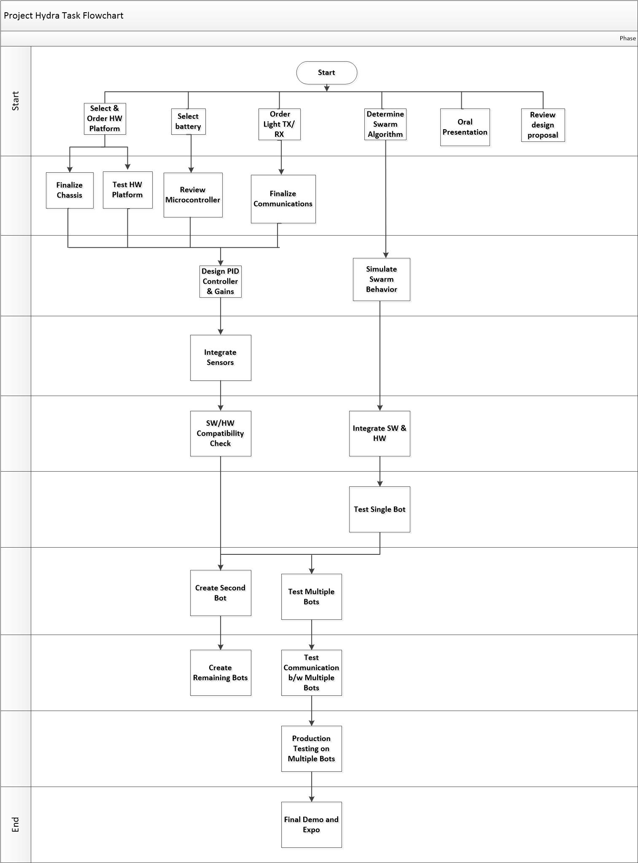

**Appendix B - Gantt Chart**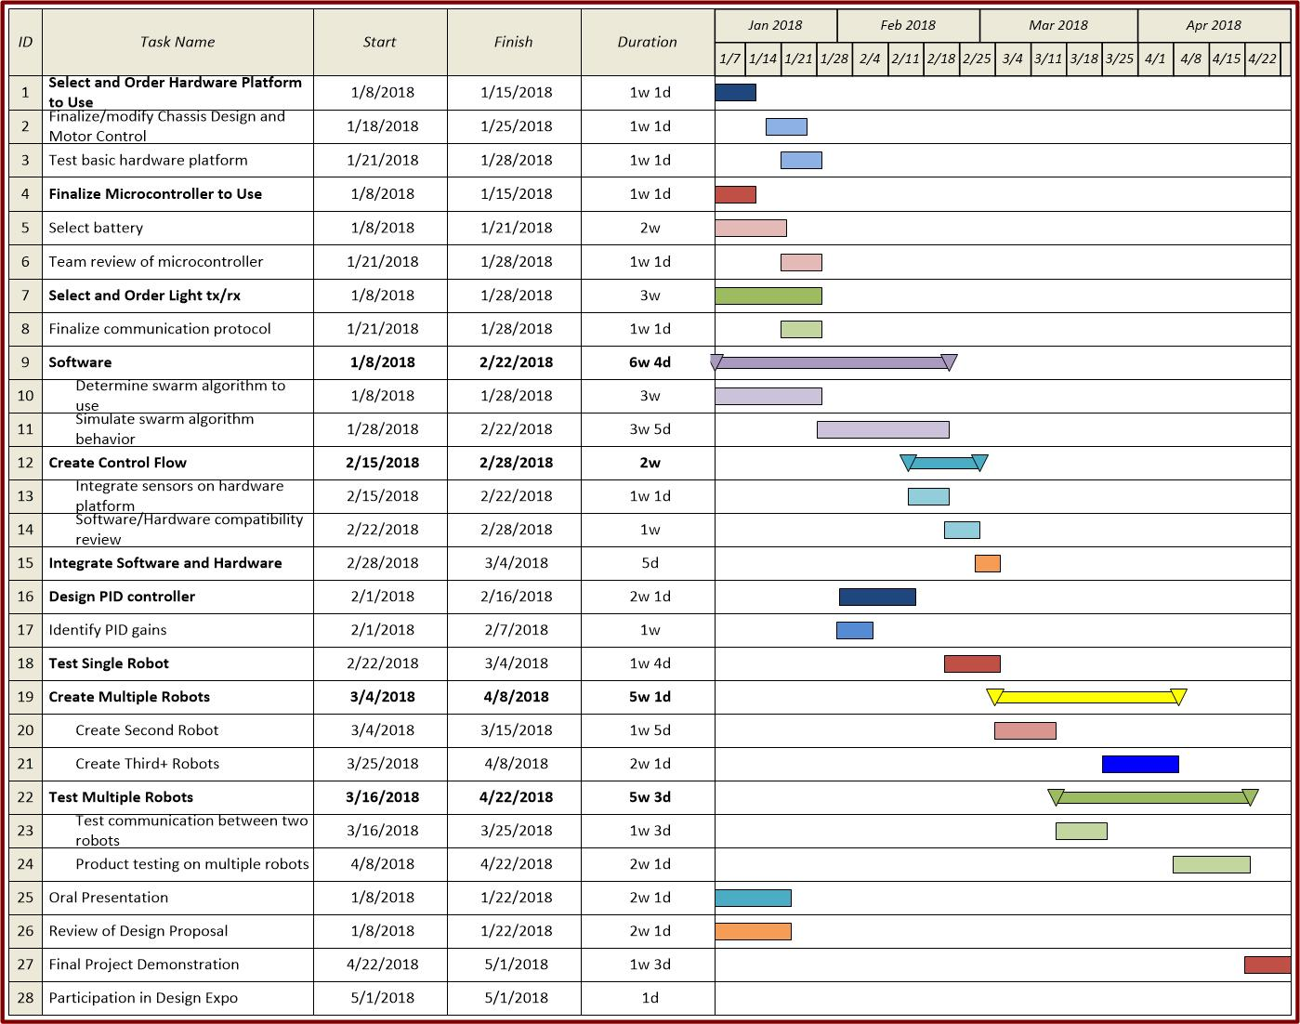

**Appendix C - PERT Chart**

|  |  |  |  |  |  |  |  |
| --- | --- | --- | --- | --- | --- | --- | --- |
| **Task** | **Most Likely Duration** | **Optimistic Duration** | **Pessimistic Duration** | **Expected Duration** | **Standard Deviation** | **SQR** | **STDEV OF TOTAL** |
| 5 | 53 | 40 | 60 | 52 | 3.333333333 | 11.11111111 | 7.096556285 |
| 9 | 12 | 8 | 26 | 13.66666667 | 3 | 9 |  |
| 10 | 5 | 2 | 10 | 5.333333333 | 1.333333333 | 1.777777778 |  |
| 11 | 35 | 20 | 45 | 34.16666667 | 4.166666667 | 17.36111111 |  |
| 12 | 36 | 25 | 45 | 35.66666667 | 3.333333333 | 11.11111111 |  |
| 13 | 9 | 9 | 9 | 9 | 0 | 0 |  |