**SkyIsland: Aerial Docking Drone System**

ECE 4011 Senior Design Project

SKYISLAND

Jennifer Hasler

Latifah Almaghrabi, [lalmaghrabgi3@gatech.edu](mailto:lalmaghrabgi3@gatech.edu)

Ayca Ermis, [aycaermis@gatech.edu](mailto:aermis3@gatech.edu)

Adrian de la Iglesia Valls, [aliv3@gatech.edu](mailto:aliv3@gatech.edu)

Jiaqing Li, [jli651@gatech.edu](mailto:jli651@gatech.edu)

Lingfeng Zhou, [lingfeng_zhou@gatech.edu](mailto:lingfeng_zhou@gatech.edu)

Submitted

Nov 30th, 2017

**Table of Contents**

**Executive Summary (5 pts)** ii

1. **Introduction (5 pts)** 1
   1. Objective xx
   2. Motivation xx
   3. Background xx
2. **Project Description and Goals (15 pts)** xx
3. **Technical Specification (20 pts)** xx
4. **Design Approach and Details (20 pts)**
   1. Design Approach xx
   2. Codes and Standards xx
   3. Constraints, Alternatives, and Tradeoffs xx
5. **Schedule, Tasks, and Milestones (10 pts)** xx
6. **Project Demonstration (5 pts)** xx
7. **Marketing and Cost Analysis (5 pts)** xx
   1. Marketing Analysis xx
   2. Cost Analysis xx
8. **Current Status (10 pts)** xx
9. **References (5 pts)** xx

**Appendix A** xx

**Appendix B** xx

**Executive Summary**

SkyIsland is a drone system comprised of independent quadrotors with the ability to interlock and reconfigure into one collective drone structure. The reconfigured drone structure will also have the ability to reverse the formation by breaking apart into its constituent drones. This dynamic assembly operation gives the system a high degree of flexibility. The system can reassemble itself based on the characteristics of the assigned task and the required features to execute it.

This flexibility of the system makes it versatile and adaptable in applications involving search and rescue in hazardous areas, cargo delivery, military recon, and performing difficult inspections in inaccessible areas. The ability for the drone swarm to reconfigure and reshape provides for flexibility in un-navigable regions, such as narrow canyons, crowded traffic, and dense forests while minimizing air traffic in open areas.

Electro-permanent magnets will be utilized to provide holding force to maintain the connection between coupled drones. Distance sensors such as ultrasonic sensors and optical detectors and emitters will be employed to achieve mid-air, crash-free alignment between the drones prior to docking. The system will also be enhanced with a complex control system to guide the drones while in swarm mode and when docking mid-air. Drone swarm interactions will incorporate wireless communications utilizing a low-latency, in-order, and reliable transmission protocol. Docking and swarm interactions will be integrated into a centralized software platform coupled to a human machine interface (HMI) at a central ground station.

A wide variety of open-source software toolsets and drone-platforms are readily available for the implementation of the SkyIsland system which aids in keeping the development costs relatively low. The project is estimated to cost $600.00 which will fund both the material costs of prototyping as well as acquiring any relevant software licensing.

**SkyIsland: Aerial Docking Drone System**

**1. Introduction**

The SkyIsland team will design a search and inspection drone system that features mid-air self-docking and undocking following commands from the ground. The team requests $600.00 to develop a prototype of this system.

* 1. **Objective**

The team will design and prototype a system of three specialized inspection drones that perform stabilized self-docking and undocking mid-air to achieve flexible configuration, high payload capacity, and multifunctionality. The inputs from the user include movement directions, docking, and undocking commands. Individual drones operate semi-autonomously until a docking command is received. A set of three drones can aggregate together, perform mid-air docking, and operate in unity. When an undocking command is received, the three drones separate, and can perform individual tasks.

* 1. **Motivation**

Most of the commercially available drones operate individually with one functionality. There is no available product in the drone market that utilizes a drone system with docking and undocking in mid-air. Mid-air docking of drones is a relatively new topic in research area as well. One comparable product in research is Daniel Wilson’s unmanned aerial vehicles with airborne docking, from the University of Sydney. However, this research is only for mid-air refueling of human-sized aircrafts. The researched product also requires specific shapes of the leader and follower drones: a cone-shaped, parachute-like drogue and nose[1]. The motivation of SkyIsland system is to introduce multipurpose and easy-to-assemble inspection drone system into the market. The team aspires to design a prototype that, when manufactured in large scale, will be cost-effective and has a wide range of applications. Currently, the primary customer base is comprised of communications, power, search & rescue, and military industries. With an inspection drone system of a smaller scale, the product could be extended to any business or individual who needs to search and inspect from the air.

* 1. **Background**

The closest commercial product to SkyIsland available is the on-ground self-recharging inspection drone DRONEBOX from H3 Dynamics [2]. Mid-air docking, however, has been explored as a research topic (i.e. Daniel Wilson from University of Sydney used a combination of Infrared cameras, GPS, and inertial sensors to allow accurate positioning of two unmanned aerial vehicles for airborne docking) [1].

There are four key components in this inspection drone system design: drone-to-drone communication, aerial interlocking, stability control, and software integration. There is plenty of research conducted in these distinct four areas.

Module to module communication has been explored and implemented by Senseable City Lab at MIT. Seaswarm is a project they developed to clean up oil spills in the ocean. Individual units in the system communicate through GPS and WiFi to position themselves according to the aggregation behavior [3].

Using electro-permanent magnet as locking mechanism has been employed in M-blocks, a product made by researchers at MIT. By activating and deactivating electro-permanent magnets in certain patterns, cubes interlock and reconfigure into a collective structure [4]. In addition, the interlocking of robotic modules employs position sensors to bring modules into proximity of each other, before activating electro-permanent magnets. Won et al. shows, signal strength is mathematically related to distance and angle between emitter and receiver of a pair of position sensors [5]. At a fixed distance, robotic modules can be aligned based on signal strength.

For stability control, the Euler-Newton equation applies to all models regardless of their geometries or number of rotors. The mathematical model is a set of equations that can determine the response of the motors to given reference commands and disturbances [6].

Open-source flight controller software solutions are available as well for software integration. The PX4 Professional Autopilot SDK and flight controller firmware allow full software extensibility and integration with swarm management systems such as UgCS [7]. Additionally, the PX4 SDK allows for the full customization of mounted sensory either through a PX4 compatible controller or from a PX4 Pro Controller distributed directly through the Dronecode Project which maintains the PX4 software suite.

**2. Project Description and Goals**

The main goal of this project is to design a drone system enabled with a docking mechanism that allows two or more drones to dock mid flight and operate as one unit. Docking will be achieved by the use of switchable electro-permanent magnets. The magnetic interlock will be designed by the team and installed as an outer shell onto the drones comprising the system. The design of the interlock will include an isolated power source from the drone’s main power source and a complex control system used to manage flight stability, path planning and flight execution. The final product would be excellent for search and inspection applications. The ability to dock more than two drones together allows the system to maximize efficiency in rotor operation for a larger drone structure. This modularity allows the optimal utilization of current resources to diversify the capabilities of user. It also offers much more flexibility and optimization. Assuming that the design is adaptable to any drone, the target price for a kit of three drones is $1600. The final output for the project will have the following features:

* The ability to fly with great stability to accomplish an assigned task in three different modes:
  + Autonomously
    - Each of the drones comprising the system can fly as one individual unit
  + As one docked unit
    - Magnetic interlock is activated, the drones comprising the system are docked together and operate as a single unit
  + As a swarm
    - The drones comprising the system are on standby for a docking command from ground. They are not physically attached, but their behaviour and flight control is influenced by the other drones in the swarm
* Midflight autonomous alignment and docking
  + Each of the drones comprising the system has active and passive sites on the its outer shell. These sites are defined as the following.
    - Active Sites: locations where a controllable electro-permanent magnet is installed
    - Passive Sites: locations where a soft magnetic materials is installed
  + Magnetic interlock maintains its holding force without actively consuming power during docked flight
  + Alignment is achieved by the utilization of the ultrasonic sensors, optical sensors and GPS
* Wireless communication and Network
  + The drones comprising the system are connected to a local area wireless network
  + Drone-to-drone communication is utilized significantly during alignment before docking
  + Drone-to-ground communication is maintained at all times

1. **Technical Specifications**

The specifications of the system are separated in two parts, hardware and software. Table 1 shows hardware specifications, and Table 2 shows software specifications. A Position sensor will detect the range and directivity to determine available docking area. Alignment sensor sensitivity, orientation precision, and position precision ensures docking accuracy. The minimum electro-permanent magnetic force sets the physical limits for the added docking apparatus. Communication ranges determine the system coverage area. The stability correction rate sets threshold for operating conditions under outside influences such as wind. Communications latency and bit rate ensure timely exchange of information and the amount of command input determines user friendliness.

|  |  |
| --- | --- |
| **Hardware Feature** | **Specification** |
| Position Sensor Detection Range | > 10m |
| Position Sensor Directivity | > 40º |
| Alignment Sensor Sensitivity | < 1cm |
| Minimum Re-polarization Magnetic Field | > 50kA/m |
| Drone-to-Drone Communication Sensor Distance | > 20m |
| Drone-to-Ground Communication Sensor Distance | ~100m |
| Power Supply | < 5V |
| Flight Duration | > 5 minutes |

**Table 1**. Hardware Technical Specification

|  |  |
| --- | --- |
| **Software Feature** | **Specification** |
| Amount of Command Input | < 12 |
| Bit Rate | 125 kbs/s |
| Communication Latency | < 250ms |
| Orientation precision | ±5º |
| Position Precision | ±5cm |
| Stability Correction Rate | > 100Hz |

**Table 2.** Software Technical Specification

1. **Design Approach and Details**
   1. **Design Approach**

Based on the multi-UAV system *Yanmaz et al.* designed [1], the SkyIsland system will consist of four main design blocks and will be augmented with a software interface. Path planning and task distribution occur in the *Coordination* block. The *Sensing* block is responsible for analyzing all the data of the environment gathered by the sensors implemented, and the *Communications & Networking* block enables the circulation of information among devices in the network (includes drone-to-drone and drone-to-ground communication). The *Swarm platform* contains drones, hardware and software for high-level and low-level controls and onboard processors, as well as the electromagnetic interlock mechanism which will allow drones to lock together in mid-air. The *Application* denotes the goal of the swarm system.

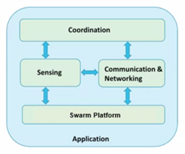

**Figure 1.** High level swarm design blocks [1].

* + 1. **System Overview**

The system consists of three quadrotors with a custom outer shell attached to each drone. Drone-to-drone and drone-to-ground communication systems will be implemented to ensure data and command transmission in the system. Each drone has one active side comprised of electro-permanent magnets, and three passive sides made of soft magnetic material. Each drone carries power electronics to regulate the magnet polarity of its active side. 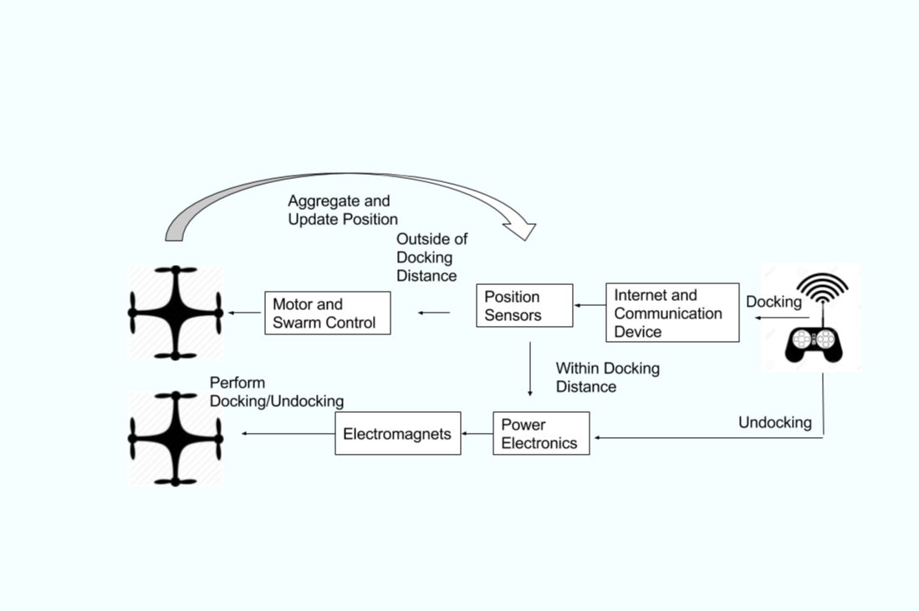

**Figure 2.** Comprehensive diagram of design block.

Figure 2 shows a comprehensive block diagram of the SkyIsland system. The ground station (i.e. remote controller), sends out projected path to drones, a command to invoke “swarm mode” and a command to initiate docking process or alternatively undocking process via drone-to-ground communication. When a docking command is transmitted, the “docking” state in the probabilistic finite state machine in swarm mode will be invoked and power electronics on two drones will send out a strong current to each electromagnet. When the undocking command is transmitted, power electronics will send strong currents flowing in opposite directions, thus reversing the polarity of the electro-permanent magnets.

* + 1. **Coordination**

Path planning with obstacle avoidance will be established on the ground station and then will be transmitted to the target drone via drone-to-ground communication. There are two envisioned path planning models; one for drones behaving independently from each other (no swarm behavior) and one for the docked drone structure. In the case of independent drones, path planning model with obstacle avoidance will be transmitted to each drone separately. When all the drones are docked mid-air, the ground station will re-assess the path for the structure to follow and convey it to the head drone. On the head drone, the implemented control systems will enable rotors on docked drones to rotate accordingly.

In case drones stray off the projected path due to an unexpected obstacle etc., the drone will reposition itself to its last location on the path prior to the obstacle.

To maintain spatial organization in the swarm, aggregation behavior will be used. A probabilistic finite state machine (PFSM) with two main states, “go” and “wait” will be implemented to ensure relative positioning and spatial organization in the swarm. Main state “go” will have two sub-states; “approach”, to move close to other drones in the swarm, and “pull back”, to move away from other drones. When the proximity conditions for docking are met, “wait” state will be invoked, and in the “wait”, docking procedure will be initiated after a small amount of waiting to dock in a specific pattern provided by the ground station. Transition between states will be based on the data disseminated via drone-to-drone communication and drone-to-ground communication and will have a stochastic component to account for random aggregation dynamics [2]. PFSM will be initiated only if the drones are in “swarm mode”, which will be activated by the ground station.

* + 1. **Sensing**

This project utilizes Infrared sensor and Infrared LED for drone alignment. Figure 2 shows the working mechanism. The relationship between signal strength (S), distance (L), and angle (θ) between IR emitter and receiver is shown in [5, eq. (1)], where the gain (a) and offset (β) are specific to the IR emitter and receiver.

S(L,θ) = a*cos(θ)/L2+β **(Eqn 1)**

θ =θe+ θr **(Eqn 2)**

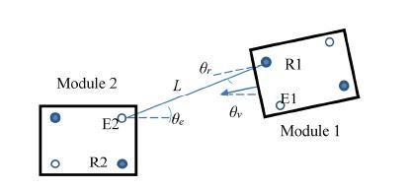

**Figure 3.** Schematic of two robotics modules, distances between IR sensors, and emitter and receiver angles.

R1 and R2 represent receivers and E1 and E2 represent emitters [5].

Signal strength decreases quadratically with distance, and the signal strength is the strongest when the emitter and receiver line up. The IR receiver model is TSOP38238 and requires a 5V input, with its wavelength sensitivity ranging from 800nm to 1100nm with peak response at 940nm. The frequency range of the sensor is 35KHz to 41KHz with peak detection at 38KHz. The typical transmission distance is 45 meters, and typical directivity is 45 degrees []. The IR LED model is IR333-A. Its peak wavelength is at 940nm, with a 20 degree beam width [].

The Ultrasonic sensor LV-EZ1 Maxbotix Ultrasonic Rangefinder will be implemented for sensor alignment. It requires input power from 2.5V to 5.5V. The sensor can detect objects from 0 to 6.54 meters, and provide sonar range information from 0.1524 to 6.54 meters with a 0.0254 meter resolution []. This project will use Ultimate GPS Version 3 for positioning. The power supply is 5V, the sensitivity is -165 dBm, and the update frequency is 10 Hz []. Figure 3 depicts the sensing components.

1. **(b) (c)**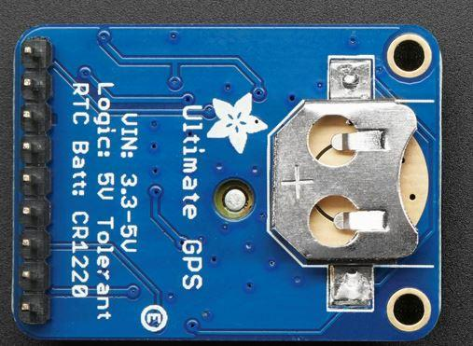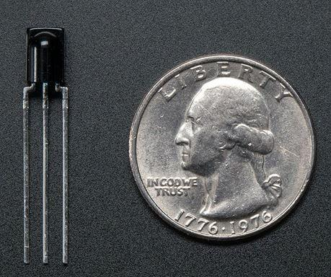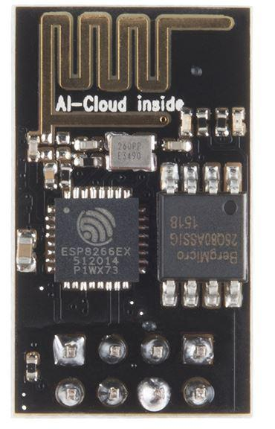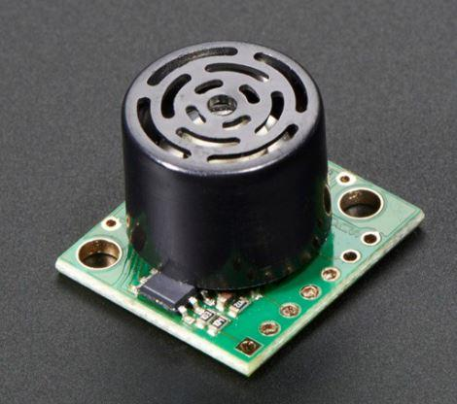

**(d) (e)**

**Figure 4.** Sensor modules proposed to use in SkyIsland. (a) IR receiver TSOP38238[] (b) IR LED IR333-A[] (c) ultrasonic sensor LV-EZ1 Maxbotix Ultrasonic Rangefinder [] (d) GPS module [] and (e) Wifi module [] .

* + 1. **Communication and Networking**
       1. **Drone-to-Drone Communication**

Decentralized drone-to-drone communications could be achieved via Bluetooth, wireless LAN or infrared [3]. Since infrared is directional, it will prove inefficient when drones are within line of sight of each other. Bluetooth is a more preferably method of drone-to-drone communication especially in areas with scarce WiFi hotspots etc. and its low power consumption constricts the power source of the drones significantly less for long-term use. On the other hand, wireless LAN has a range of approximately 300 feet outdoors in comparison to a range of approximately 95 feet bluetooth has and a significantly higher bit rate of 600Mbps, which makes it more suitable for drone-to-drone communications in larger areas, where drones might be farther away from each other [4]. Based on the disadvantages of bluetooth, a wireless LAN will be utilized for drone-to-drone communication. Depending on our communication choice, a WiFi module will be used to connect the drones to the Internet via an IEEE 802.11b wireless network.

Each drone in the swarm will be assigned an unique ID to distinguish communication routes. To simplify the drone-to-drone communication, transmission data will include only ID, position of the transmitting drone and maybe a simple command or status phrase. Conveyed data will be used by each drone for spatial positioning and path planning purposes in the swarm.

For drone-to-drone communication, the ESP8266 WiFi module will be utilized. Wake up and transmit packets exchange within 2ms. Standby power consumption is less than 1.0mW and TCP/IP is integrated into the protocol stack [9].

* + - 1. **Drone-to-Ground Communication**

Drone to ground communications will require a different RF system to ensure reliable and high-bandwidth information exchange. One system in consideration is the proprietary DJI Lightbridge technology which employs a custom 2.4 GHz radio to give a maximum transmission distance of 3 km of HD video and telemetry transmission given no obstructions and interference. Furthermore the swarm can be designed to work in conjunction to transmit from drone to drone to ground station to further increase the transmission distance of the entire system where the drone with the best signal strength will handle telemetry transmission of the entire swarm to the ground station.

* + 1. **Swarm Platform**
       1. **Drone Choice and Shell**

For the SkyIsland prototype, three modified Crazepony MINI drones will comprise of the three drone kit. The Crazepony MINI is an open-source and ultra-compact quadcopter development kit with a publicly developed and maintained Git repository. The drone comes with its own RC controller as well as Bluetooth 4.0 LE connectivity for wireless connections with smartphones and tablets. Each unit only costs $90 and is ready to fly out of the box without prerequisite assembly or configuration. Alternative choices such as the DJI F450 Naza-M Kit and the LHI 220 Quadcopter Kit were ruled out due to their high per unit pricing (>$200) for a complete and flight ready aircraft, and lack of RF transmitters/receivers which alone would cost over $60 per pair to support SkyIsland’s advanced functionalities.

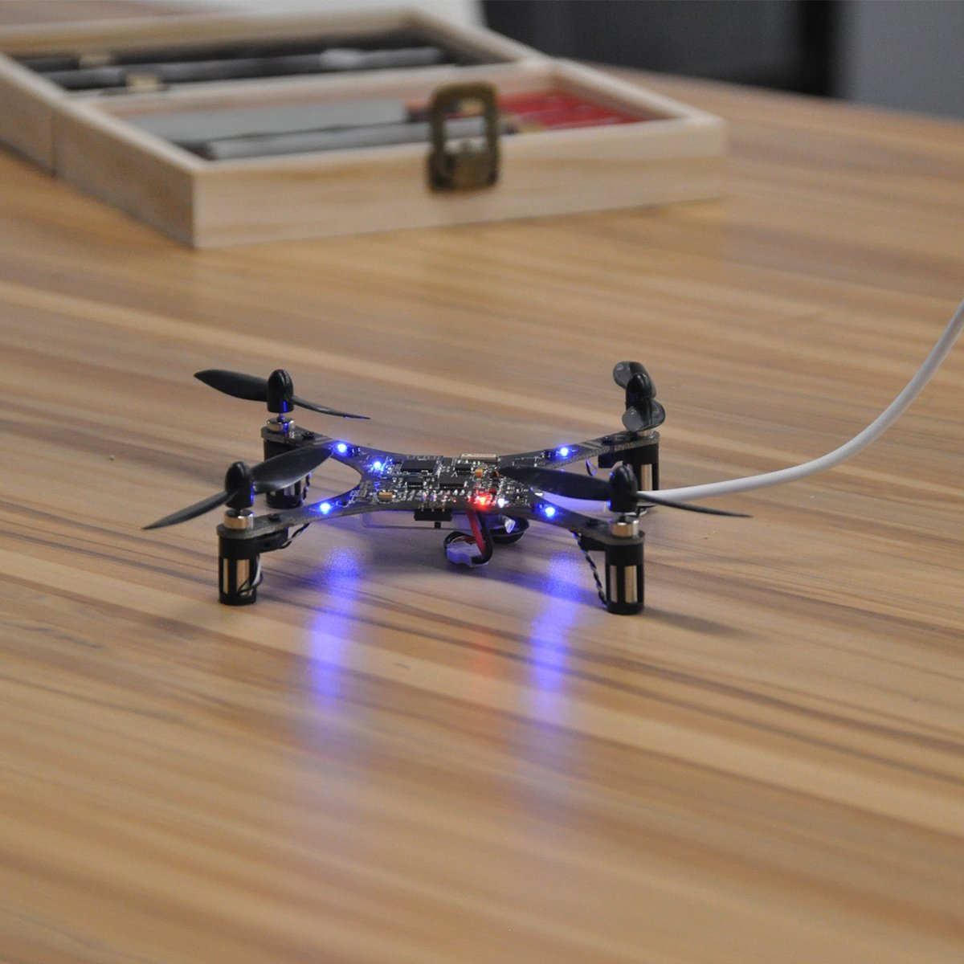

**Figure 4.** Uploading new firmware to a Crazepony MINI unit.

The physical design of this project heavily relies on the shell that the drones must have to be able to dock. This shell must host the magnets, sensors and electronics needed for the docking. The use of this shell resembles the use of a collision shield and is added to a specific compatible drone to give it the possibility to dock mid-air, and can be later removed. The criteria that most influences the design is the total weight, followed by the mechanical strength and the mechanical aids to the docking.

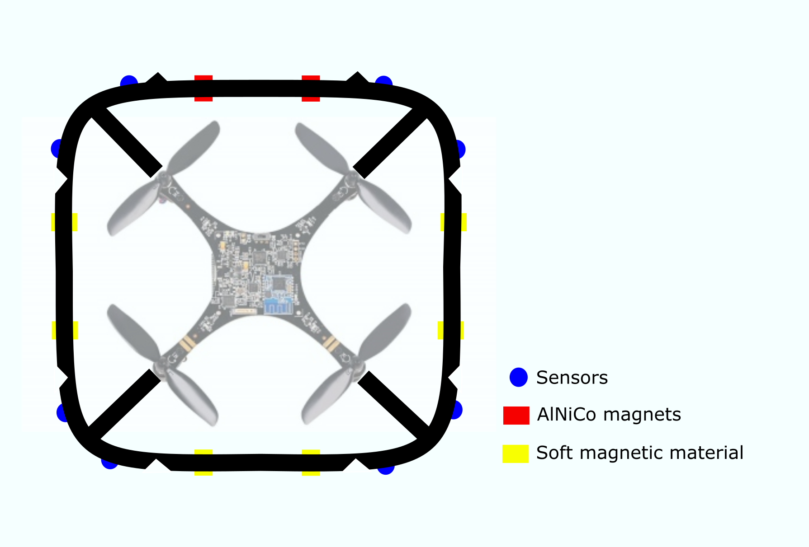

**Figure 5.** Sketch of the shell design.

* + - 1. **Magnetic Interlock Mechanism**

The interlock mechanism is an electromechanical system employed in the docking process of the system drones. The interlock mechanism uses the pulling force of an electro-permanent magnet system. An electro-permanent magnet is a magnet that can be repolarized with a short pulse of high current.

To build the magnetic drone interlock, two AlNiCo magnet rods will be held next to one another inside a a housing. The housing will be made of a soft magnetic material such as iron and will simply comprise of two plates sandwiching the AlNiCo magnets as shown in Figure 3. One of the magnets has a coil of copper wire wrapped around it forming a solenoid. This magnet structure forms forms the active site on a drone. A short pulse of current is passed through the coil creating a magnetic field that can repolarizes the AlNiCo magnet enclosed by the coil. Once repolarized, the magnet maintains its altered magnetic field properties without the need for a power source. When the coiled magnet is polarized in the same way as the uncoiled magnet, magnetic flux from both magnets adds together and flows through the soft magnets of the housing and through air around the magnets. However when a plate of soft magnet is present in the vicinity as shown in the “ON” state of Figure 3. The magnetic flux will flow through the closed soft magnet structure and a magnetic lock is achieved. This third soft magnet plate is what forms the passive site on a drone. When magnetic interlock is achieved two drones are said to be docked. However when the two AlNiCo magnets are polarized differently, the magnetic flux is contained within the two magnets and a the soft magnet on the passive site of another drone will not be attracted. In that case a magnetic lock is not achieved and the two drones are said to have undocked.

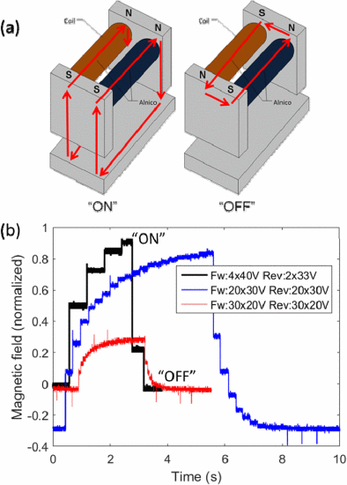

**Figure 5.**Caption.

A major part of the magnetic interlock mechanism is designing a circuit that can control the direction of current flow in the coil surrounding one of the AlNiCo magnets which allows the repolarization of the magnet. One way to control the current direction is by the use of 4 n-MOSFETs to direct the current in two directions through the same coil as shown in Figure 4. Transistors Q1 and Q3 are controlled with the same pin on the microcontroller while transistors Q2 and Q4 are controlled with the another pin on the microcontroller. To repolarize the coiled AlNiCo magnet, the generated magnetic field must be greater than than the intrinsic coercivity of the magnet. The intrinsic coercivity for a 1” cylindrical A5 AlNiCo magnet manufactured by Littlefuse is reported to be 640 Oe [6]. The current required to overcome the intrinsic coercivity is listed in **Table X** for different wire gauges along with the resistance for the required length of wire. In addition, the power dissipated by the coil wire is also calculated. Appendix D lists the equations used to create the table along with relevant constants. The table will be used during wire gauge testing and optimization depending on the available copper wires and maximum current tolerated by the overall system. If the voltage drop needed to create the repolarization field is unattainable, a DC-DC converter will be used to step up or step down the voltage to required level.

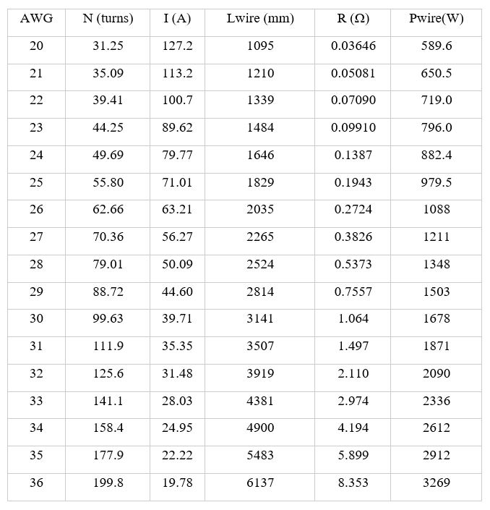

**Table 3.** Add figure caption.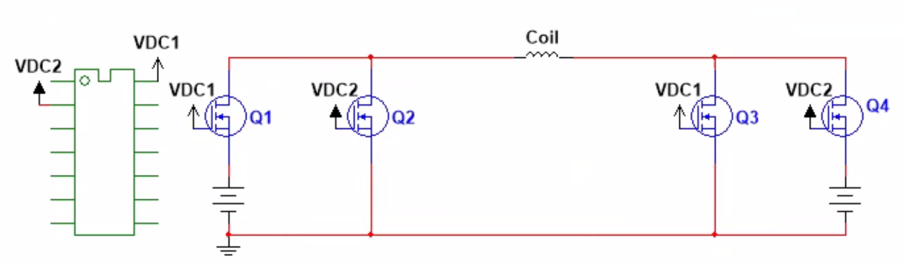

**Figure 6.**Caption.

* + - 1. **Control**

The control system of this project is going to be based on a 12 dimensions state space. The goal is to be able to control the position with 3 cartesian coordinates (x, y, z), the orientation with 3 angular coordinates (α, β, γ) and all their derivatives. These variables are arranged on a vector called state and the change on the state is calculated with the influence of the current state on a matrix A and the influence of the input to the actuators on a matrix B as we see on the equation.

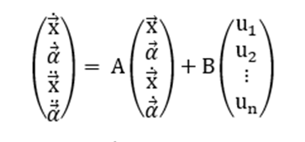

The matrices A and B are calculated according to the mathematical model of the system and the Euler-Newton equations [X].

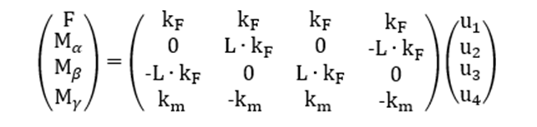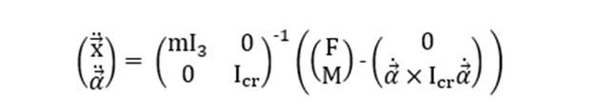

These equations model any generic dynamic system. The system on this project may have any number of motors starting from four. And there will be magnetic forces on the docking and undocking procedures. To account for these factors we generalize the equations.

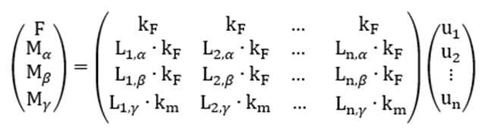

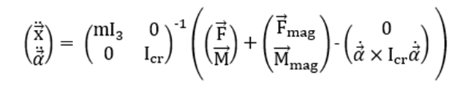

To optimize the response, a cascade controller is implemented to divide the model in two. The outer controller reads a cartesian position and calculates a reference value for roll, pitch, and the vertical velocity (α, β, z’). The inner controller takes those values and a desired yaw (γ) and calculates the input (u1, …, un) to each motor on the system.

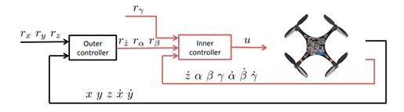

**Figure 7.** Cascade control diagram.

* + - 1. **Human Machine Interface**

The human machine interface (HMI) of the SkyIsland system will utilize a simple RC controller with a basic LCD display showing essential telemetry coupled with the smartphone or tablet device to display the first-person-view (FPV) feed and other more advanced features. Using a touch display readily available in a smartphone or tablet will allow for maximum flexibility and update serviceability in the graphical user interface (GUI) while the analog joysticks on the RC controller coupled with the smartphone or tablet device will provide the system operator with the proper ergonomics and fine-tune control for manual and semi-autonomous flight. Figured below is one such example of proposed HMI built by DJI.

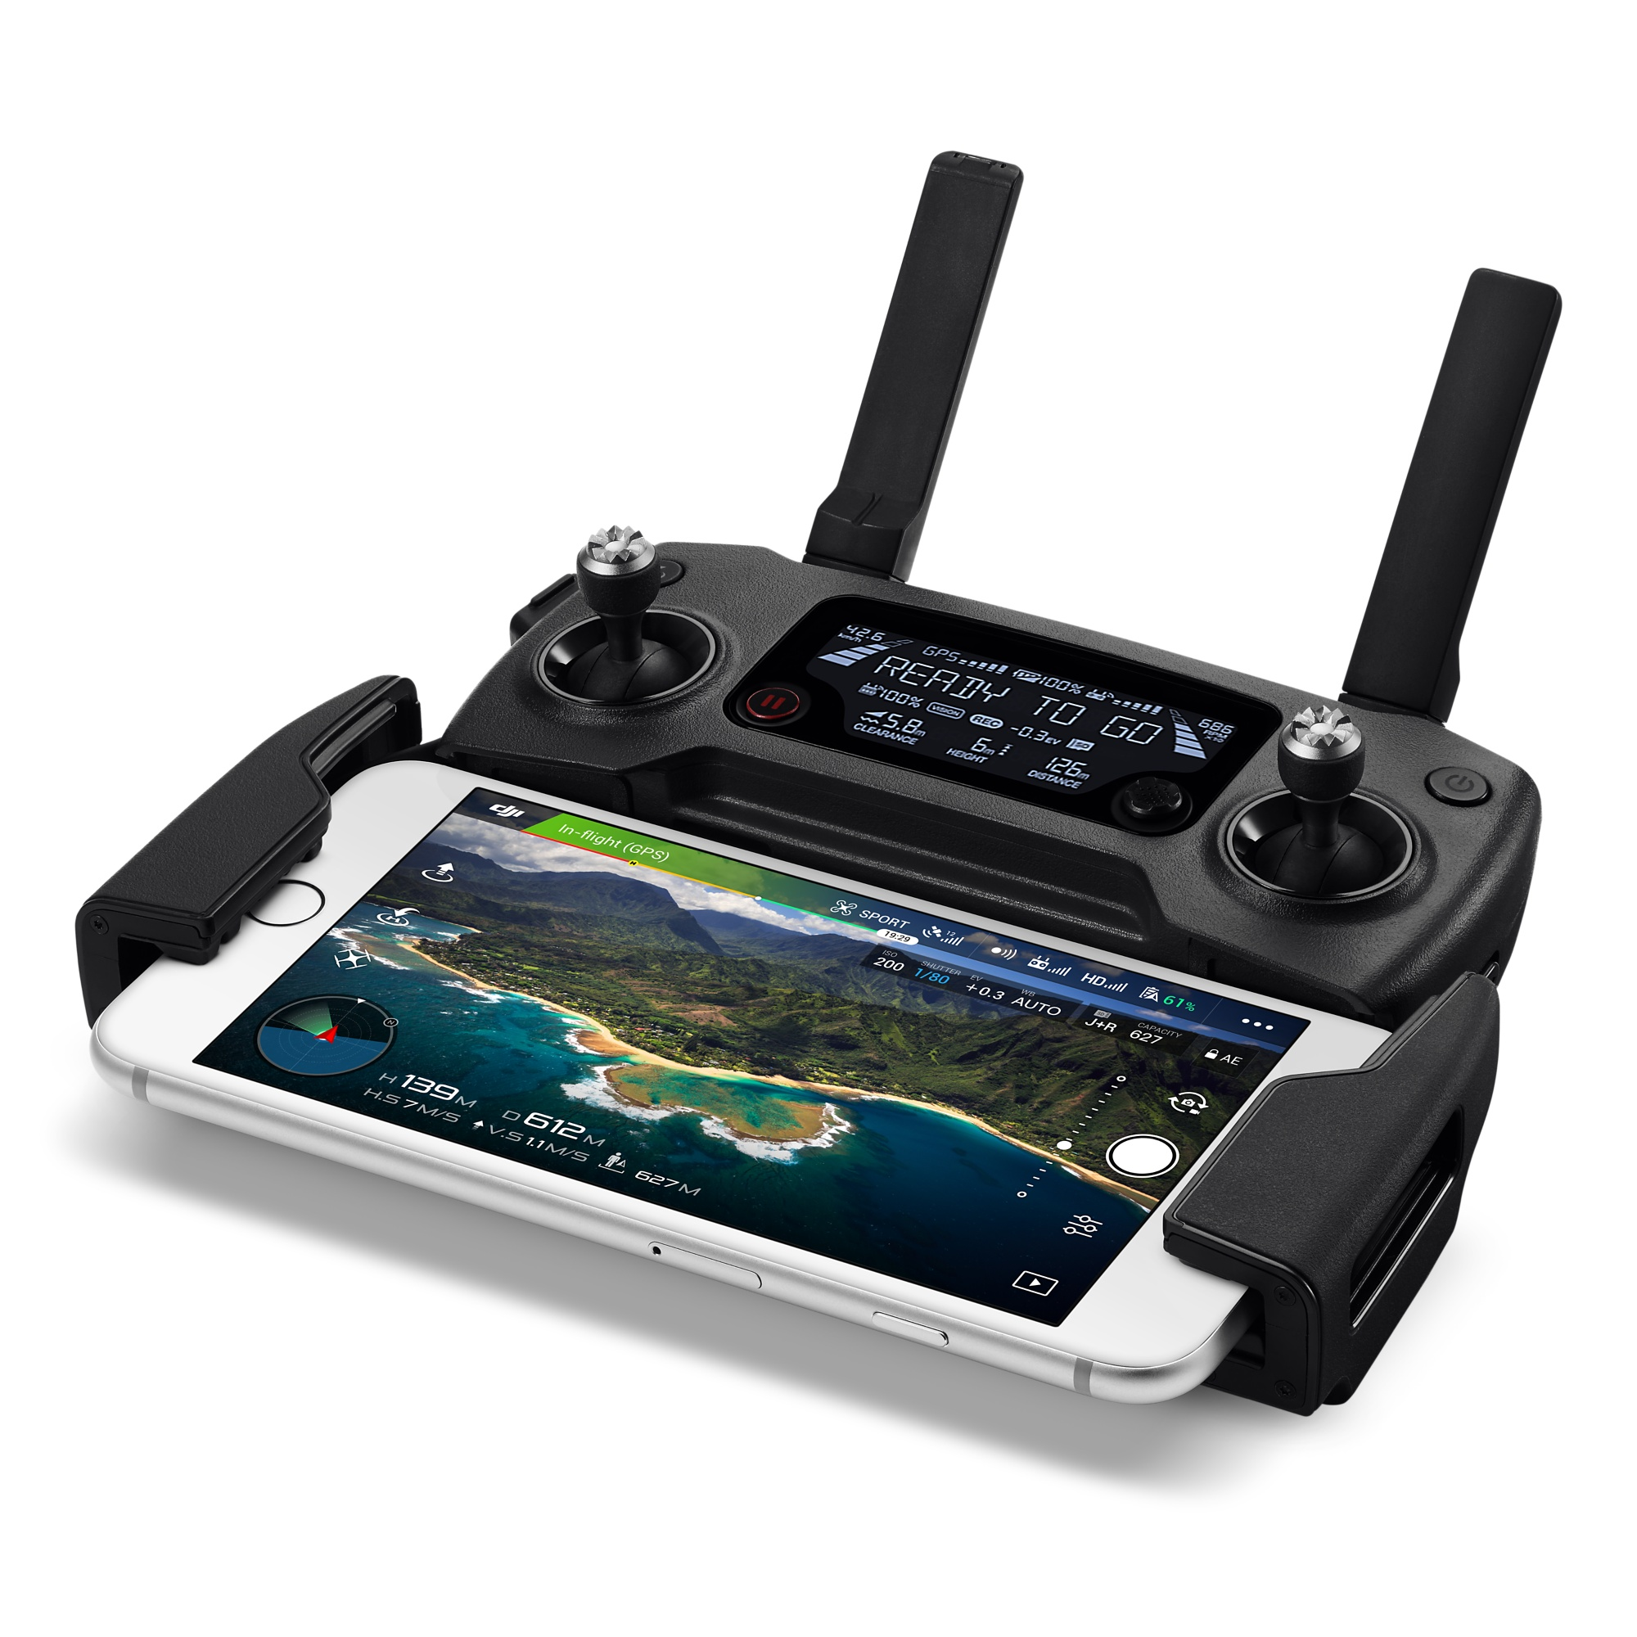

**Figure 7.** DJI Mavic Pro remote controller coupled with an iPhone providing the drone FPV feed and advanced functionality.

* 1. **Codes and Standards**

1. The Inter-integrated Circuit (I2C) Protocol will be employed to allow multiple digital integrated circuits/chips to communicate with one or more master chips.
2. Bluetooth protocol will be used for short-range, low-power, low-cost, wireless transmissions between electronic devices.
3. GPS protocol will be adopted for relative positioning.
4. TCP/IP , UDP and DJI Lightbridge protocols will be used for communication purposes.
5. UAS NOTAM FDC7/7282 defines a restricted airspace for flight, and is utilized to determine drones of choice.
6. IEEE 802.11b will be used to provide Internet access to each drone and enable drones to disseminate information among themselves.
   1. **Constraints, Alternatives, and Tradeoffs**

Alternatives for drone-to-drone communication are WiFi and Bluetooth networks. A WiFi network provides a greater range of 300 feet outdoors in comparison to a Bluetooth range of approximately 95 feet indoors and WiFi has a greater bit-rate than Bluetooth. A Bluetooth system is best suitable for close-range applications and has lower power consumption compared to WiFi. A disadvantage of Bluetooth over WiFi is that Bluetooth is more susceptible to interference, causing it to be less efficient outdoors.

Drone-to-ground communications require expensive and high powered RF systems for the aircrafts to maintain connectivity in ranges above 1 km. For the prototyping and demonstration phase of the project, a cheap short range solution will be adopted with the Crazepony MINI’s Bluetooth LE serial interface and 2.4 GHz low-power radio working in conjunction for basic flight controls and flight telemetry collection. These two solutions are low-cost and are already integrated with the Crazepony MINI as shipped from the manufacturer, but could only support an operating range of up to 100 meters.

The choice for magnetic interlock was driven by how lower power consumption could be achieved. Electromagnets are widely used and are readily available but they require constant current supply during operation. An electro-permanent magnet, however, only requires a high current impulse to flip its polarity and then it maintains its new state which is more effective in terms of power consumption.

1. **Schedule, Tasks, and Milestones**

Appendix A, lists all tasks and major milestones, team member(s) assigned to each specific task, and risk levels of these tasks. Appendix B contains a comprehensive Gantt chart presenting the timeline of the project. In Appendix C, a comprehensive PERT chart is presented to outline the critical paths and risks associated with each task.

1. **Project Demonstration**

A demonstration of full project functionality will include swarm flight, docking procedures, a docked flight and undocking procedures, all in one exercise. To demonstrate the search and rescue abilities of the system, a small object will be located and retrieved on the exercise. As this presentation serves as a proof of concept, and not a finish product, the demonstration will include a human intervention if necessary.

Before getting to this point two previous demonstrations are required, a docking demonstration on the ground to prove the design and implementation of the docking mechanism, electronics and sensors along with a simulated flight on MATLAB to validate the software and the control system.

1. **Marketing and Cost Analysis**
   1. **Marketing Analysis**

There are currently no competing products in the market today which would mirror the aerial docking capabilities of the SkyIsland platform. However, there are two rising commercial autonomous drone platforms which can compete against the swarm capabilities of SkyIsland. However, these competitors lack the flexibility, modularity, and on-mission reconfigurability that SkyIsland provides [F1, F2]. Current competing systems only provide swarm/fleet management and autonomous docking with a charging dock at the ground station [F1, F2]. For search and rescue as well as aerial reconnaissance applications, SkyIsland offers unparalleled flexibility for operators to execute flight missions as efficiently as possible.

* 1. **Cost Analysis**

The team consists of five engineers working at an hourly rate of $45.00 part-time. Assuming a 6 hour weekly individual workload, the weekly personnel operating cost for the project comes out to be $1350.00 spanning over a period of 12 weeks for a total personnel cost of $16200.00 to develop the product. The drones can be reasonably acquired for $200.00 per unit, upgrading from the $90.00 unit cost of the prototype drones. The improved drones should comprise of a more power RF transmission and receiver system as well as an upgraded FPV gimbal camera system. The SkyIsland system will be sold in kits of three individual drones which would put the material costs at $600.00 per kit. The cost of software development for the system is folded into the personnel cost as open-source toolsets will be utilized. In order to achieve reasonable market penetration, the SkyIsland kit will be priced at $1600.00 at launch. A total of 16 units of the kit will need to be sold in order recuperate the costs of R&D and materials.

|  |  |  |  |
| --- | --- | --- | --- |
| **Labor Type** | **Salary (USD/Hr)** | **Weekly Hours** | **Total Cost (USD)** |
| Individual Work | $45 / Hour | 4 Hours | $180.00 |
| Group Work | $45 / Hour | 2 Hours | $90.00 |
| Total Work / Member | $45 / Hour | 6 Hours | $270.00 |
| **Total Project Labor** | **$225 / Hour** | **6 Hours** | **$1350.00** |

**Table 4.** Project labor breakdown and associated costs.

|  |  |  |  |
| --- | --- | --- | --- |
| **Part Description** | **Quantity** | **Unit Price (USD)** | **Total Cost (USD)** |
| Crazepony MINI | 3 | $90.00 | $270.00 |
| IR receiver TSOP38238 | 3 | $1.95 | $5.85 |
| IR LED IR333-A | 3 | $0.40 | $1.20 |
| Wifi Module ESP8266 | 3 | $6.95 | $20.85 |
| Ultimate GPS Version 3 | 3 | $39.95 | $119.85 |
| AlNiCo Magnets | 12 | $2.63 | $31.56 |
| Drone RF System Upgrades | 3 | $50.23 | $150.69 |

**Table 5.** Individual SkyIsland kit component costs.

|  |  |
| --- | --- |
| **Project Component** | **Cost (USD)** |
| Labor | $16200.00 |
| Prototype Materials & Parts | $600.00 |
| **Total** | **$16800.00** |

**Table 6.** Projected total development costs.

1. **Current Status**

Individual research (on drone, sensor parts, magnets, and power electronics) and project proposal have been 100% completed and on time. The next step on the timeline is to make a presentation on our project proposal to our faculty advisor Dr. Hasler and order parts. The team already contacted Dr. Hasler to set up a date and time for proposal presentation.

1. **References**

Introduction

[1] Daniel Briggs Wilson et al., “Guidance and Navigation for UAV Airborne Docking”, Robotics: Science and Systems, 2015.

[2] Kelsey D. Atherton. (2016, February), DroneBox is A Nest For Drones [Online]. Available:

https://www.popsci.com/dronebox-is- nest-for-drones

[3] Senseable City Lab (2017). Sea Swarm. [online] Available at:

http://senseable.mit.edu/seaswarm/index.html [Accessed 22 Oct. 2017].

[4] D. Rus, J. Romanishin, K. Gilpin, “Modular Angular-Momentum Driven Magnetically

Connected Robots,” U. S. Patent 14, 067,132, 9 Oct., 2014.

[5] Peter Won et al., “Development of an Effective Docking System for Modular Mobile Self-

Reconfigurable Robots Using Extended Kalman Filter and Particle Filter”, Robotics, vol. 4, pp. 25-59,

2015.

[6] Q. Quan, “Thrust and moments model on multicopters,” in Introduction to

multicopter design and control, Springer, Singapore, 2017, pp-128.

[7] Dronecode Project Inc. (2017, 10/24/2017). PX4 Pro Open Source Autopilot. Available:

<http://px4.io/>

[1] E. Yanmaz, S. Yahyanejad, B. Rinner, H. Hellwagner and C. Bettstetter, “Drone Networks: Communications, coordination and sensing”, *Ad Hoc Networks*, vol. 68, pp 1-15, January 2018. [Online serial], Available:<http://www.sciencedirect.com/science/article/pii/S1570870517301671> [Accessed Nov. 25th, 2017].

[2] N.E. Shlyakhov, I.V. Vatanamiuk, A.L. Ronzhin, “Survey of Methods and Algorithms of Swarm Aggregation”, *Journal of Physics: Conference Series*, from *International Conference on Information Technologies in Business and Industry 2016*, 2017. [Online Serial], Available: <http://iopscience.iop.org/article/10.1088/1742-6596/803/1/012146/pdf> [Accessed Nov. 26th, 2017].

[3] “Swarm Communication”. [Online], Available:<http://www.swarmrobot.org/Communication.html> [Accessed Nov. 25th, 2017].

[4] “Bluetooth vs. WiFi”, Nov. 14th, 2017. [Online], Available:<https://www.diffen.com/difference/Bluetooth_vs_Wifi> [Accessed Nov. 25th, 2017].

[5] M. Deffenbaugh, E. Buzi, L. Al-Maghrabi, G. Ham, H. Seren and G. Bernero, "An untethered sensor for well logging," 2017 IEEE Sensors Applications Symposium (SAS), Glassboro, NJ, 2017, pp. 1-5.

[6]

Magnet Calculations

“Wire Gauge and Current Limits Including Skin Depth and Strength,” *PowerStream*. [Online]. Available:<https://www.powerstream.com/Wire_Size.htm>. [Accessed Nov. 29, 2017].

Littlefuse, “Magnetic Actuators,” H34 series datasheet. [Online]. Available:<http://www.littelfuse.com/~/media/electronics/datasheets/magnetic_actuators/littelfuse_magnetic_actuators_datasheet.pdf.pdf>. [Accessed Nov. 29, 2017].

**Appendix A: Task Distribution**

|  |  |  |
| --- | --- | --- |
| **Task Name** | **Task Lead1** | **Risk Level** |
| **Planning, Documentation and Presentations** | All | Low |
| Research on drones | All | Low |
| Research on sensor parts | All | Low |
| Research on magnets | All | Low |
| Project Proposal | All | Low |
| Proposal Presentation (for parts) | All | Low |
| Ordering parts | All | Low |
| Final Project Presentation | All | Low |
| Final Project Demonstration | All | Medium |
| Final Project Report | All | Low |
| **Docking Mechanism Design** | All | Medium |
| Building magnet interlock | LA | Low |
| Power electronics and circuit design | LA | Medium |
| Sensor-based alignment design | JL, AIV | Medium |
| **Ground Testing** | All | Medium |
| **Prototyping** | AIV, AE, JL,LA | Low |
| Shell Assembly | AIV | Low |
| Sensor Implementation | JL, AIV, AE | Low |
| Power electronics implementation | LA | Medium |
| **Control Design and Implementation** | AIV, AE, JL,LZ | Medium |
| Stability Control | AIV | Medium |
| Drone-to-Drone Communication | AE, LZ | Low |
| Swarm Control | AE | Low |
| Path Planning | AIV, AE | Medium |
| Docking Control | AIV, JL | High |
| Simulation Testing before implementation | All | Medium |
| **Software Integration** | LZ, AIV, AE | Low |
| Communication Protocol | LZ, AE | Low |
| Human Machine Interface (HMI) | LZ | Low |
| Controls | LZ, AIV, AE | Low |
| **Testing and Optimization** | All | High |
| Indoor Testing | All | Medium |
| Field Testing | All | High |

[1]

**Appendix B: Comprehensive Gantt Chart**

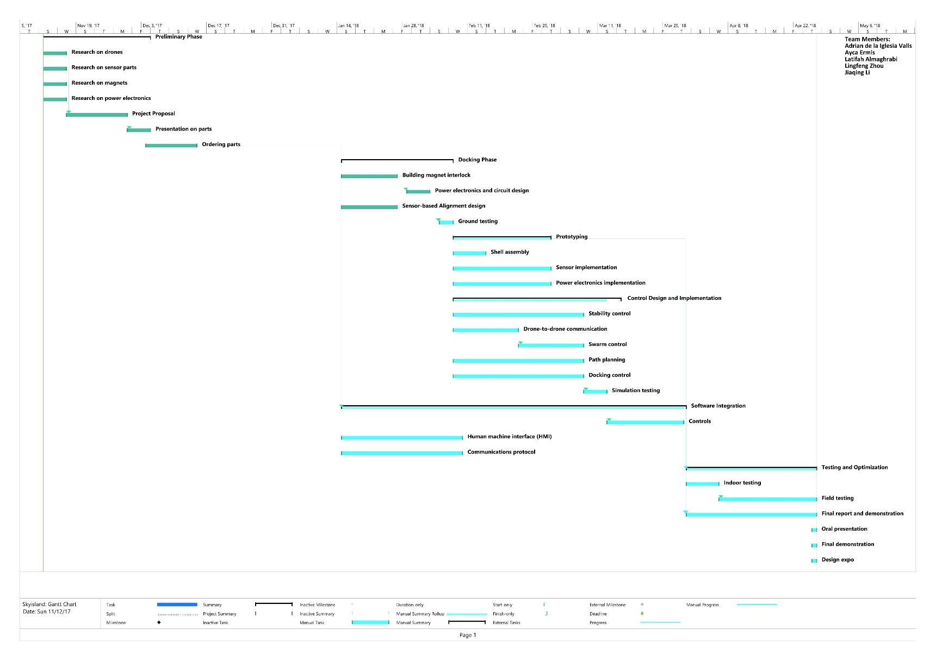

**Appendix C: Comprehensive PERT Chart**

Add the pic CPM2

**Appendix D: Coil Calculations**

1. AIV: Adrian de la Iglesia Valls, AE: Ayca Ermis, JL:Jiaqing Li, LA: Latifah Almaghrabi, LZ: Lingfeng Zhou.