Smart Medication Adherence Phone Case

Section A05, Smart Medication Adherence Phone Case Team
ECE 4011 Senior Design Project

Project Advisor, Dr. Maysam Ghovanloo
and Dr. Kevin Murnane

Kedeng Pan, kedengpan@gatech.edu
Xiannan Di, dixinananben@gatech.edu
Xingyuan Zhu, xzhu75@gatech.edu
Yuhao Lin, ylin354@gatech.edu
Zhipeng Shao, ryanshao@gatech.edu

Submitted
01.25.2018
Table of Contents

Executive Summary 3

- Introduction 4

  - Objective 4
  - Motivation 5
  - Background 5

- Project Description and Goals 7

- Technical Specification 8

- Design Approach and Details

  - Design Approach 12
  - Codes and Standards 16
  - Constraints, Alternatives, and Tradeoffs 17

- Schedule, Tasks, and Milestones 18

- Project Demonstration 19

- Marketing and Cost Analysis 20

  - Marketing Analysis 21
  - Cost Analysis 22

- Current Status 24

- References 25

Appendix A 28

Appendix B 29

Appendix 30
Executive Summary
Adherence to medical product has been proved efficient to user’s health. However, a considerable number of patients are not taking medicines regularly. Thus, a portable and cost-efficient medical dispensing device, the Smart Medication Adherence Phone Case, is being proposed. The Phone Case is a small pill tray integrated as a phone case and attached to an Android smartphone. It can automatically dispense pills via the Bluetooth control from the Android application and record the medical taking behavior back to the smartphone application. Once logged with medical adherence information, the smartphone application will remind the user to take medicines at proper time by sound, vibration and camera flashlight. The Case is designed to be able to dispense pills piece by piece automatically. LED and photosensors on the Case would detect the pill-dropping occurrence and log it into the smartphone app. The system will also record necessary GPS information of the medical taking occurrences. Linked with medical center and family members, the Phone Case will be a great assistant for elderly people in case of emergency. With considerations of parts and services being used, the cost of this device would be approximately $80. The final outcome of this project will be a fully functional prototype of the Smart Medication Adherence Phone Case and potentially some user feedbacks.

Smart Medication Adherence Phone Case
1. Introduction
Smart Medication Adherence Phone Case is a convenient and cost-efficient solution that dispenses medications to patients and monitors their medication adherence conditions. The solution consists of a Pill-Dispensing Phone Case and an Android application. The team requests $500 to develop a prototype for the Phone Case.
  - Objective
The team is to prototype a medication dispensing and monitoring system. Through this system, a patient can retrieve dispensed medications from the Pill-Dispensing Phone Case, and refill medications to it upon approval from the Android app. Using the sensors built-in on the Android smartphone, the Android app is biometrically accessible: it can recognize a patient’s fingerprint to allow further access. The app enables a patient to input the dose and time for his or her medications, set and receive reminders, and monitor individual medication adherence data. The Phone Case communicates with the Android app via BLE (Bluetooth Low Energy) protocol.
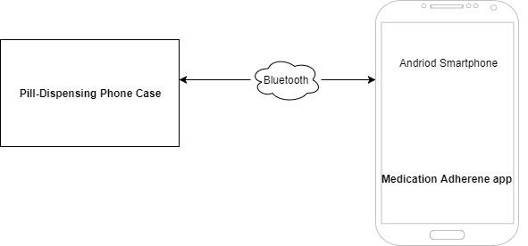
Figure 1. System overview block diagram of Smart Medication Adherence Phone Case.
  - Motivation
Pharmaceutical compliance is a huge medical issue nowadays. Research shows that “between $100 and $300 billion of avoidable annual healthcare costs” attribute to patients to taking their medications on time [1]. The project aims at building a low-cost medication adherence system that separates from other expensive, bulky pill-dispensing products on the market. The team decides to take advantage of the popularity of today’s smartphones and reuse their built-in sensors. This not only reduces cost significantly, but also trims down the physical size of the Pill-Dispensing Phone Case. The final product targets at patients, especially seniors, who need to adhere to their medications on a daily basis. The Pill-Dispensing Phone Case makes for a convenient add-on gadget to their smartphone. Therefore, patients can carry their medications around and still easily adhere to their medications regardless of their physical locations.
  - Background
Many commercial products that aid patients’ medication adherence are already on the market. However, extensive research conducted by the team shows that logging, pricing, and physical size are usually the drawbacks for the existing products.
1.3.1 Smart Wireless Pill Bottles
AdhereTech builds a “smart” bottle that senses the amount of medication inside the bottle and updates the value to the cloud server [2]. Furthermore, the OS software API offered by the company leads to an integration of hardware, mobile software and medication platforms. The retail fee is about two dollars each. Another type of pillbox, called uBox, is owned by Abiogenix [3]. It connects to schedules and calendars stored on user mobile devices. At the beginning of dosing time, it unlocks itself and automatically supplies desired medicine. This feature prevents accidental overdosing. The product does not retail; instead, the company cooperates with insurance company, clinical center and pharmacy to supply a complete solution that covers from the beginning of prescription to the end of recovery. Compared to the proposed solution by the team, AdhereTech’s smart pill bottle is as conveniently portable, but there is no mobile application with which a patient can log and track their adherence data.
1.3.2 Philips Medication Dispensing Service
Philips’ Medication Dispensing Service is a subscription-based, pill-dispensing machine. It can hold up to 60 cups of medication and dispense medications according to schedule [4]. The overall size of the Philips dispenser is comparable to that of a water boiler. The large size is due to a spinner mechanism inside the dispenser, and a reservoir bank that holds medications not taken on time, preventing overdose. The Dispenser requires connection with a home telephone in order to send out notification to caregivers when patients miss their medications. There is a one-time installation charge of $100 and a monthly $59.95 subscription fee. Compared to the proposed solution by the team, Philips pill-dispenser is immobile and unaffordable. Despite being a complete product, Philips Dispenser is not a viable solution for the majority of patients, such as seniors, who need strict medical adherence.

2. Project Description and Goals
The final solution consists of two major components: first, a Pill-Dispensing Phone Case, and second, an Android application.
The Pill-Dispensing Phone Case is expected at a dimension similar to an eyeglass case. It includes a 3D printed container and a dispenser inside. The dispenser is made up of an nRF52 microcontroller board by Adafruit that enables Bluetooth communication with smartphone, a rechargeable lithium ion battery power supply, a spring-based dispenser mechanism and physical space for three parallel pill storage channels (potentially fitting pills of three different dimensions).
The mobile app will be developed on the Android platform. The Android app integrates a user-friendly GUI through which patients are notified timely for their medication and their adherence data are recorded.
General Features
- Phone Case that dispenses medications and records medication adherence data
- Physical components required to prototype the Phone Case is around $80
Pill-Dispensing Phone Case
- Holds and dispenses medications to patients on schedule
- Communicates with Android app by BLE
Android App
- Notifies patients to take medications
- Monitors medication adherence data
- Biometrically controlled through fingerprint sensor on smartphone
- Technical Specifications
  - Adafruit Feather nRF52 Bluefruit LE
Table 1 contains product specification for Bluetooth Low Energy board with a native-Bluetooth chip, the nRF52832, implemented on the phone case.
Table 1. Adafruit Feather nRF52 Bluefruit LE Specification
Item | Specification
Core | ARM® Cortex®-M4 32-bit processor with FPU, 64 MHz
Power | 1.7 V–3.3 V voltage input; up to +4dBm output power
Memory | 512 kB flash/64 kB SRAM
Transceiver | -96 dBm sensitivity in Bluetooth low energy mode
Pinout | 9 GPIO, 8 x 12-bit ADC pins, up to 12 PWM outputs (3 PWM modules with 4 outputs each)
Dimension | 2.0" x 0.9" x 0.28" (51mm x 23mm x 8mm)
Supporting OS | Android, iOS, Mac OS X, Windows 8+

  - Dispense Mechanism
Table 2 contains design specification for dispense mechanism.
Table 2. Dispense Mechanism Specification
Item | Specification
Storage dimension of output pill | 0.5 cm(l) x 0.5 cm(w) x 1 cm(h)
Digital input | 0 or 1 (close or open)
Pill dispensing wait time | 5 ± 0.5s

  - Phone Case
Table 3 contains design specification for pill dispenser phone case.
Table 3. Pill Dispenser Phone Case Specification
Item | Specification
Input pill maximum | 30
Dimension | Top container: 10 cm(l) x 5 cm(w) x 2 cm(h)  Bottom dispenser: 2 cm(l) X 5 cm(w) X 2 cm(h)
Dispense speed | 5 s/pill
Temperature | 0 ℃ to 50 ℃

  - Samsung Galaxy S6
Table 4 contains product specification for a target smart phone example.
Table 4. Samsung Galaxy S6 Specification [5]
Item | Specification
Weight | 150g / 5.291 oz
Dimension | 146.81 x 73.41 x 8.64 mm / 5.78 x 2.89 x 0.34-inches
OS | Android 5.0.2 Lollipop with TouchWiz
Sensors | Accelerometer, ambient light, barometer, compass, gyroscope, hall, heart rate monitor, HRM, proximity, fingerprint sensor
Battery | 3500 mAh

  - Android App Specification
Table 5 contains design specification for smart pill phone case android app interface.
Table 5. Android App Specification
Item | Specification
Function page | 10
Connection type | Bluetooth Low Energy
Dimension | Device dependent fullscreen
Additional function | GPS device tracking  Speaker reminder  Camera flash light reminder  Phone vibration reminder  Fingerprint scanner

- Design Approach and Details
  - Design Approach
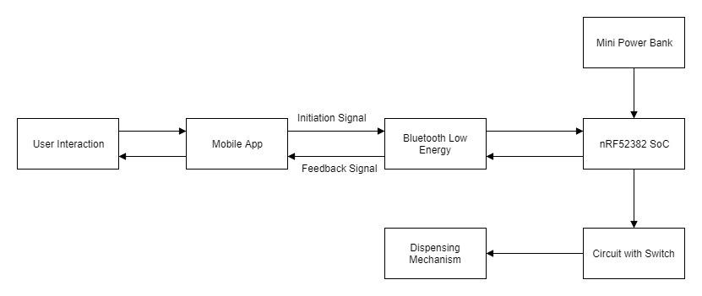
The Smart Medication Adherence Phone Case consists of three major components: the physical phone case with a smart-phone attached to it, the microcontroller that is responsible for monitoring and controlling the state of phone case and a mobile app that will provide a user interface and interacts between the user and the Medical Adherence Phone Case.
Figure 2. Block Diagram of System of Signals
4.1.1 Physical Phone Case
The smart pill dispenser will be in the form of a phone case so that the users are able to carry the important pills with them as long as they carry their smartphones. The case will consist of two layers. The container in the top will be embedded with the microcontroller which connects to the dispenser in the bottom. As a result, the medical adherence phone case will be larger than the normal cases due to the nonnegotiable microcontroller size. Potential PCB board with microcontroller chip mounted will be designed to reduce the device size. The bottom layer will be the pill dispenser that contains a switch that controls the output gate. After receiving the command to deliver pills, the dispenser will be able to control the exact number of pills going out and provide feedback to the microcontroller. Details about the dispensing mechanism will be discussed further. The fabrication of the phone case will be achieved with 3-D printing of polycarbonates.
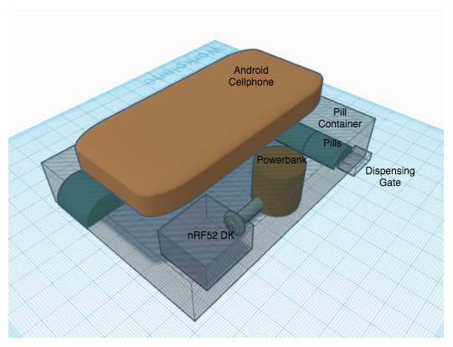
Figure 3. Prototype model CAD of Medical Adherence Phone Case
4.1.2 Microcontroller
The microcontroller implemented to control and monitor the behavior of the physical cases will be nRF52832 Feather board designed by Adafruit. It features the nRF52832 SoC, all I/O access via connectors and a Bluetooth Low Energy compatible radio[6]. A simple circuit connection will be built around it along with the switch mechanism that enables the control of the dispenser.
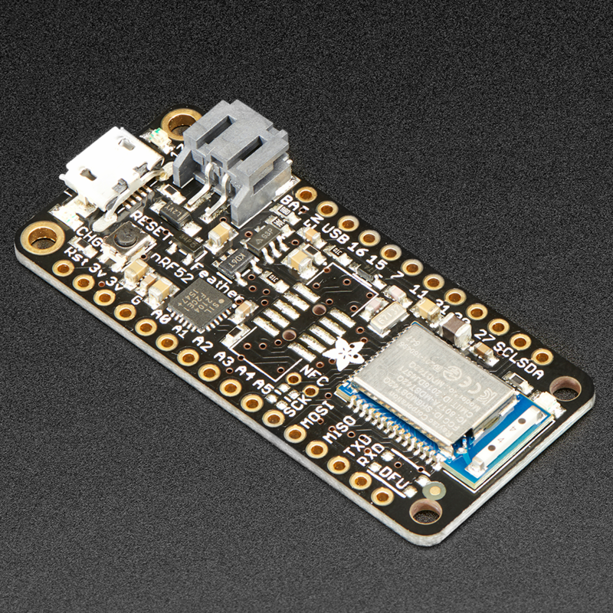
Figure 4.Adafruit nRF52 Bluefruit LE Board
Wireless Communication
A wireless communication channel will be established between the microcontroller and the smartphone with Bluetooth low energy. The nRF52832 SoC incorporates with 2.4GHz radio technology that supports multiple protocols including Bluetooth low energy. Meanwhile, most modern-day smartphones also obtain built-in Bluetooth modules. The board also has a micro-USB interface which enables the microcontroller to be connected to PC, allowing further programming and debugging. The microcontroller will be programmed to take charge of receiving the digital signal of enabling the dispenser and transmitting feedback signal with the information regarding states of the dispenser and result of actions back to the phone. The mobile app will then react according to the feedback signal: whether log the successful dispersion or warn the user about failure actions.
Power Supply
The Adafruit nRF52 Bluefruit LE will operate between 1.7v to 3.3v and the most common form of power supply will be thorough the on board power management circuitry. As a result, a rechargeable lithium ion battery is chosen to be the power supply of the board.

Contingency Plan
The combination of Bluetooth low energy communication and portable power supply is the priority plan. However, if such approach does not work due to some technical issues, the contingency plan will be to connect the microcontroller directly to the smartphone using its micro-USB port. This design provides power supply and allows signal transmissions simultaneously. However, it will have a trade-off that additional cables will be needed, and the only port of smartphone will be in requisition, preventing connections of the phone to either PC or power supply.
4.1.3 Mobile App
All user’s interactions with Medical Adherence Phone Case will be through the mobile App. After the user or medical provider input the treatment and pill-taking schedule, the App is responsible to send push notifications to notify the user to take medicine at exact times. The app will then transmit the signal wirelessly to microcontroller with the users’ permission to initiate a pill-dispensing action. After receiving the feedback signal from the microcontroller, the App will either record this specific action if it succeeded or report an error if the dispenser fails. A full copy of users’ pill-taking behavior will be stored locally in the app.
The platform chosen to implement the prototype is Android with Samsung Galaxy S6 phone. Android Studio provides the SDK necessary to build an Android App. The SDK also grants the developing app to access the Bluetooth device connected to the phone. In addition, Samsung Galaxy S6 includes multiple sensors that can be used to enhance the user experience. Fingerprints scanner will be used for identity checks, granting only specific people to have access to the pills inside the phone case. Furthermore, speakers will alarm the user to take the medicine while GPS location service of the phone can help the user to find their Phone Case from other devices.

GUI
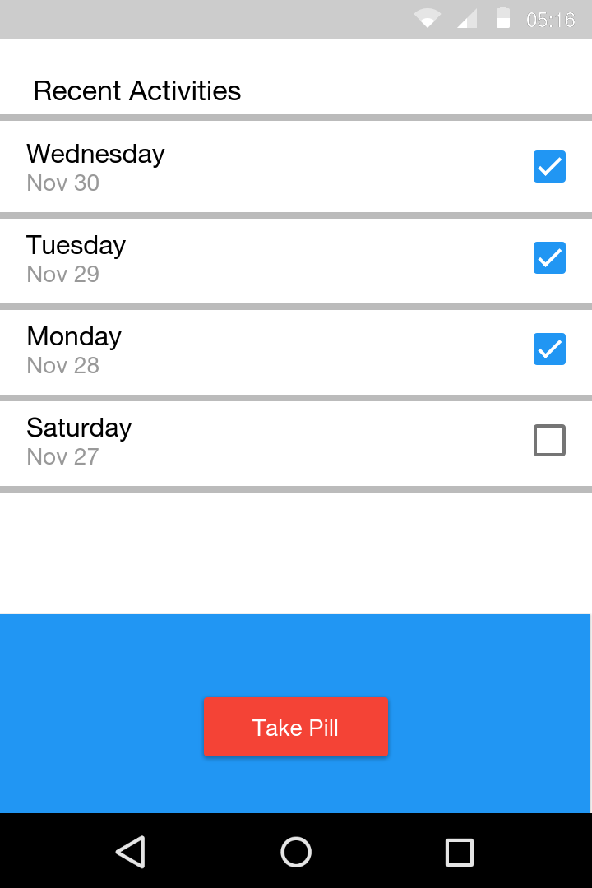
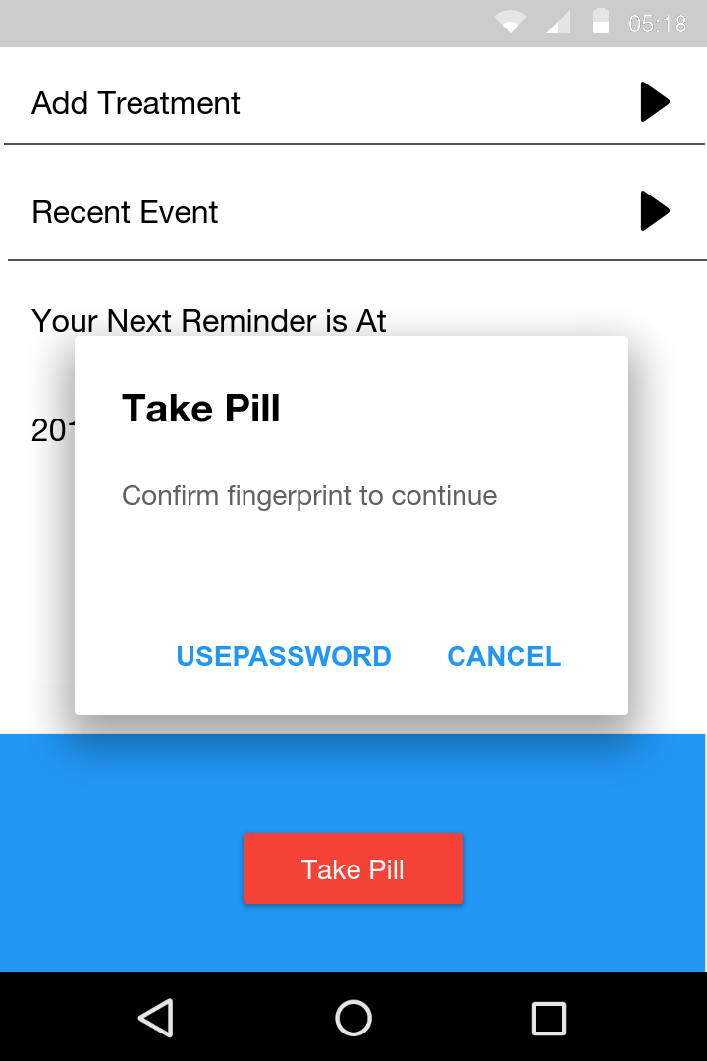
The Graphic User Interface(GUI) is designed to be intuitive and user friendly. It will display next pill-taking time and recent pill-taking behaviors. It will also have an interaction page where users can initiate a pill-dispensing action. If there is a reminder or an error reported, a push notification or an in-app alert will pop up to inform the user the state of the device. Figure ? represents a simple idea of the app GUI.
Figure 5. Potential App GUI Design
  - Codes and Standards
- Wireless communication will be established between the smartphone and nRF52382 microcontroller via Bluetooth 5, it features:
  - 4 discrete data rates speeds with maximum speed of 2Mbs,
  - 2.4GHz ISM (Industrial, Scientific Medical) band [7].
- Universal serial bus(USB) is used for the nRF52 DK to connect to PC for programming and debugging, it provides:
  - 480Mbps hi-speed data transmission,
  - Up to 5v power supply to the microcontroller [8].
- The processor of nRF52382 SoC is 32-bit ARM Cortex-M4F with Operating System of Mbed OS, it features:
  - Online compiler and multiple online library,
  - Real Time software execution,
  - End to end Security [9].
- The operating system on the prototype Samsung Galaxy S6 is Android Nougat 7.0, and the development software is Android Studio ver 3.0 which supports:
  - Java 8 libraries and Java 8 language features,
  - Building separate APKs based on language resources,
  - Support for Android Test Support Library 1.0 [10].
  - Constraints, Alternatives, and Tradeoffs
An alternative design approach would be developing in the iOS platform. One advantage of developing in the iOS platform is unlike the varying versions of Android system running on different devices, the consistent OS version and hardware device will provide stability and prevent potential bugs caused by app running on different devices. However, the Apple Development SDK cost developers more time and money granting the app access of certain sensors of the device such as fingerprints scanner, recording system and camera access. In addition, certain constraints applied during our decision making such as the target users for the phone case is elders who prefer Android phones over iPhones.
One other constraints applied while choosing the operating system of the microcontroller is sustainability. Because Mbed OS supports a large number of microcontrollers, it allows us to perform a full upgrade to newer microcontroller in the future without changing our code structures.
- Schedule, Tasks, and Milestones
The Medical Adherence team will be implement the system in the following four months. The project milestones and the person assignments as well as the approximate difficulties are being listed in Appendix A. Appendix B contains the GANTT chart displaying the tasks and time management. Appendix C includes the PERT chart showing the graphical flow of task dependencies and paths time.

- Project Demonstration
The product is designed to be a portable device which attached on the user’s phone case. Thus the functionality demonstration should be done by one demonstrator doing several tasks using the phone and the medical adherence phone case. These tasks are a series of a common pill-taking procedure, including user logging into the app, unlocking the pill case by fingerprint authentication, taking pills out of the case and recording the medication adherence behavior using camera or microphone.
The design specification will be demonstrated and tested as follow:
- Dispense Mechanism:
Record time needed for one pill-dispensing process. Adjust the dispensing mechanism or modify the gate open time intervals if design specifications are not realized.
- Pill Dispenser Case:
Measure the case dimensions and compare with design specification.
- Smartphone App:
  - Perform a regular operation flow, including first time registration, prescription login, load medicine, receiving reminder and taking medicines.
  - Extract GPS data and measure for accuracy.
  - Test and check for speaker reminder function, vibration and flash light reminder function.
  - Register one user’s fingerprint on the app. Switch the user and check for the supposed rejection from the fingerprint lock.
After prototype building, the phone case will be tested and evaluated before further development. Potential real-world trials would be conducted, and user’s feedback would be collected accordingly. Improvements will be made based on these assessment contents.
- Marketing and Cost Analysis
  - Marketing Analysis
Currently several products exist in the market, sharing the same goal of increasing medical adherence as the proposed solution. However, the features of the existing products and the technology used behind them are different from the solution. Vitality has made a GlowCap that will glow to remind the patient when it is time for patient to take medication [11], but it doesn’t specify the amount of medication to take and therefore the patients may make mistakes. Another product is the automated medication dispensing service provided by Philips [12], which dispenses the required amount of medication and remind the patient to take them. However, the dispenser is large and therefore is not convenient to carry when the patient is on vacation. The proposed dispense case utilized the sensors build on the smartphone and therefore is smaller in size and cheaper in cost. Thus, the proposed dispense case is unique in the market.

  - Cost Analysis
The smart medical adherence phone case is composed mainly of a phone case, the dispensing mechanism inside the case, a Adafruit Feather nRF52 Bluefruit LE microcontroller and an Android App that is used to control. The smartphone doesn’t come with the case and therefore is not counted as a cost. The following table shows a breakdown of the cost of the parts used to make the prototype.
Item name | Cost | Number | Total Cost
nRF52 | $25 | 1 | $25
Pill dispenser case | $30 | 1 | $30
Power Supply, cable and packaging | $30 | 1 | $30
Total Cost |  |  | $85
Table 6. Component costs for prototype.
The development cost is shown in the following table. The labor cost is assumed to be 30 dollars per hour. The development of the Android App and the experimentation of pill dispensing mechanism is expected to take most of time since their complexity.

Project Component | Labour Hour | Labour Cost | Part Cost | Total Component Cost
Dispensing Mechanism Design | 10 | $300 | $60 | $360
Dispensing Mechanism Testing | 40 | $1200 | 0 | $1200
Android App Development | 50 | $1500 | 0 | $1500
Integration and Testing of All Parts | 20 | $600 | $20 | $620
Reports | 10 | $300 | 0 | $300
Weekly Meeting | 200 | $6000 | 0 | $6000
Demo Prep | 10 | $300 | 0 | $300
Total Cost |  |  |  | $10280
Table 7. Development Costs.
The fringe benefit is 30% and overhead is 120%. Therefore, the total development cost is $29348, as shown in the table 8.

Parts | $85
Labor | $10200
Fringe Benefits, % of Labor | $3060
Subtotal | $13340
Overhead, % of Matl, Labor & Fringe | $16008
Total | $29348
Table 8. Total Development Costs.
The production will consist of 5000 units sold over a 5-year period at a price of $100. Table 4 shows the expected profit and selling price calculation of each product. The sales expense will be 5% of the selling price, which is $12.5. At the price of $250 per unit, the total expected revenue of 5000 units is $1250000, which yields a profit of $38 per unit. The labor cost of assembly and testing is $20 per hour.
Based on | 5000 Units
Parts Cost | $85
Assembly Labor | $4
Testing Labor | $2
Fringe Benefits, % of Labor | $1.8
Subtotal | $87.8
Overhead, % of Matl, Labor & Fringe | $105.36
Total | $193.16
Sales Expenses | $12.5
Amortized Development Costs | $6
Subtotal, All Costs | $211.66
Profits | $38
Selling Price | $250
Table 9. Selling Price per Unit Determination.

- Current Status
Currently the team is experimenting on the dispense mechanism design and two members are working on the Android App development. The team has achieved the remote control of a pill tray using Bluetooth and mbed microcontroller through a C# software on the PC. Therefore, the team is trying to build an IOS App that shares the same functionality as the C# software. Once this proposal is approved, the case will be 3D-printed and both software and hardware implementation will begin.

- References
[1] IMS Institute for Healthcare Informatics Avoidable costs in US health care. 2013. Available at:http://www.imshealth.com/deployedfiles/imshealth/Global/Content/Corporate/IMS%20Institute/RUOM-2013/IHII_Responsible_Use_Medicines_2013.pdf. [Accessed 30 Oct. 2017].
[2] Ho, P., Bryson, C. and Rumsfeld, J. (2009). Medication Adherence: Its Importance in Cardiovascular Outcomes. Circulation, 119(23), pp.3028-3035.
[3] Comstock, J. (2017). Slideshow: 8 pillboxes that connect to your phone. [online] MobiHealthNews. Available at: http://www.mobihealthnews.com/20795/slideshow-8-pillboxes-that- connect-to- your-phone/page/0/4 [Accessed 30 Nov. 2017].
[4] Philips Lifeline, "Automated Medication Dispensing Service," Philips, 2012. [Online]. Available: https://www.lifeline.philips.com/pill-dispenser/health-mdp.html. [Accessed 1 December 2017].
[5] MARTONIK, A. (2017). Samsung Galaxy S6 active specs. [online] Android Central. Available at: https://www.androidcentral.com/samsung-galaxy-s6-active-specs [Accessed 30 Nov. 2017].
[6] Nordic. (2017). nRF52 DK Specification. [online] Available at: https://www.adafruit.com/product/3406 [Accessed 24 Jan. 2018].
[7] Nordic. (2017). Bluetooth 5 ICs/solutions. [online] Available at: https://www.nordicsemi.com/eng/Products/Bluetooth-5 [Accessed 2 Dec. 2017].
[8] Universal Serial Bus Cables and Connectors Class Document. (2017). 7th ed. [ebook] USB Cables and Connectors Class Document, pp.30-69. Available at: http://www.usb.org/developers/docs/devclass_docs/CabConn20.pdf [Accessed 2 Dec. 2017].
[9] Arm Mbed. (2017). Mbed OS | Mbed. [online] Available at: https://www.mbed.com/en/platform/mbed-os/#features [Accessed 2 Dec. 2017].
[10] Notes, A. (2017). Android Studio Release Notes | Android Studio. [online] Developer.android.com. Available at: https://developer.android.com/studio/releases/index.html [Accessed 2 Dec. 2017].
[11]"Vitality - NantHealth", NantHealth, 2017. [Online]. Available: https://nanthealth.com/vitality/. [Accessed: 25- Oct- 2017].
[12] "Medication Dispensing Service | Philips Lifeline ®", Philips, 2017. [Online]. Available: https://www.lifeline.philips.com/pill-dispenser/health-mdp.html. [Accessed: 30- Nov- 2017].

Appendix A
Project Milestones Table
Risk levels are evaluated by relevant previous background or experience. High risk level means no previous experience is presented.
Task Content | Member Assignment | Risk Level
Planning, Preparation and Deliverables
Order Parts | All | Low
Project Proposal and Summary | All | Medium
Proposal Presentation | All | Low
Progress Report | All | Low
Final Demonstration and Presentation | All | Medium
Final Report | All | High
Pill Tray Case Design
Dispensing Mechanism | All | High
Microcontroller Control and Power Distribution | Shao, Lin | Medium
Case Design and 3D Printing | Lin, Zhu | Medium
Microcontroller PCB Design | Zhu | Potential Task
Smartphone App Development
Function Realization | Pan | High
UI Design | Pan, Di | Medium
Built-in Sensor Data Acquisition | Pan, Di | High
App and Device Communication
Bluetooth Communication | Lin, Pan, Di | Medium
Inspection and Improvement | All | Low

Appendix B
GHANTT Chart
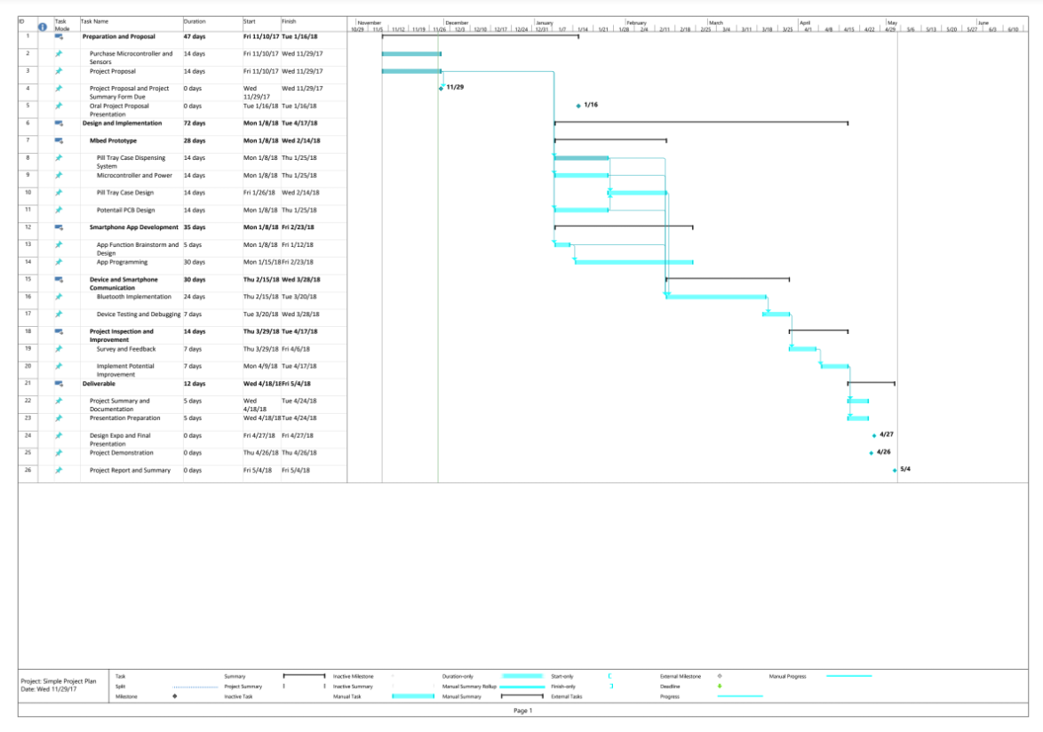

Appendix C
PERT Chart
